Task-based Activity Cover Sheet
Task Title: Automotive Service Technicians Communicate to Solve Problems
Learner Name:

Date Started: Date Completed:

Successful Completion: Yes___ No___
Goal Path: Employment✓ Apprenticeship✓ Secondary School Post Secondary Independence___
Task Description:
Automotive service technicians (AST) use digital technology to communicate with colleagues to solve problems. They may search manufacturer’s web sites or web sites built to answer questions by ASTs.
Competency:  A: Find and Use Information  B: Communicate Ideas and Information  D: Use Digital Technology | Task Group(s):  A1: Read continuous text  A2: Interpret documents  B2: Write continuous text
Level Indicators:
A1.2: Read texts to locate and connect ideas and information
A2.2: Interpret simple documents to locate and connect information
B2.1: Write brief texts to convey simple ideas and factual information
D.2: Perform well-defined, multi-step digital tasks
Performance Descriptors: see chart on last page
Materials Required:
- Computer with a word processor
- Internet access
- Email account

Task Title: Automotive Service Technicians Communicate to Solve Problems
Automotive service technicians communicate with others to find solutions to problems. They use digital technology to ask questions and search for solutions.
Learner Information and Tasks:
An automotive service technician is working on a Ford. The customer has told the technician that the error code for coolant Ford thermostat comes on after the engine has warmed up.
Task 1: Click on the following link: http://www.justanswer.com/ford/
Scroll down the page to the section Recent Articles in Ford; select All Ford Articles. Find the Thermostat link and open the page. Navigate through the questions to find the one addressing this error code. Select and copy the answer.

Task 2: In a word processing program type your name and below that paste the question and answer from the web site into the document. Save the file as Thermostat Problem.

Task 3: Attach the file to an email to your instructor. Describe the problem in the email and note that solution is attached.
Task Title: Automotive Service Technicians Communicate to Solve Problems
Answer Key
Task 1:
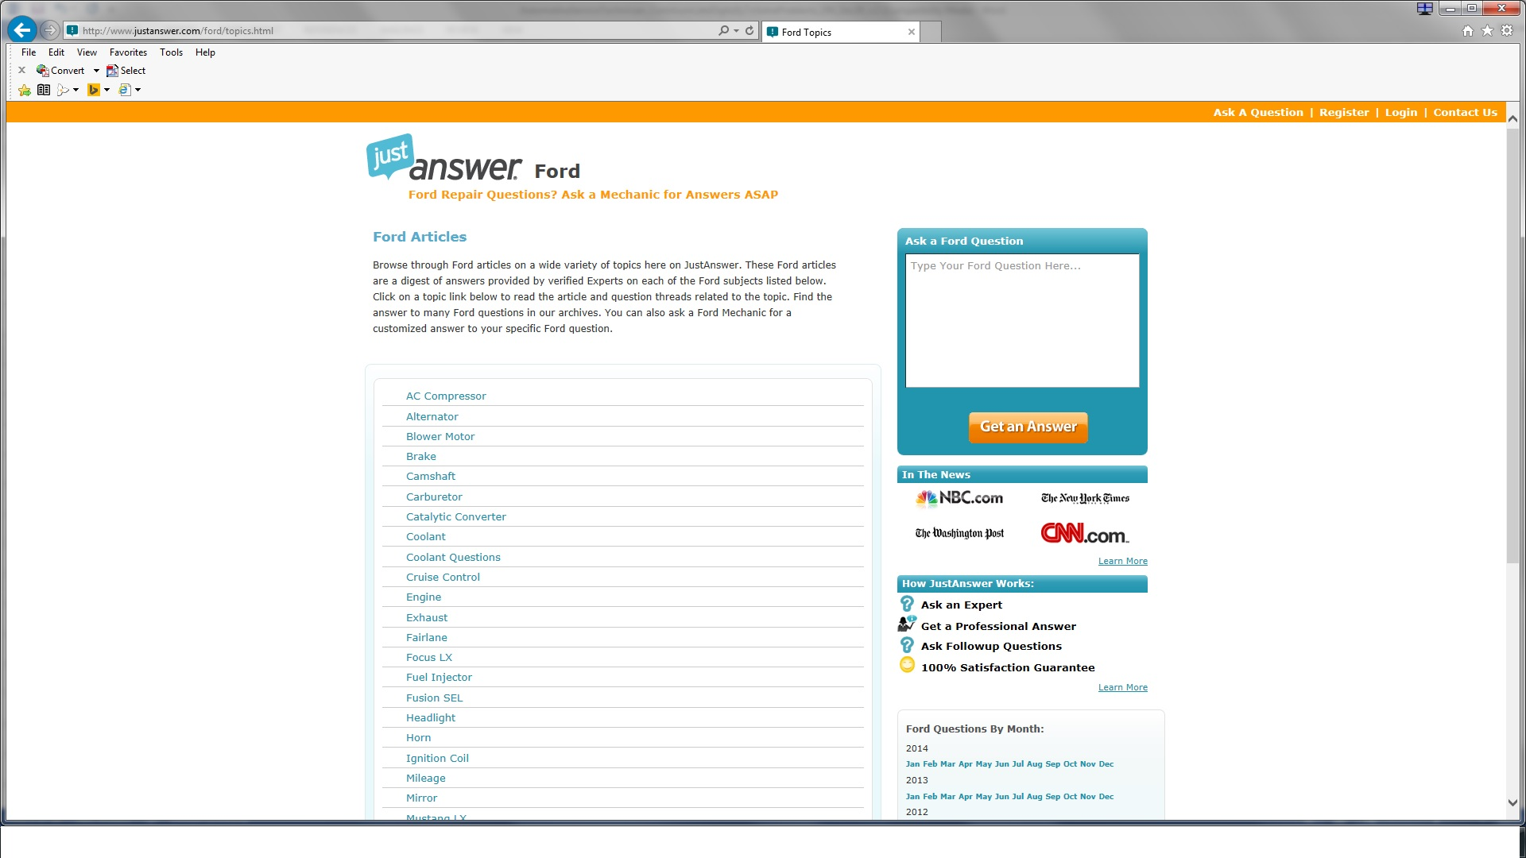
Site valid as of May 2015

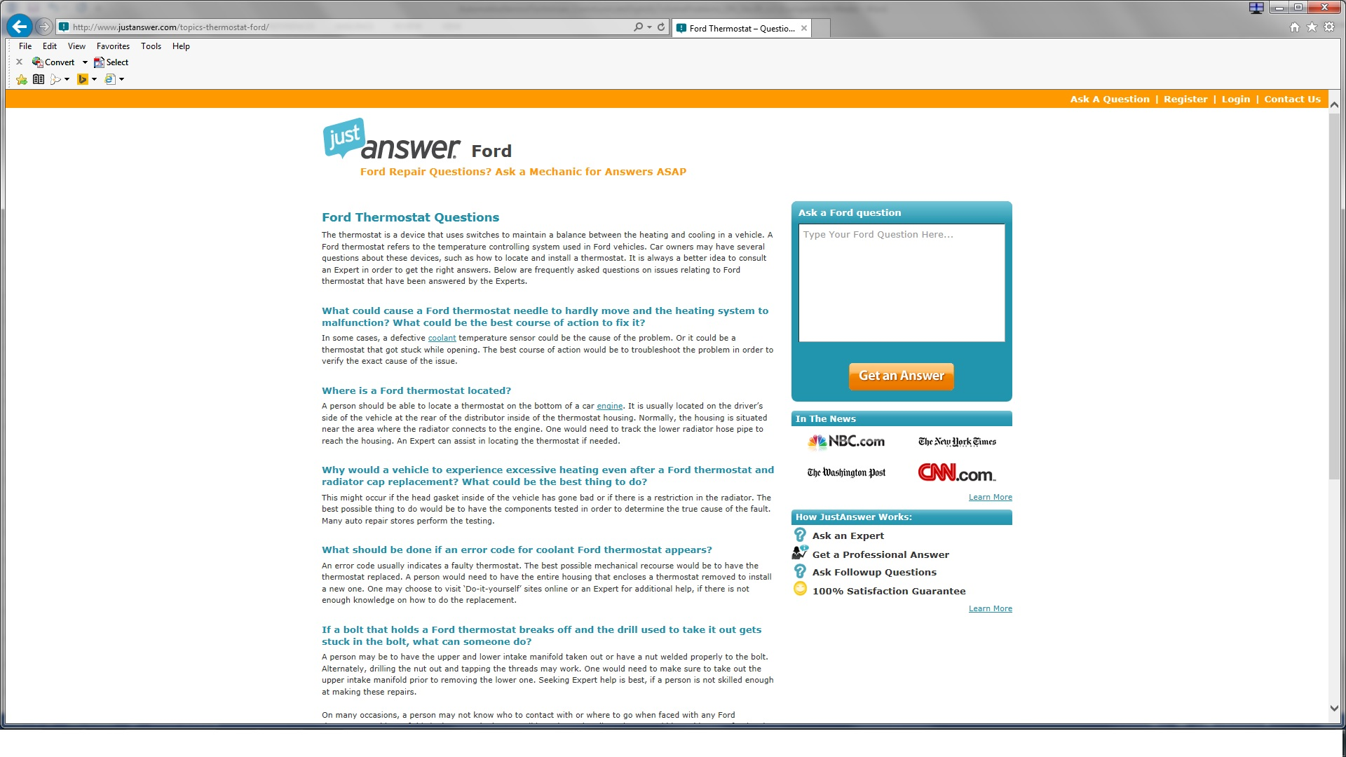
Site valid as of May 2015
Task 2:
Student

What should be done if an error code for coolant Ford thermostat appears?
An error code usually indicates a faulty thermostat. The best possible mechanical recourse would be to have the thermostat replaced. A person would need to have the entire housing that encloses a thermostat removed to install a new one. One may choose to visit ‘Do-it-yourself’ sites online or an Expert for additional help, if there is not enough knowledge on how to do the replacement.
Task 3:
The email should include the document and brief explanation of the problem and that the solution is attached.

Task Title: Automotive Service Technicians Communicate to Solve Problems
Performance Descriptors |  | Needs Work | Completes task with support from practitioner | Completes task independently
A1.2 | - scans text to locate information
 | - locates multiple pieces of information in simple texts
 | - makes low-level inferences
 | - reads more complex texts to locate a single piece of information
 | - follows the main events of descriptive, narrative and informational texts
 | - obtains information from detailed reading
A2.2 | - performs limited searches using one or two search criteria
 | - uses layout to locate information
 | - makes connections between parts of documents
 | - makes low-level inferences
B2.1 | - writes simple texts to request, remind or inform
 | - conveys simple ideas and factual information
 | - uses sentence structure, upper and lower case and basic punctuation
 | - uses highly familiar vocabulary
 | - begins to select words and tone appropriate to the task
D.2 | - begins to organize writing to communicate effectively
 | - selects and follows appropriate steps to complete tasks
 | - locates and recognizes functions and commands
 | - makes low-level inferences to interpret icons and text

This task: was successfully completed___ needs to be tried again___

Learner Comments

____________________________ _________________________

Instructor (print) Learner Signature

