Task-based Activity Cover Sheet
Task Title: Automotive Road Safety Recalls Database
Learner Name:

Date Started: Date Completed:

Successful Completion: Yes___ No___
Goal Path: Employment_✓_ Apprenticeship_✓_ Secondary School Post Secondary Independence___
Task Description:
Understand how to use the internet to search, locate, and use information related to vehicle recalls.
Competency:  A: Find and Use Information  B: Communicate Ideas and Information  D: Use Digital Technology | Task Group(s):  A1: Read continuous text  A2: Interpret documents  B2: Write continuous text  B3: Complete and create documents  D: Use Digital Technology
Level Indicators:
A1.2: Read texts to locate and connect ideas and information
A2.1: Interpret very simple documents to locate specific details
B2.1: Write brief texts to convey simple ideas and factual information
B3.1b: Create very simple documents to display and organize a limited amount of information
D.2: Perform well-defined, multi-step digital tasks
Performance Descriptors: see chart on last page
Materials Required:
- Computer with internet access
- Pencil and paper
- Valid e-mail address
- Optional: cell phone with texting capabilities
Task Title: Automotive Road Safety Recalls Database
Automotive service technicians use the internet to access recall notices. They need to know about potential safety defects that could put motor vehicle operators and their passengers at risk of possible injury or death.
Learner Information and Tasks:
Task 1: Perform a keyword search to locate Transport Canada’s website “Road Safety Recalls Database.” Why does the description of the problems detailed on the database generally start with the words: “On certain vehicles…”?

Task 2: Using the database, do a recall search for a Dodge Ram 2010 - 2012. What model years were affected by an issue with the powertrain?

Task 3: From the list of recall notices, click on recall number 2013044. E-mail or text your instructor what the issues are related to this recall notice and how an automotive service technician would explain it to a paying customer.

Task 4: Other than the Dodge Ram, create a list of the other makes and models, along with model year(s) affected that are also impacted by recall notice 2013044. Give the list a title.
Task Title: Automotive Road Safety Recalls Database
Answer Key
Task 1: Website: http://wwwapps.tc.gc.ca/saf-sec-sur/7/vrdb-bdrv/search-recherche/menu.aspx
Not all vehicles within a specified Vehicle Identification Number (VIN) range may be involved in the recall.
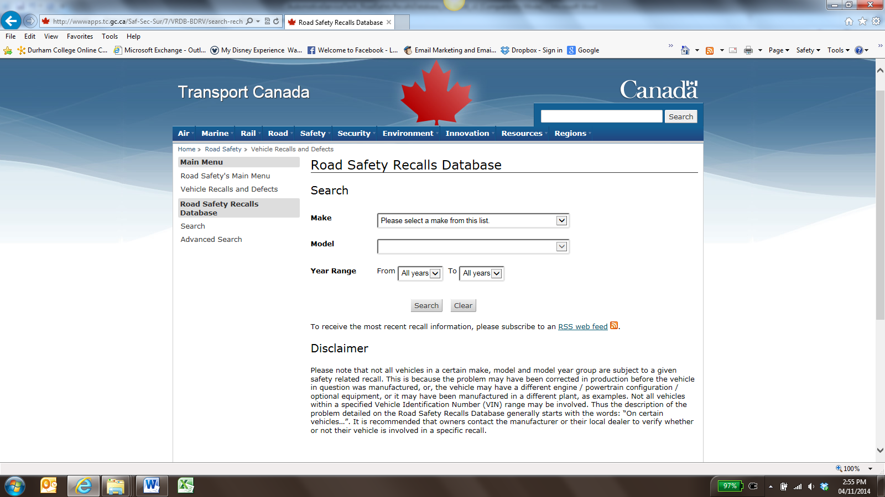
Image as of May 2015
Task 2: 2009, 2010
Task 3: “On certain vehicles, the rear axle pinion nut could loosen and allow the rear driveshaft to detach from the axle, or fully detach from the vehicle. Pinion nut separation could also cause the rear axle differential to fail suddenly, causing rear wheel lockup.”
The explanation to a customer will vary, but should involve a description of the recall notice and “These issues could result in loss of propulsion, danger to other road users, loss of vehicle control and possible crash causing property damage and/or personal injury. Correction: Dealers will install a pinion nut retainer.”
The instructor will need to provide a valid e-mail address or phone number suitable for receiving text messages.
Task 4: Written list should appear similar to the following:
Vehicles Affected by Recall # 2013044
- 2009 Chrysler Aspen
- 2009 Dodge Dakota
- 2010 Dodge Dakota
- 2009 Dodge Durango
- 2011 Ram 1500
- 2012 Ram 1500

Task Title: Automotive Road Safety Recalls Database
Performance Descriptors |  | Needs Work | Completes task with support from practitioner | Completes task independently
A1.2 | - scans text to locate information
 | - locates multiple pieces of information in simple texts
 | - makes low-level inferences
 | - makes connections between sentences and between paragraphs in a single text
 | - reads more complex texts to locate a single piece of information
 | - follows the main events of descriptive, narrative and informational texts
 | - obtains information from detailed reading
 | - begins to identify sources and evaluate information
A2.1 | - scans to locate specific details
 | - identifies how list are organized (e.g. sequential, chronological, alphabetical)
B2.1 | - writes simple texts to request, remind or inform
 | - conveys simple ideas and factual information
 | - demonstrates a limited understanding of sequence
 | - uses highly familiar vocabulary
B3.1b | - follows conventions to display information in lists, labels, simple forms, signs
 | - organizes lists to suit purpose (e.g. chronologically, alphabetically, numerically, sequentially)
D2 | - selects and follows appropriate steps to complete tasks
 | - locates and recognizes functions and commands
 | - makes low-level inferences to interpret icons and text
 | - begins to identify sources and evaluate information
 | - performs simple searches using keywords (e.g. internet, software help menu)

This task: was successfully completed___ needs to be tried again___

Learner Comments

____________________________ _________________________

Instructor (print) Learner Signature

