Task-based Activity Cover Sheet
Task Title: Automotive Vehicle Alignment Machine
Learner Name:

Date Started: Date Completed:

Successful Completion: Yes___ No___
Goal Path: Employment_✓_ Apprenticeship_✓_ Secondary School Post Secondary Independence___
Task Description:
Understand how to use the internet to search a video-sharing website to locate and use information related to computerized tools and equipment.
Competency:  A: Find and Use Information  B: Communicate Ideas and Information  D: Use Digital Technology | Task Group(s):  A1: Read continuous text  A3: Extract info from films, broadcasts and presentations  B2: Write continuous text  D: Use Digital Technology
Level Indicators:
A1.1: Read brief texts to locate specific details
A3: Tasks in the task group are not rated for complexity
B2.1: Write brief texts to convey simple ideas and factual information
D2: Perform well-defined, multi-step digital tasks
Performance Descriptors: see chart on last page
Materials Required:
- Computer with internet access
- Pencil and paper
- Skill-building Activity: to familiarize the learner with A3 use the A3 and The Employment Path curriculum developed by Project READ Literacy Network
Task Title: Automotive Vehicle Alignment Machine
Automotive service technicians access on-line videos to learn how to use computerized equipment to service vehicles properly.
Learner Information and Tasks:
Task 1: Do an internet search for “How Vehicle Alignment Machine Works video” and view the video. What is the name of the automotive service repair shop where the video was recorded?

Task 2: What is the Hunter alignment machine taking a picture of?

Task 3: How does the automotive service technician use the numbers highlighted in red on the computer monitor?

Task 4: Search the internet for the definition of “caster angle”. What is an on-line definition for a “caster”?

Task 5: Search the internet for the definition of “camber angle”. What is an on-line definition for a “camber angle”?

Task Title: Automotive Vehicle Alignment Machine
Answer Key
Task 1a: Website: https://www.youtube.com/watch?v=C3BhnWqW-fY
Ripley's Muffler & Brakes
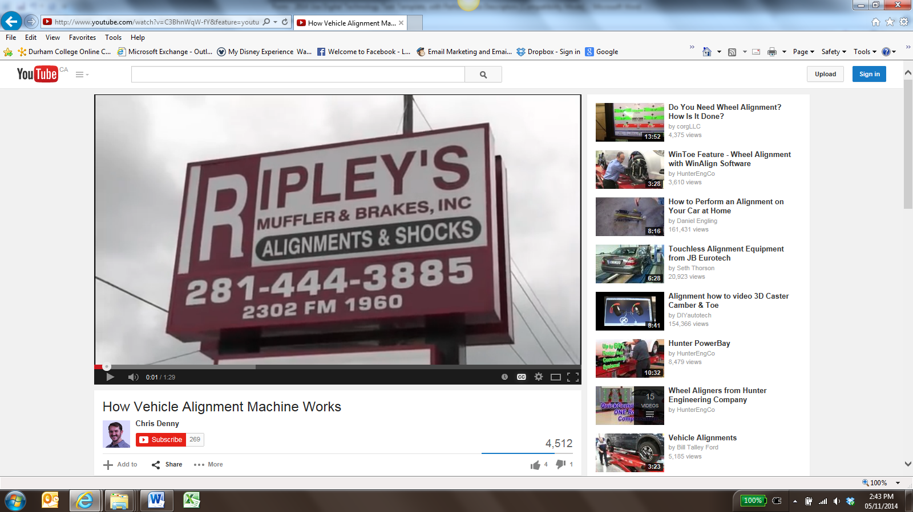
Image as of May 2015
Task 2: The Hunter alignment machine is taking a picture of a target on the every wheel (the learner may also say front and rear wheel).
Task 3: The technician uses the highlighted numbers to make adjustments to be within the range of the specifications for that particular vehicle’s wheels. The learner may also say that it is used to get the tires into the green zone or to come closer to the alignment or to tighten the “toe”.
Task 4: The caster angle[1] or castor angle[2] is the angular displacement from the vertical axis of the suspension of a steered wheel in a car, bicycle or other vehicle, measured in the longitudinal direction. (http://en.wikipedia.org/wiki/Caster_angle)
Task 5: Camber angle: the angle made by the wheels of a vehicle. (en.wikipedia.org/wiki/Camber_angle)

Task Title: Automotive Vehicle Alignment Machine
Performance Descriptors |  | Needs Work | Completes task with support from practitioner | Completes task independently
A1.1 | - Decodes words and makes meaning of sentences in a single text
 | - Reads short texts to locate a single piece of information
 | - Follows simple, straightforward instructional texts
A3 | - the tasks in this task group are not rated for complexity
B2.1 | - writes simple texts to request, remind or inform
 | - conveys simple ideas and factual information
 | - demonstrates a limited understanding of sequence
 | - uses highly familiar vocabulary
D2 | - selects and follows appropriate steps to complete tasks
 | - locates and recognizes functions and commands
 | - makes low-level inferences to interpret icons and text
 | - begins to identify sources and evaluate information
 | - performs simple searches using keywords (e.g. internet, software help menu)

This task: was successfully completed___ needs to be tried again___

Learner Comments

____________________________ _________________________

Instructor (print) Learner Signature

