Task-based Activity Cover Sheet
Task Title: Book a Hotel Room Online
Learner Name:

Date Started: Date Completed:

Successful Completion: Yes___ No___
Goal Path: Employment ✓ Apprenticeship __ Secondary School __ Post Secondary __ Independence ✓
Task Description:
Go online to the Holiday Inn website to book a hotel room online. Then fill out a booking form with information supplied.
Competency:  B: Communicate Ideas and Information  A: Find and Use Information  D: Use Digital Technology | Task Group(s):  B3: Complete and Create Documents  A1: Read Continuous Text  A2: Interpret Documents  D2: Use Digital Technology
Level Indicators:
B3.2: Use layout to determine where to make entries in simple documents
A1.2: Read text to locate and connect ideas and information
A2.2: Interpret simple documents to locate and connect information
D2: Perform well-defined, multi-step digital tasks
Performance Descriptors: see chart or click here
Skill Building Activities: see last page or click here
Materials Required:
- Computer with internet connection
- Booking form (included)
- Pencil
ESKARGO:
- Uses layout to determine where to make entries
- Begins to make some inferences to decide what information is needed, where and how to enter the information
- Makes multiple entries using a limited range of vocabulary
- Follows instructions on document
- Makes entries on simple forms and tables

Attitudes:
Practitioner,
We encourage you to talk with the learner about attitudes required to complete this task set. The context of the task has to be considered when identifying attitudes.
With your learner, please check one of the following:
___Attitude is not important ___ Attitude is somewhat important ___ Attitude is very important

Task Title: Book a Hotel Room Online
Travelers often book hotel rooms online to ensure that rooms are reserved for them before traveling. Administrative clerks often book hotel rooms for an employer or other employees.

A clerk has been asked to book a hotel room for one month from today. The room is for one adult for one night in Kitchener, Ontario. The room must be non-smoking and have wireless access to the internet. Using the internet, find a suitable room at the cheapest rate.

Learner Information and Tasks:
Task 1: Using the internet go to the Holiday Inn website to find a hotel: http://www.ihg.com/holidayinn/hotels/us/en/reservation .

Task 2: Enter the required information in the “Find a Hotel” search box and click “Find a Hotel”.

Task 3 In the “Search Results” webpage, look at all the options. Using the dropdown arrow, change “all amenities” to “wireless internet”. Change “km away” from “50” to “10”. Click Apply to see the options.

Task 4: Choose a hotel that seems most suitable for the price. It does not have to be a Holiday Inn hotel. Click Check Rates.

Task 5: Choose a suitable room and write down the following information:
Name of Hotel:
Cost of room before taxes:
Number and type of bed(s):

Task 6: For the room chosen, click view rates. Click BOOK THIS ROOM. When actually booking the room online this form would be completed, but a copy of this form has been provided below. Use the following information to fill out the “Booking form”. For the credit card information, circle the correct type of card, month and year. When actually booking a hotel, the dropdown arrow is used to fill out this information.
  - John Smith
  - 123 King Street West, Hamilton, ON L8P 1A5
  - 905-555-1234
  - John905smith@hotmail.com
  - MasterCard 6018 5555 4444 3333 May 2015
Booking Form
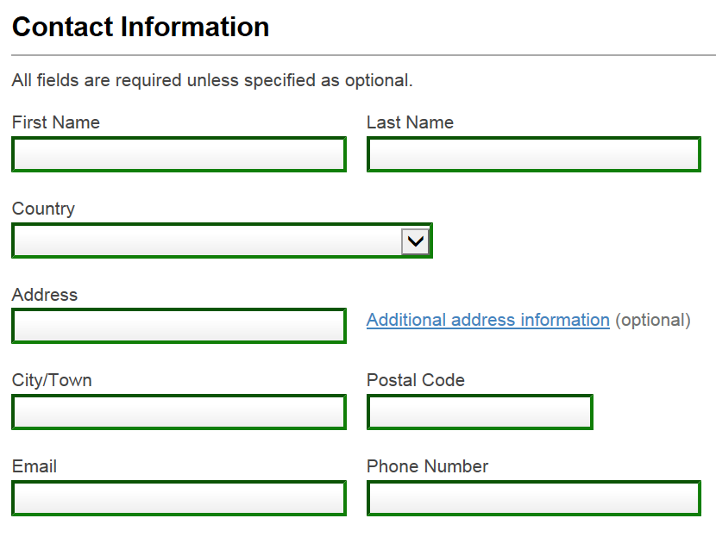
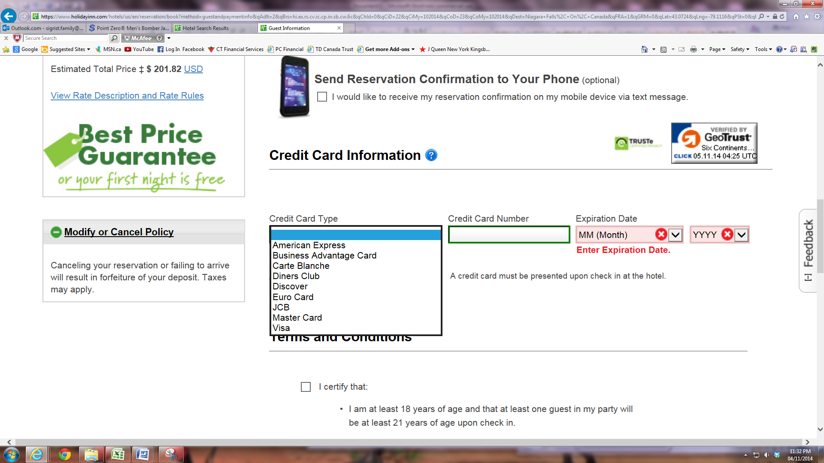
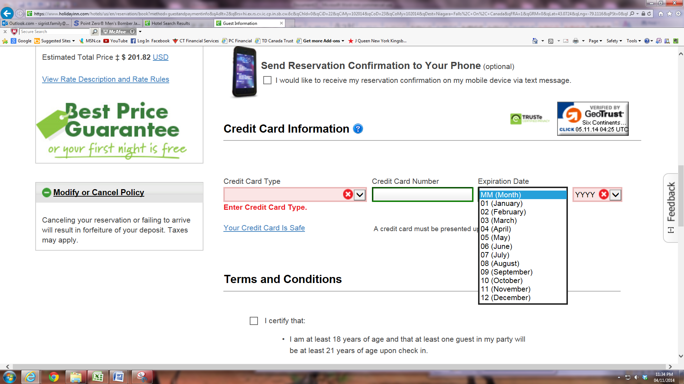
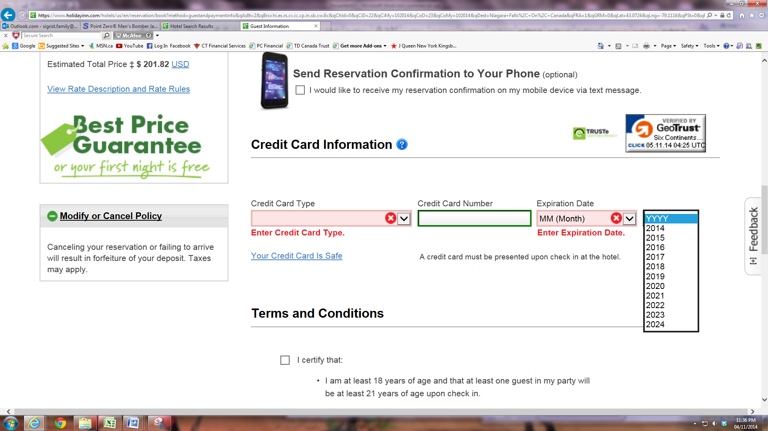

Task Title: Book a Hotel Room Online
Answer Key
Task 1: Must open up Google and type in “Holiday Inn”
Task 2: Be able to type in information required as given in the scenario. On the screen, there should be a list of hotel rooms.
Task 3: Correct dropdown keys should be clicked and the information changed as required in task 3. “Apply” key should be clicked.
Task 4: There should only be a few options for Kitchener.
Task 5: Name of Hotel: (answers will vary) Any type of hotel is acceptable
Cost of room before taxes: answers will vary but it should be between $100-175.
Number and type of bed(s): something like: “1 King bed Standard Non-smoking”
Task 6: Should have booking online form on the screen. See next page for what the completed form will look like.
Please note: If the learner is capable to complete the online portion of this task on their own, they do not need to follow the directions given. However, the point of the directions is to guide the learner to locate the form. The form then is filled out on paper. This also provides proof that the learner completed the task. The purpose of the task is to be able to complete forms (B3.2), which they do with the paper copy.

Task Title: Book a Hotel Room Online - Answer Key for Task 6
John
Smith
Canada
123 King St. W.
Hamilton
L8P 1A5
John905smith@hotmail.com
905-555-1234
601855554444333

Task Title: Book a Hotel Room Online
Performance Descriptors |  | Needs Work | Completes task with support from practitioner | Completes task independently
B3.2 | - uses layout to determine where to make entries
 | - begins to make some inferences to decide what information is needed, where and how to enter the information
 | - makes entries using a limited range of vocabulary
 | - follows instructions on documents
A1.2 | - scans text to locate information
 | - locates multiple pieces of information in simple texts
A2.2 | - performs limited searches using one or two search criteria
 | - uses layout to locate information
D.2 | - selects and follows appropriate steps to complete tasks
 | - locates and recognizes functions and commands
 | - makes low-level inferences to interpret icons and text
 | - performs simple searches using keywords (e.g. internet, software help menu)

This task: was successfully completed___ needs to be tried again___

Learner Comments

____________________________ _________________________

Instructor (print) Learner Signature

Skill Building Activities

Links for online resources:
Filling in a Form (BBC Skillwise)
http://www.bbc.co.uk/skillswise/topic/filling-out-a-form
“Filling in forms accurately is a key skill in applying for jobs, schools, bank loans, etc.” By clicking on this link, the learner is able to watch a 1 minute video about filling in forms. In the video a janitor, hotel receptionist, and engineer explain as to why filling it forms is important for their job. The learner also has access to the “Form Finder Game” in which they have practice finding the appropriate fields on a form.
Filling in Forms (Literacytools)
http://www.literacytools.ie/pages/actions/viewPdfFile.cfm?pId=184
In this document, “Filling in Forms,” learners are given 7 general tips of best practice when completing a form. There are several exercises within the document to help learners practice their skills when filling out forms: forms with boxes, writing dates in boxes, application forms, etc. There is also a section on vocabulary commonly used when filling out forms.
Filling out a Form (LaRue Literacy Exercies)
http://www.mcedservices.com/litex/litex.htm
There are two sections to note on this website: “Online Literacy Learning Activities” and “Printable Literacy Learning Activities.” The learner has the option to work on the “Filling out a Form” online lessons or can choose to download lesson material. The online and printable sections have an introduction to filling out a form and Exercised 3.1, 3.2, and 3.3 to practice where information should be inserted on a form.
LearningHUB Courses Available:
- Independent Study, PLATO PLE (Assigned by Practitioner after assessment):
- Document Use Level 1 (Assignment 1): Unit 2 – Forms 1
- Document Use Level 2 (Assignment 1): Unit 2 – Forms 2
- Document Use Level 3 (Assignment 1): Unit 1 – Forms 3
- Live Classes (SABA) –
- Filling in Forms
*To access LearningHUB courses, learners must register for the LearningHUB e-Channel program by completing the registration form on their website and completing the course selection (page 2 of the registration form): https://www.learninghub.ca/get_registered.aspx
*To Access LearningHUB Course Catalogue:
http://www.learninghub.ca/Files/PDF-files/HUBcoursecatalogue,%20December%2023,%202014%20revision.pdf

