 Task-based Activity Cover Sheet
Task Title: Budgeting
Learner Name:

Date Started: Date Completed:

Successful Completion: Yes □ No □
Goal Path: Employment □ Apprenticeship □ Secondary School □ Post-Secondary □ Independence X
Task Description:
Learner completes a budget worksheet for an individual on Ontario Works.
Competency:  B: Communicate Ideas and Information  C: Understand and Use Numbers | Task Group(s):  B3: Complete and create documents  C1: Manage money
Level Indicators:
B3.2a: Use layout to determine where to make entries in simple documents
C1.1: Compare costs and make simple calculations

Performance Descriptors: see chart on last page
Materials Required:
- Pencil or pen

Task Title: Budgeting
Budgeting is an important part of understanding finances. To create a budget an individual needs to track their expenses for 3 months, but first it is important to track them by week. Look at the “Handout E: Financial Literacy – Budgeting”.
Learner Information and Tasks:
Task 1: Calculate the amount of money someone living on Ontario Works has each week if there are 4 weeks in a month. The maximum benefit for an individual on Ontario Works is $681/month.

Task 2: Calculate the cost per week for the following monthly expenses and enter them in the budget chart:
Rent $350
Insurance $0
Travel/Bus pass $69
Cell Phone $20
Cable $42
Internet $38
Groceries $250
Restaurants/Tim’s $40
Clothes $40
Hair $20
Laundry $5
Entertainment $40
Pets $70

Task 3: Calculate the difference between income and expenses if the individual is on Ontario Works.

Task 4: Where can the individual reduce their budget to not be over-spent? Look at needs as compared to wants.

Task 5: Calculate the new total based on items removed or reduced in Task 4

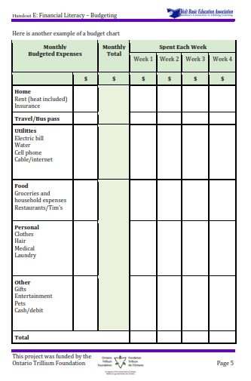
Task Title: Budgeting
Notes for instructors/facilitators:
Always use the learner’s math from the previous task in the set to mark the next task, as it is about understanding the calculations and just because one number/answer is incorrect it doesn’t mean the next one is automatically wrong just because the numbers used were wrong previously.
Also important to remember that when dealing with percents you can have a 1 cent difference in HST amounts dependent on how the math is completed.
Answer Key
Task 1: Calculate the amount of money someone living on Ontario Works has each week if there are 4 weeks in a month. The maximum benefit for an individual on Ontario Works is $681/month.
A: 681 / 4 = 170.25
Task 2: Calculate the cost per week for the following monthly expenses and enter them in the budget chart:
Rent $350 = 87.50 Need
Insurance $0
Travel/Bus pass $69 = 17.25 Want
Cell Phone $20 = 5.00 Want
Cable $42 = 10.50 Want
Internet $38 = 9.50 Want
Groceries $250 = 62.50 Need
Restaurants/Tim’s $40 = 10.00 Want
Clothes $40 = 10.00 Need
Hair $20 = 5.00 Want
Laundry $5 = 1.25 Need
Entertainment $40 = 10.00 Want
Pets $70 = 17.50 Want

Task 3: Calculate the difference between income and expenses if the individual is on Ontario Works.
A: Total of all costs = $984 984 – 681 = $303
Task 4: Where can the individual reduce their budget to not be over-spent? Look at needs as compared to wants.
See the above Need and Want breakdown …. The learner should find that on OW you will need to eliminate your wants
Task 5: Calculate the new total based on items removed or reduced in Task 4
A: normally it would be $319 of Wants removed, but the learner maybe creative as long as they can eliminate $303 of expenses

Task Title: Budgeting
Performance Descriptors |  | Needs Work | Completes task with support from practitioner | Completes task independently
B3.2a | - uses layout to determine where to make entries
B3.2a | - begins to make some inferences to decide what information is needed, where and how to enter the information
C1.1 | - adds, subtracts, multiplies and divides whole numbers and decimals
 | - identifies and performs required operation
 | - follows apparent steps to reach solutions
 | - interprets and represents costs using monetary symbols and decimals
 | - uses strategies to check accuracy (e.g. estimating, using a calculator, repeating a calculation, using the reverse operation)

This task: was successfully completed □ needs to be tried again □

Learner Comments

____________________________ _________________________

Instructor (print) Learner Signature

