

Task Title: Calculate Change from Purchase

# OALCF Cover Sheet – Practitioner Copy

**Learner Name: __________________________________________**

**Date Started: ___________________________________________**

**Date Completed: _________________________________________**

|  |  |  |
| --- | --- | --- |
| **Goal Path:** | Employment | Apprenticeship |
| Secondary School | Post Secondary | Independence |

**Successful Completion:**  Yes No

**Task Description:** Calculate the change to be received after making a cash purchase.

**Main Competency/Task Group/Level Indicator:**

* Understand and Use Numbers/Manage money/C1.1

**Materials Required:**

* Pen/pencil and paper and/or digital device
* Calculator or digital device with calculator function (optional)

# Notes for Instructors/Practitioners

This task has been levelled at C1.1 so the learner has not been asked to calculate sales tax on purchases. To maintain task authenticity, the learner will review a flyer for a store that is having a “tax-free event”.

The learner may round to the nearest 0.05 for cash purchases now that the penny is not in circulation. If you have not reviewed rounding money with your learner, you can accept the exact amounts for each calculation. Both responses are listed in the answer key.

This could also be completed as a C1.2 task by asking the learner to calculate sales tax on each purchase. These answers have not been provided.

While this task is written for a “cleaner”, it is suitable for someone on either the Employment or Independence goal path.

# Learner Information

People often purchase cleaning and other supplies for home or work. When paying with cash it is important to make sure you get the right amount of change back from a purchase.

Review the “Cleaning Supplies Flyer” from the local hardware store. This week, there is a tax-free event. Every item in this flyer costs the listed price. Tax will not be added to purchases.

**Cleaning Supplies Flyer**

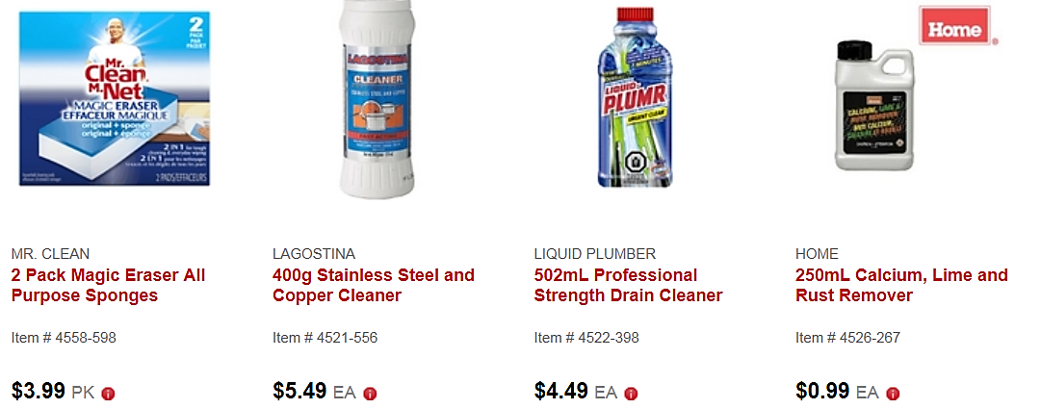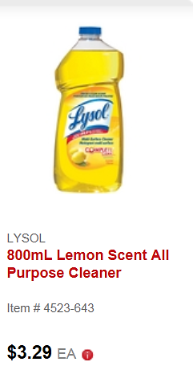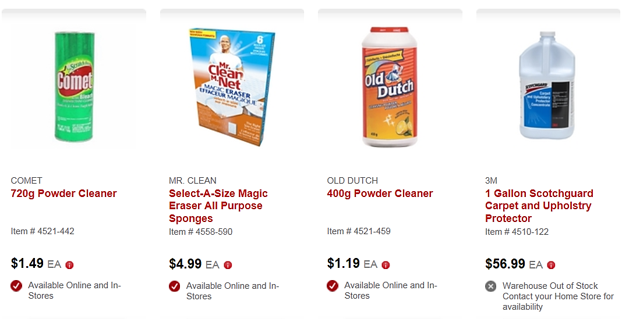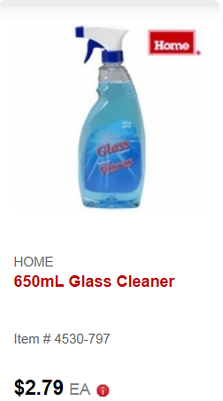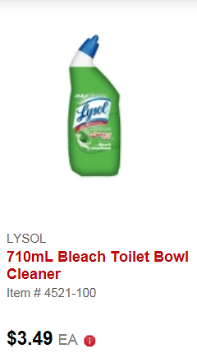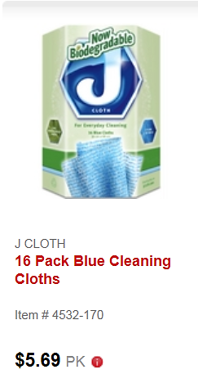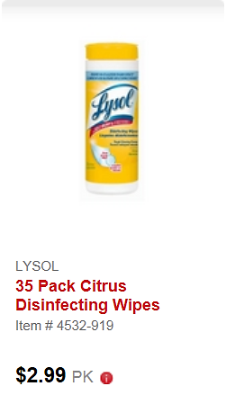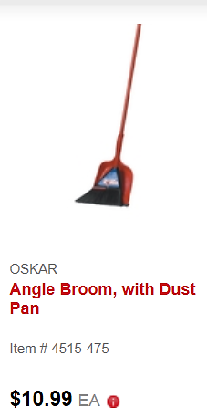

# Work Sheet

**Task 1: A cleaner is purchasing Lysol Citrus Disinfecting Wipes and Lysol Bleach Toilet Bowl Cleaner. They are paying with a $10 bill. Calculate the amount of change the cleaner should receive.**

Answer:

**______________________________________________________**

**Task 2: A cleaner is purchasing Old Dutch Powder Cleaner and Home Glass Cleaner. The cleaner pays with a $20 bill. Calculate the amount of change the cleaner should receive.**

Answer:

**______________________________________________________**

**Task 3: A cleaner is purchasing two Oskar Angle Brooms and two packages of J Cloth 16-pack Blue Cleaning Cloths. The cleaner pays with a $50 bill. Calculate the amount of change the cleaner should receive.**

Answer:

**______________________________________________________**

**Task 4: A cleaner is purchasing Mr. Clean 2 Pack Magic Erasers, Old Dutch Powder Cleaner, and Lysol Bleach Toilet Bowl Cleaner. The cleaner pays with $15. Calculate whether the cleaner has enough to also purchase Lysol Lemon Scent All Purpose Cleaner.**

Answer:

**______________________________________________________**

# Answers

**Task 1: A cleaner is purchasing Lysol Citrus Disinfecting Wipes and Lysol Bleach Toilet Bowl Cleaner. They are paying with a $10 bill. Calculate the amount of change the cleaner should receive.**

Answer: $2.99 + $3.49 = $6.48

$10.00 - $6.48 = $3.52 (rounded to $3.50 with a cash purchase)

**Task 2: A cleaner is purchasing Old Dutch Powder Cleaner and Home Glass Cleaner. The cleaner pays with a $20 bill. Calculate the amount of change the cleaner should receive.**

Answer: $1.19 + $2.79 = $3.98

$20.00 - $3.98 = $16.02 (rounded to $16.00 with a cash purchase)

**Task 3: A cleaner is purchasing two Oskar Angle Brooms and two packages of J Cloth 16-pack Blue Cleaning Cloths. The cleaner pays with a $50 bill. Calculate the amount of change the cleaner should receive.**

Answer: 2x$10.99 + 2x$5.69 = $33.36

$50 - $33.36 = $16.64 (rounded to $16.65 with a cash purchase)

**Task 4: A cleaner is purchasing Mr. Clean 2 Pack Magic Erasers, Old Dutch Powder Cleaner, and Lysol Bleach Toilet Bowl Cleaner. The cleaner pays with $15. Calculate whether the cleaner has enough to also purchase Lysol Lemon Scent All Purpose Cleaner.**

Answer: $3.99 + $1.19 + $3.49 = $8.67

$10.00 - $8.67 = $1.33. The Lysol Lemon Scent All Purpose Cleaner costs $3.29. The cleaner will not have enough for this additional purchase.

# Performance Descriptors

| Levels | Performance Descriptors | Needs Work | Completes task with support from practitioner | Completes task independently |
| --- | --- | --- | --- | --- |
| C1.1 | adds, subtracts, multiplies and divides whole numbers and decimals |  |  |  |
|  | recognizes values in number and word format |  |  |  |
|  | identifies and performs required operation |  |  |  |
|  | interprets and represents costs using monetary symbols and decimals |  |  |  |
|  | follows apparent steps to reach solutions |  |  |  |
|  | uses strategies to check accuracy (e.g. estimating, using a calculator, repeating a calculation, using the reverse operation) |  |  |  |

This task: Was successfully completed Needs to be tried again

Learner Comments:

Instructor (print): Learner (print):

**__________________ _________________**