Task-based Activity Cover Sheet
Task Title: Calculate Change from a Purchase
Learner Name:

Date Started: Date Completed:

Successful Completion: Yes___ No___
Goal Path: Employment ✓ Apprenticeship __ Secondary School __ Post Secondary __ Independence __
Task Description:
Calculate the change to receive after making a cash purchase.
Competency:  C: Understand and Use Numbers | Task Group(s):  C1: Manage Money
Level Indicators:
C1.1: Compare costs and make simple calculations
Performance Descriptors: see after answer key or click here
Links to skill building activities: see the last page or click here
Materials Required:
- Optional: Home Hardware flyer (attached) (not required to answer questions)
- Pencil and eraser
ESKARGO:
C1.1
- Understands place value
- Writes and solves simple addition and subtraction sentences (e.g., 5 + 6 = 11)
- Subtracts whole numbers by borrowing
- Identifies the effect of zero in addition and subtraction
- Adds and subtracts multi-digit whole numbers with and without regrouping
- Identifies and performs required 1-step operations
- Adds and subtracts multi-digit whole numbers and decimals

Attitudes:
Practitioner,
We encourage you to talk with the learner about attitudes required to complete this task set. The context of the task has to be considered when identifying attitudes.
With your learner, please check one of the following:
___Attitude is not important ___ Attitude is somewhat important ___ Attitude is very important

Task Title: Calculate Change from a Purchase
Learner Information and Tasks:
Cleaners purchase cleaning supplies. When paying with petty cash from work, it is important to make sure to get the right amount of change back from a purchase.

Task 1: The total cost with tax for buying Lysol all-purpose cleaner is $3.70. The cleaner pays for it with a $10 bill. Calculate the amount of change the cleaner should receive.
Task 2: The total cost with tax for buying Lysol disinfecting wipes and Old Dutch powder cleaner is $4.70. The cleaner pays with a $20 bill. Calculate the amount of change the cleaner should receive.
Task 3: The total cost with tax for buying Magic Erasers, a glass cleaner, and an all-purpose cleaner is $11.40. The cleaner pays with a twenty-dollar bill. Calculate the amount of change the cleaner should receive.
Task 4: The total cost with tax for buying a broom, cleaning cloths, and toilet bowl cleaner is twenty-two dollars and seventy-five cents. The cleaner pays with a fifty-dollar bill. Calculate the amount of change the cleaner should receive.


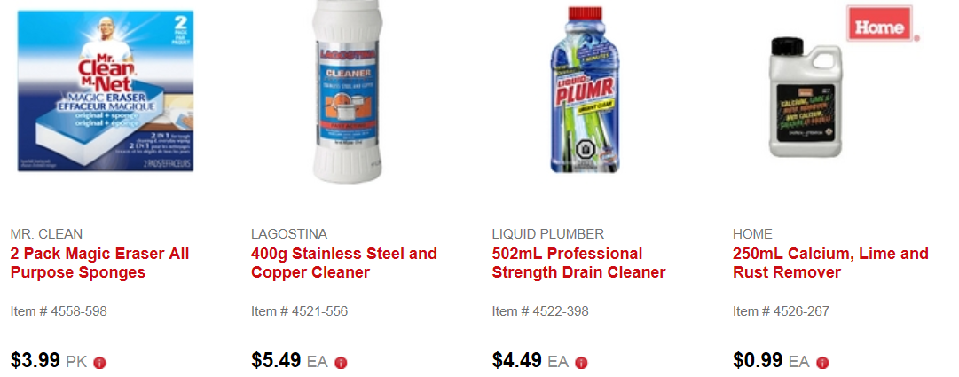
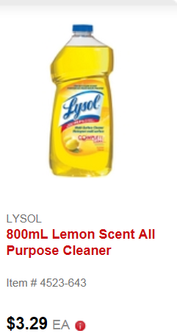
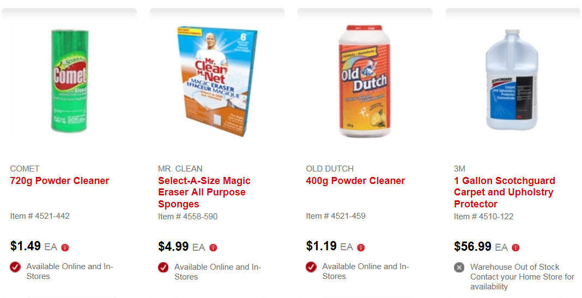
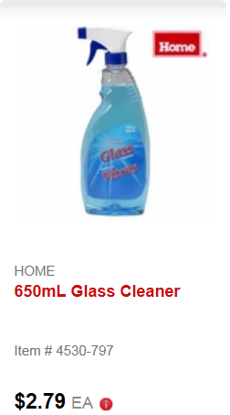
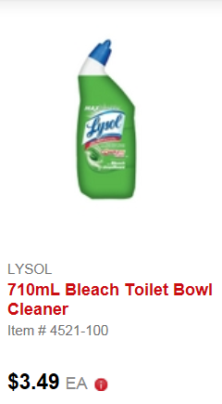
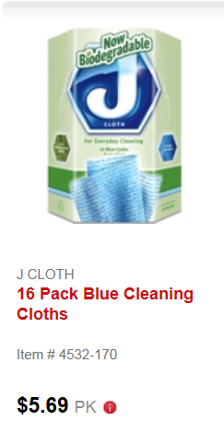
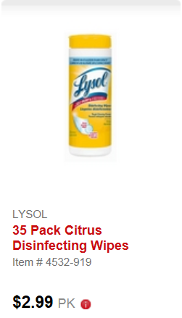

(optional)

Task Title: Calculate Change from a Purchase
Answer Key
Task 1: The total cost with tax for buying Lysol all-purpose cleaner is $3.70. The cleaner pays for it with a $10 bill. Calculate the amount of change the cleaner should receive.
$10.00 - 3.70 = $6. 30
Task 2: The total cost with tax for buying Lysol disinfecting wipes and Old Dutch powder cleaner is $4.70. The cleaner pays with a $20 bill. Calculate the amount of change the cleaner should receive.
$20.00 – 4.70 = $15.30
Task 3: The total cost with tax for buying Magic Erasers, a glass cleaner, and an all-purpose cleaner is $11.40. The cleaner pays with a twenty-dollar bill. Calculate the amount of change the cleaner should receive.
$20.00 – 11.40 = $8.60
Task 4: The total cost with tax for buying a broom, cleaning cloths, and toilet bowl cleaner is twenty-two dollars and seventy-five cents. The cleaner pays with a fifty-dollar bill. Calculate the amount of change the cleaner should receive
$50.00 - $22.75 = $27.25

Task Title: Calculate Change from a Purchase
Performance Descriptors |  | Needs Work | Completes task with support from practitioner | Completes task independently
C1.1 | - adds, subtracts, multiplies and divides whole numbers and decimals
 | - recognizes values in number and word format
 | - identifies and performs required operation
 | - interprets and represents costs using monetary symbols and decimals
 | - follows apparent steps to reach solutions
 | - uses strategies to check accuracy (e.g. estimating, using a calculator, repeating a calculation, using the reverse operation)

This task: was successfully completed___ needs to be tried again___

Learner Comments

____________________________ _________________________

Instructor (print) Learner Signature

Skill Building Activities

Links to Online Resources:

- http://www.gcflearnfree.org/edlmoney/count-change (An interactive online game for counting change, although it focuses on American coins, but still helpful for counting by 1’s/5’s/10’s/25’s)
- http://www.gcflearnfree.org/math/additionsubtraction/addition (The basics of Addition)
- http://www.gcflearnfree.org/math/additionsubtraction/subtraction (The basics of Subtraction)
- http://www.ehow.com/how_2265850_count-out-change.html (A short step-by-step article on how to count change)
- http://www.bbc.co.uk/skillswise/worksheet/ma15solv-l1-w-prob-solving-with-add-and-subtract-involving-money (A worksheet that can be printed off for adding/subtracting money amounts, although it focuses on British pounds/pence but Canadian dollars/cents could be substituted with the same results)

LearningHUB Curriculum Available:

- Math, Independent Study - 100 Whole Numbers Assignment; 101 Addition, Subtraction Assignments 1 & 2; 201 Multiplication, Division Assignment; 302 Decimals Assignment. (Assigned by practitioner after assessment)

- Math, Live Classes (Saba) - Counting Coins; Making Change; Multiplication; Division; Decimals A.

*To access LearningHUB courses, learners must register for the LearningHUB e-Channel program by completing the registration form on their website and completing the course selection (page 2 of the registration form): https://www.learninghub.ca/get_registered.aspx
*To Access LearningHUB Course Catalogue: http://www.learninghub.ca/Files/PDF-files/HUBcoursecatalogue,%20December%2023,%202014%20revision.pdf

