OALCF Task Cover Sheet
Task Title: Scheduling Classes and Assignments in a College Planner
Learner Name:

Date Started: Date Completed:

Successful Completion: Yes___ No___
Goal Path: Employment___ Apprenticeship___ Secondary School Post Secondary ✓ Independence___

Task Description:
The learner will insert their classes and assignment deadlines into a semester planner sheet from a college student planner.
Competency:  A. Find and Use Information  B. Communicate Ideas and Information | Task Group(s):  A2: Interpret documents  B2: Write continuous information  B3: Complete and create documents
Level Indicators:
A2.1: Interpret very simple documents to locate specific details
B2.1: Write brief texts to convey simple ideas and factual information
B3.1a: Make straightforward entries to complete very simple documents
B3.2a: Use layout to determine where to make entries in simple documents

Performance Descriptors: see chart on last page
Materials Required:
- Fall Semester Classes & Assignment sheet
- Copy of the College Fall Semester planner sheet from 2013-2014 student planner
- Pen/Pencil

Task Title: Scheduling Classes and Assignments in a College Planner
Learner Information and Tasks:
Task 1: You have been given your list of classes and the assignment dates for each class for the Fall 2013 semester (see “Fall Semester Classes & Assignments”). To organise your studies for this semester, record your classes and assignment deadlines onto the semester planner sheet provided.
Fall Semester Classes & Assignments

Human Biology
Mondays 9.00 to 12.00
Assignment 1
Anatomy essay (Deadline: October 14th)
Assignment 2
Class Quiz (November 25th)

Chemistry Lab
Mondays 1.00 to 3.00
Assignment 1
Elements essay (Deadline: October 30th)

Business 101
Wednesdays 12.00 to 5.00
Assignment 1
Group presentation on global financial systems (Deadline November 13th)
Assignment 2
Class quiz (Deadline November 27th)

English Literature
Thursdays 10.00 to 2.00
Assignment 1
Book review (Deadline: October 17th)

Communications
Fridays 11.00 to 4.00
Assignment 1
Modern Communications essay (Deadline: November 22nd)
Assignment 2
Social Media presentation (Deadline: December 6th)

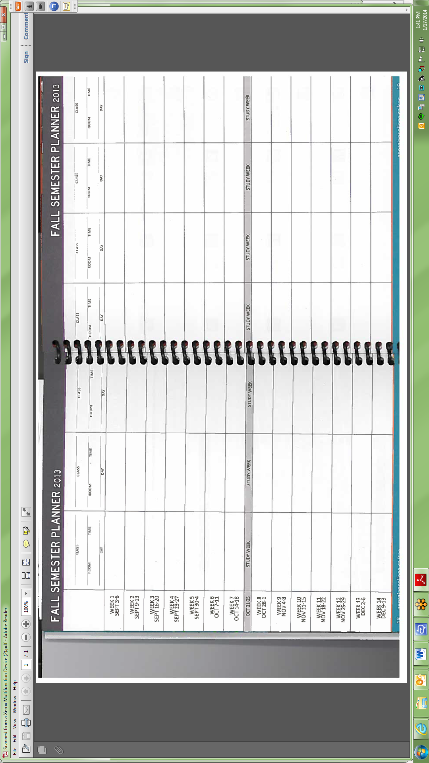
Task Title: Scheduling Classes and Assignments in a College Planner
Performance Descriptors |  | Needs Work | Completes task with support from practitioner | Completes task independently
A2.1 | - scans to locate specific details
 | - locates specific details in simple documents, such as labels and signs
 | - identifies how lists are organized (e.g. sequential, chronological, alphabetical)
B2.1 | - writes simple texts to request, remind or inform
 | - conveys simple ideas and factual information
 | - demonstrates a limited understanding of sequence
 | - uses sentence structure, upper and lower case and basic punctuation
 | - uses highly familiar vocabulary
B3.1a | - makes a direct match between what is requested and what is entered
 | - makes entries using familiar vocabulary
B3.2a | - uses layout to determine where to make entries
 | - begins to make some inferences to decide what information is needed, where and how to enter the information
 | - makes entries using a limited range of vocabulary
 | - follows instructions on documents
This task: was successfully completed___ needs to be tried again___

Learner Comments

____________________________ _________________________

Instructor (print) Learner Signature

