

Task Title: Complaint Handling Policy

# OALCF Cover Sheet – Practitioner Copy

**Learner Name: __________________________________________**

**Date Started: ___________________________________________**

**Date Completed: _________________________________________**

|  |  |  |
| --- | --- | --- |
| **Goal Path:** | Employment | Apprenticeship |
| Secondary School | Post Secondary | Independence |

**Successful Completion:**  Yes No

**Task Description:**

Use the College of Physiotherapists of Ontario – Complaints Process infographic to answer questions about how complaints are handled.

**Main Competency/Task Group/Level Indicator**

* Find and Use Information/Interpret documents/A2.2

**Materials Required:**

* Pen/pencil and paper or digital device

# Learner Information

Complaints are handled differently by each workplace or organization. Understanding how complaints are investigated is important for protecting both customers and employees.

Scan the College of Physiotherapists of Ontario – Complaints Processinfographic.

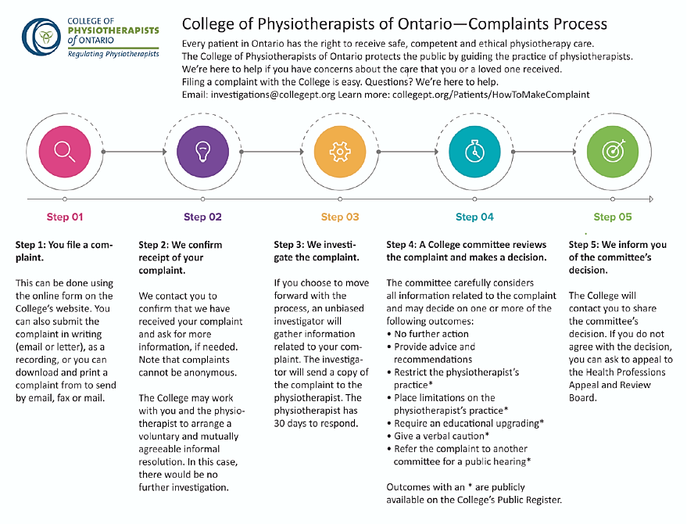

# Work Sheet

**Task 1: What are the five steps of complaint handling?**

Answer:

**______________________________________________________**

**Task 2: How long does a physiotherapist have to respond to a complaint that is being investigated?**

Answer:

**______________________________________________________**

**Task 3: What are two possible outcomes if the College committee reviews a complaint?**

Answer:

**______________________________________________________**

**Task 4: What can someone do if they do not agree with the committee’s decision?**

Answer:

**______________________________________________________**

# Answers

**Task 1: What are the five steps of complaint handling?**

Answer: Step 1: You file a complaint; Step 2: We confirm receipt of your complaint; Step 3: We investigate the complaint; Step 4: A College committee reviews the complaint and makes a decision; Step 5: We inform you of the committee’s decision.

**Task 2: How long does a physiotherapist have to respond to a complaint that is being investigated?**

Answer: 30 days.

**Task 3: What are two possible outcomes if the College committee reviews a complaint?**

Answer: Any two of the following:

* No further action
* Provide advice and recommendations
* Restrict the physiotherapist’s practice
* Place limitations on the physiotherapist’s practice
* Require an educational upgrading
* Give verbal caution
* Refer the complaint to another committee for a public hearing

**Task 4: What can someone do if they do not agree with the committee’s decision?**

Answer: If you do not agree with the decision, you can ask to appeal to the Health Professionals Appeal and Review board.

# Performance Descriptors

| Levels | Performance Descriptors | Needs Work | Completes task with support from practitioner | Completes task independently |
| --- | --- | --- | --- | --- |
| A2.2 | uses layout to locate information |  |  |  |
|  | makes low-level inferences |  |  |  |
|  | makes connections between parts of documents |  |  |  |

This task: Was successfully completed Needs to be tried again

Learner Comments:

Instructor (print): Learner (print):

**_____________________ _____________________**