Task-based Activity Cover Sheet
Task Title: Compare Hotel Room Size
Learner Name:

Date Started: Date Completed:

Successful Completion: Yes___ No___
Goal Path: Employment ___ Apprenticeship___ Secondary School Post Secondary Independence ✓
Task Description:
The learner will use the attached floor plans and dimensions to calculate and compare hotel room sizes.
Competency:  C: Understand and Use Numbers | Task Group(s):  C3: Use Measures
Level Indicators:
C3.2: Use measures to make one-step calculations
Performance Descriptors: see chart on last page or click here.
Links to skill building activities: see the last page or click here.
Materials Required:
- Pen/pencil
- Scrap paper/calculator
- Attached floor plans
ESKARGO:
- Calculates using numbers expressed as whole numbers, fractions, decimals, percentages, and integers
- Interprets and represents area and volume using symbols and abbreviations (e.g., m³)
- Understands and uses formulas for finding the perimeter, area, and volume of simple, common shapes
- Chooses and performs required operation(s); may make inferences to identify required operation(s)
- Selects appropriate steps to solutions
- Uses strategies to check accuracy (e.g., estimating, using a calculator, repeating a calculation, using the reverse operation)
Attitudes:
Practitioner,
We encourage you to talk with the learner about attitudes required to complete this task set. The context of the task has to be considered when identifying attitudes. With your learner, please check one of the following:
□ Attitude is not important □ Attitude is somewhat important □ Attitude is very important
Task Title: Compare Hotel Room Size
When travelling or booking hotel rooms it is important to know the size of the room if you need extra space.
Learner Information and Tasks:
Task 1: Calculate what the square foot difference is between the “Double-Double Suite” and the “King Suite” shown here. Both rooms are 14’ wide. The Double-Double Suite is 35’ long, and the King Suite is 29’ long.
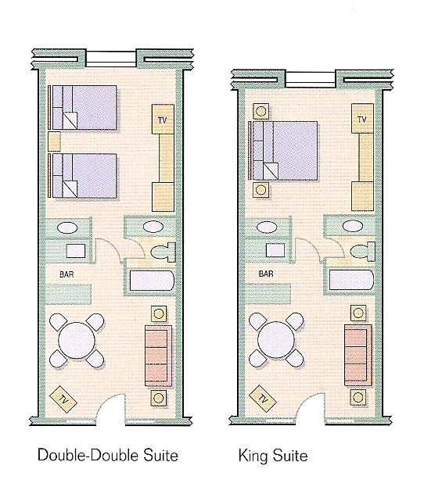

Task 2: Using the floor plans on the next page, determine which hotel room is larger, and by how many square feet.

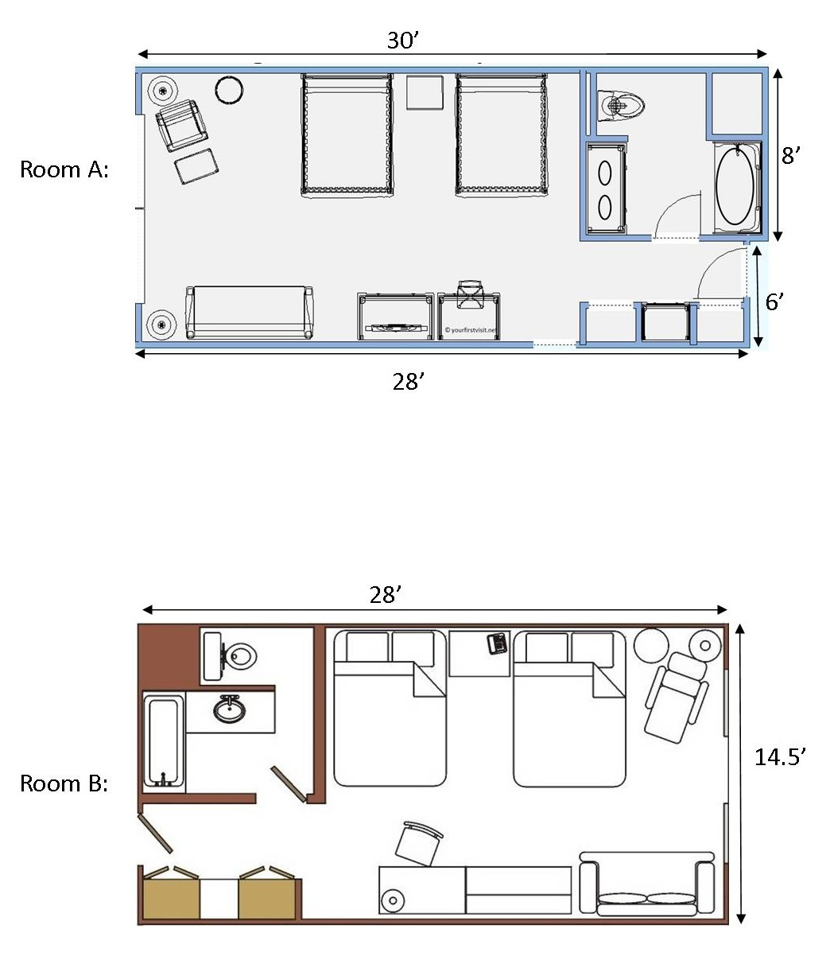
Hotel Room Floor Plans:
Task Title: Compare Hotel Room Size
Answer Key
Task 1: Calculate how what the difference is between the “Double-Double Suite” and the “King Suite”. Both rooms are 14’ wide. The Double-Double Suite is 35’ long, and the King Suite is 29’ long.
DDS: 14’ x 35’ = 490 sq feet
KS: 14’ x 29’ = 406 sq feet
490 – 406 = 84 sq feet

Task 2: Using the floor plans on the next page, determine which hotel room is larger.
Room A: 30’ x 8’ = 240 sq ft
28’ x 6’ = 168 sq ft
240 + 168 = 408 sq feet
Room B: 28’ x 14.5’ = 406 sq feet

Room A is 2 square feet larger than Room B.

Task Title: Compare Hotel Room Size
Performance Descriptors |  | Needs Work | Completes task with support from practitioner | Completes task independently
C3.2 | - calculates using numbers expressed as whole numbers, fractions, decimals, percentages and integers
 | - understands and uses formulas for finding the perimeter, area and volume of simple, common shapes
 | - chooses and performs required operation(s); may make inferences to identify required operation(s)
 | - selects appropriate steps to solutions
 | - uses strategies to check accuracy (e.g. estimating, using a calculator, repeating a calculation, using the reverse operation)

This task: was successfully completed___ needs to be tried again___

Learner Comments

____________________________ _________________________

Instructor (print) Learner Signature

Skill Building Activities
Links to Online Resources:
https://www.khanacademy.org/math/pre-algebra/measurement/perimeter/v/comparing-area-and-perimeter - 5.3 minute video comparing areas and perimeters of rectangles
https://www.khanacademy.org/math/pre-algebra/measurement/rectangle-area-perimeter-word-pr/v/comparing-area - 2.21 minute video featuring area and perimeter word problems
https://www.khanacademy.org/math/pre-algebra/measurement/area-basics/e/area_of_squares_and_rectangles - Area problem questions
http://www.mathtv.com/ - Geometry – Area & Perimeter
http://www.wikihow.com/Measure-a-Room - How to measure a room, with pictures
http://www.helpingwithmath.com/by_subject/geometry/geo_area.htm - How to calculate area
LearningHUB online courses available:

- Math, Independent Study (assigned by practitioner after assessment)
  - Multiplication/Division Assignment
  - Measurement Assignment
  - Geometry Plane Figures Assignment #1

- Independent Study, Short Courses (assigned by practitioner after assessment):
  - Apprenticeship Math

- Live Classes (SABA) – Geometry A (Part 2); Geometry B

*To access LearningHUB courses, learners must register for the LearningHUB e-Channel program by completing the registration form on their website and completing the course selection (page 2 of the registration form): https://www.learninghub.ca/get_registered.aspx

*To Access LearningHUB Course Catalogue:
http://www.learninghub.ca/Files/PDF-files/HUBcoursecatalogue,%20December%2023,%202014%20revision.pdf

