Task-based Activity Cover Sheet
Task Title: Complete a Simple Personal Information Form
Learner Name:

Date Started: Date Completed:

Successful Completion: Yes___ No___
Goal Path: Employment ✓ Apprenticeship___ Secondary School___ Post –Secondary___ Independence ✓
Task Description:
Complete the personal information sections of a Canada Post Mail Forwarding (Change of Address) form. Note: The instructor may read the task instructions to the learner.
Competency:  B: Communicate Ideas and Information | Task Group(s):  B3: Complete and Create Documents
B3.1a: Make straightforward entries to complete very simple documents
Performance Descriptors: See chart on last page or click here
Links to Skill Building Activities: see at the end of the document or click here
Materials Required:
- Photocopy of Canada Post Mail Forwarding (Change of Address) form
- Pencil or pen
- Instructor may need to help the learner with the wording in the section: YOUR AUTHORIZATION
ESKARGO:
Completes Documents
- Makes a direct match between what is requested and what is entered
- Makes entries using familiar vocabulary
- Prints and writes legibly
- Copies information accurately from printed material
- Writes and signs own first and last name
- Writes own address
- Enters information accurately in the appropriate place
- Writes number symbols 1-10
- Completes a simple form with personal information (i.e., own name, names of family
members and address)
Attitudes:
Practitioner,
We encourage you to talk with the learner about attitudes required to complete this task set. The context of the task has to be considered when identifying attitudes. With your learner, please check one of the following:
□ Attitude is not important □ Attitude is somewhat important □ Attitude is very important

Task Title: Complete a Simple Personal Information Form
When preparing for a move, it is a good idea to purchase the mail forwarding service from the post office. Mail addressed to the old address will then be forwarded to the new address. Look at the Canada Post Mail Forwarding (Change of Address) form.
Learner Information and Tasks:
Task 1: Print your current address in the section: FORWARD MAIL FROM.
Task 2: Print the address below in the section: FORWARD MAIL TO.
24 Sussex Drive
Ottawa, ON K1M 2C9
Canada

Task 3: Print your name in the section: MAIL RECIPIENTS.

Task 4: Complete the section: YOUR AUTHORIZATION.

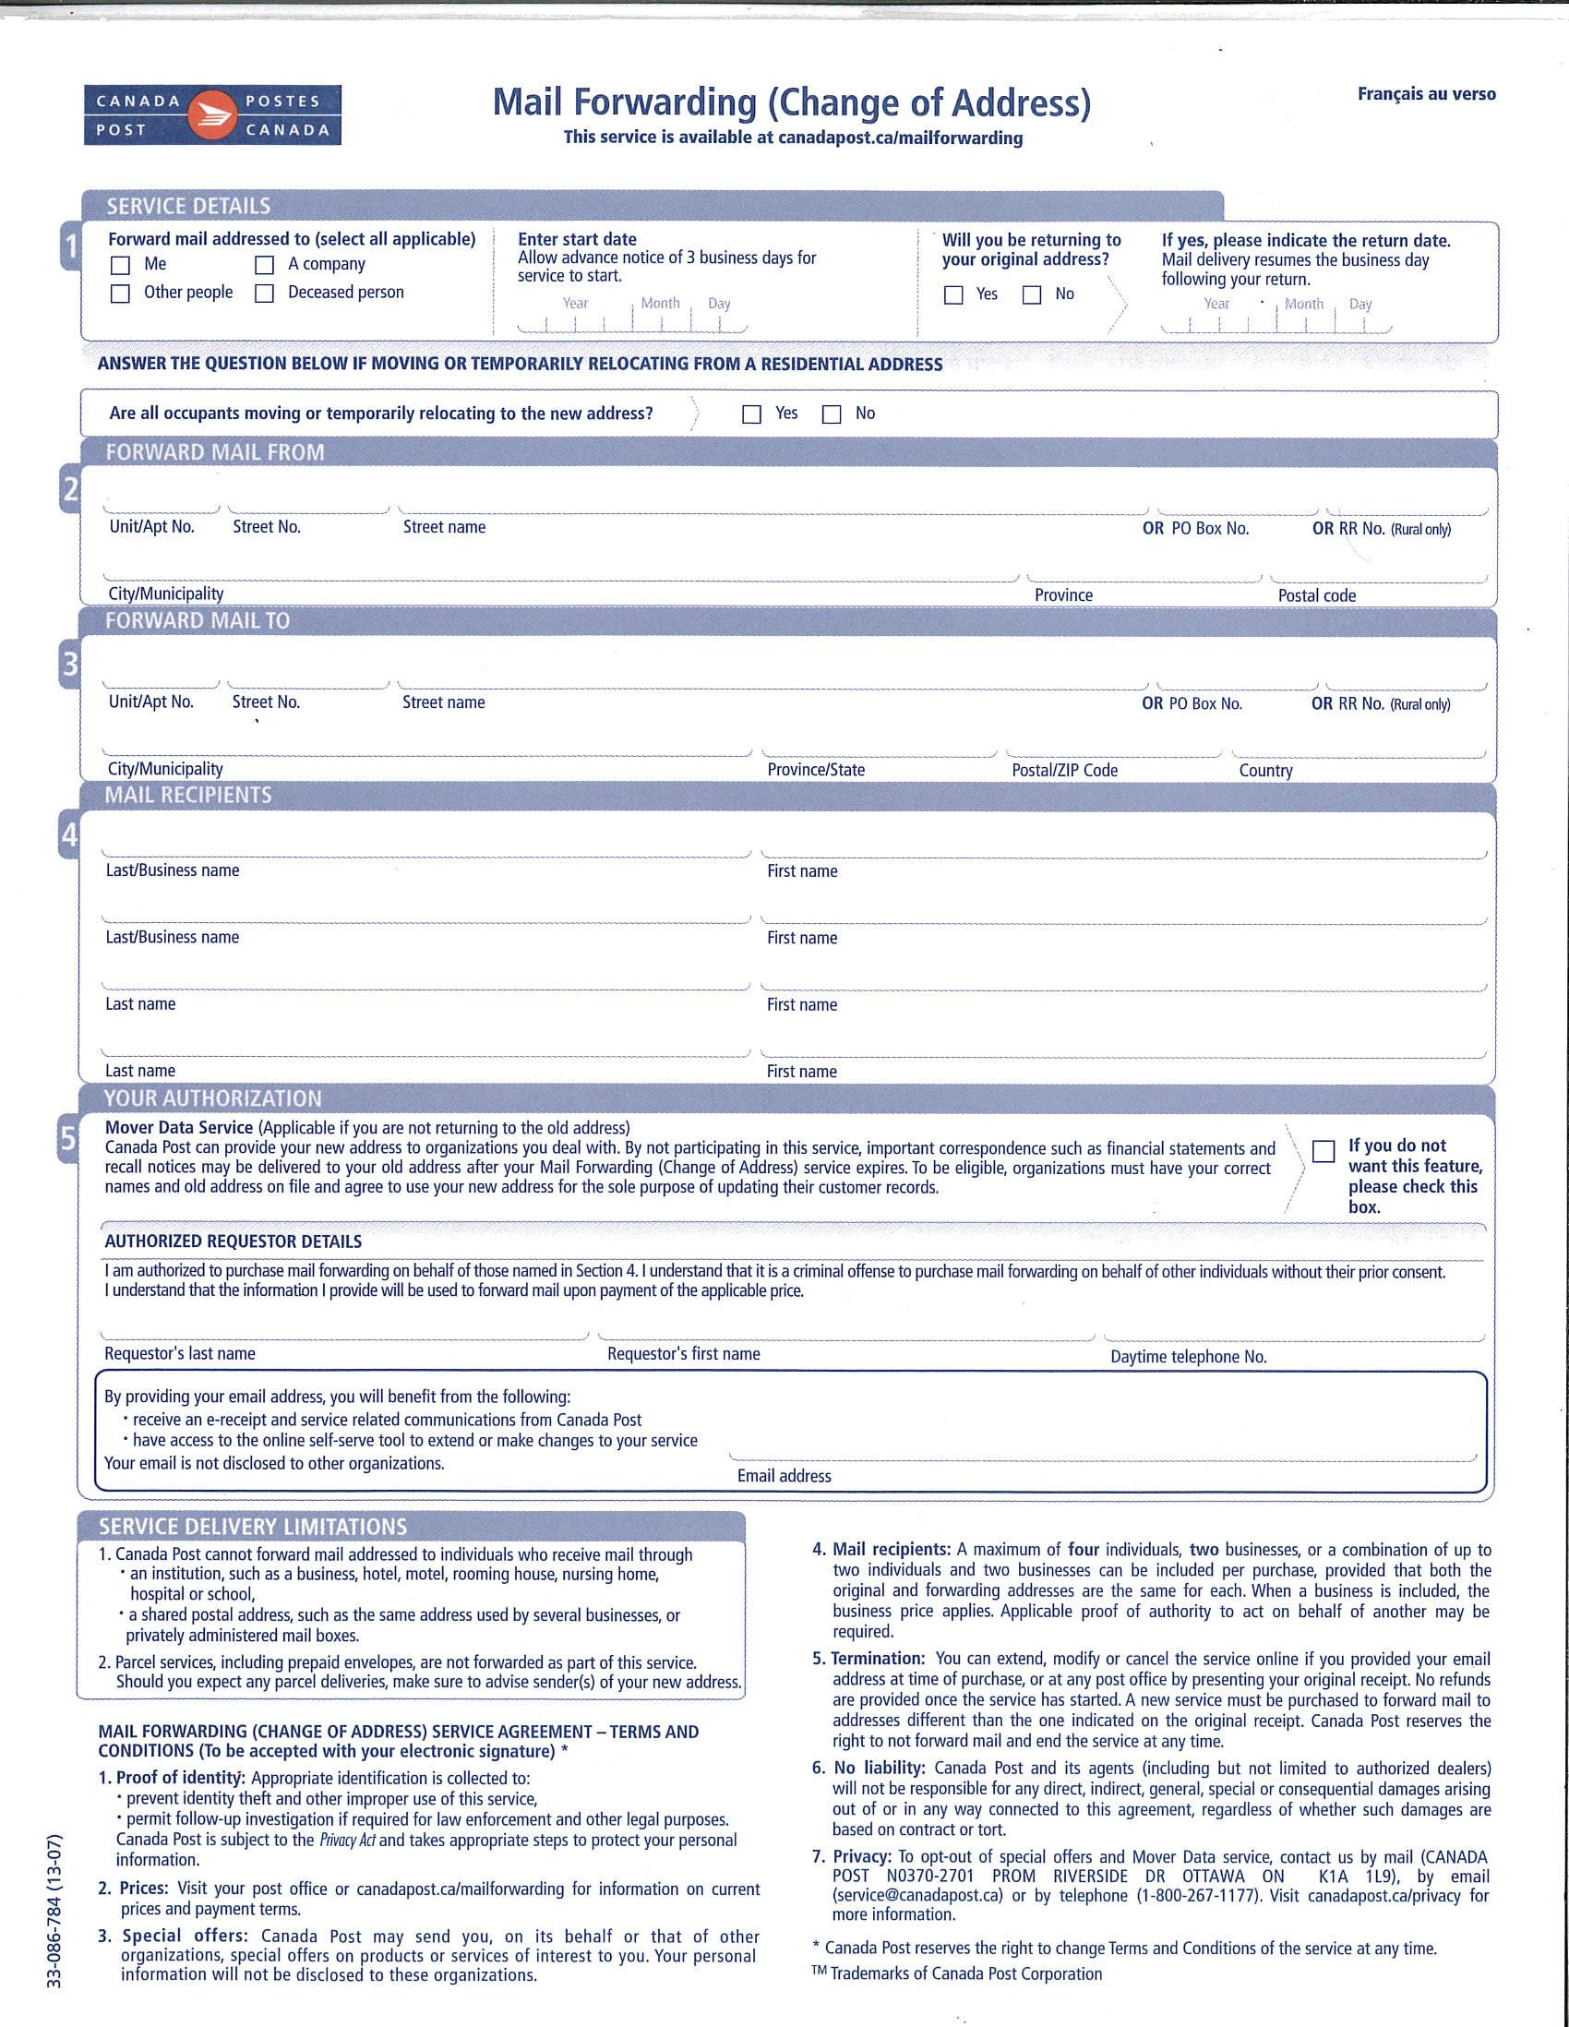

Task Title: Complete a Simple Personal Information Form
Answer Key
Tasks 1-4: Answers will vary with the person completing the task.

Task Title: Complete a Simple Personal Information Form
Performance Descriptors |  | Needs Work | Completes task with support from practitioner | Completes task independently
B3.1a | - makes a direct match between what is requested and what is entered
 | - makes entries using familiar vocabulary

This task: was successfully completed___ needs to be tried again___

Learner Comments

____________________________ _________________________

Instructor (print) Learner Signature

Skill Building Activities
Links to online resources:
- BBC Skillswise – “Filling in a Form” – http://www.bbc.co.uk/skillswise/topic/filling-out-a-form - learn about the varying purposes of forms, how and where to enter information into a form, and the language and format of forms
- LaRue Literacy Exercises – “Filling Out a Form” - http://www.mcedservices.com/litex/litex.htm - (Scroll down to “Printable Literacy Learning Activities”, then download the Introduction and Lessons 3.1-3.3 for “Filling Out a Form”) – example of how to fill in personal information into a form; locate details in form, then answer questions; using information provided, fill out a form
- Literacytools – “Filling in Forms” – http://www.literacytools.ie/pages/actions/viewPdfFile.cfm?pId=184 – tips for filling in forms; more about format and language; practise entering personal information into a variety of forms
- Skill Plan’s, “Measure Up” - http://www.skillplan.ca/measure-up , (select “English”, “Choice of Activities”, “Practice”, “Reading”, and “Labels or Forms with at least one paragraph of text”) – tasks to practise locating specific details in labels and forms

LearningHUB Courses Available:
- Live Classes (SABA) - “Filling In Forms”
- Essential Skills, Independent Study (Assigned by practitioner after assessment)
  - Document Use Level 1, Assignment 1: Reading Basic Forms
  - Document Use Level 2, Assignment 2: Locating the Details, Transferring Information, Proceeding through Forms

*To access LearningHUB courses, learners must register for the LearningHUB e-Channel program by completing the registration form on their website and completing the course selection (page 2 of the registration form): https://www.learninghub.ca/get_registered.aspx
*To Access LearningHUB Course Catalogue:
http://www.learninghub.ca/Files/PDF-files/HUBcoursecatalogue,%20December%2023,%202014%20revision.pdf

