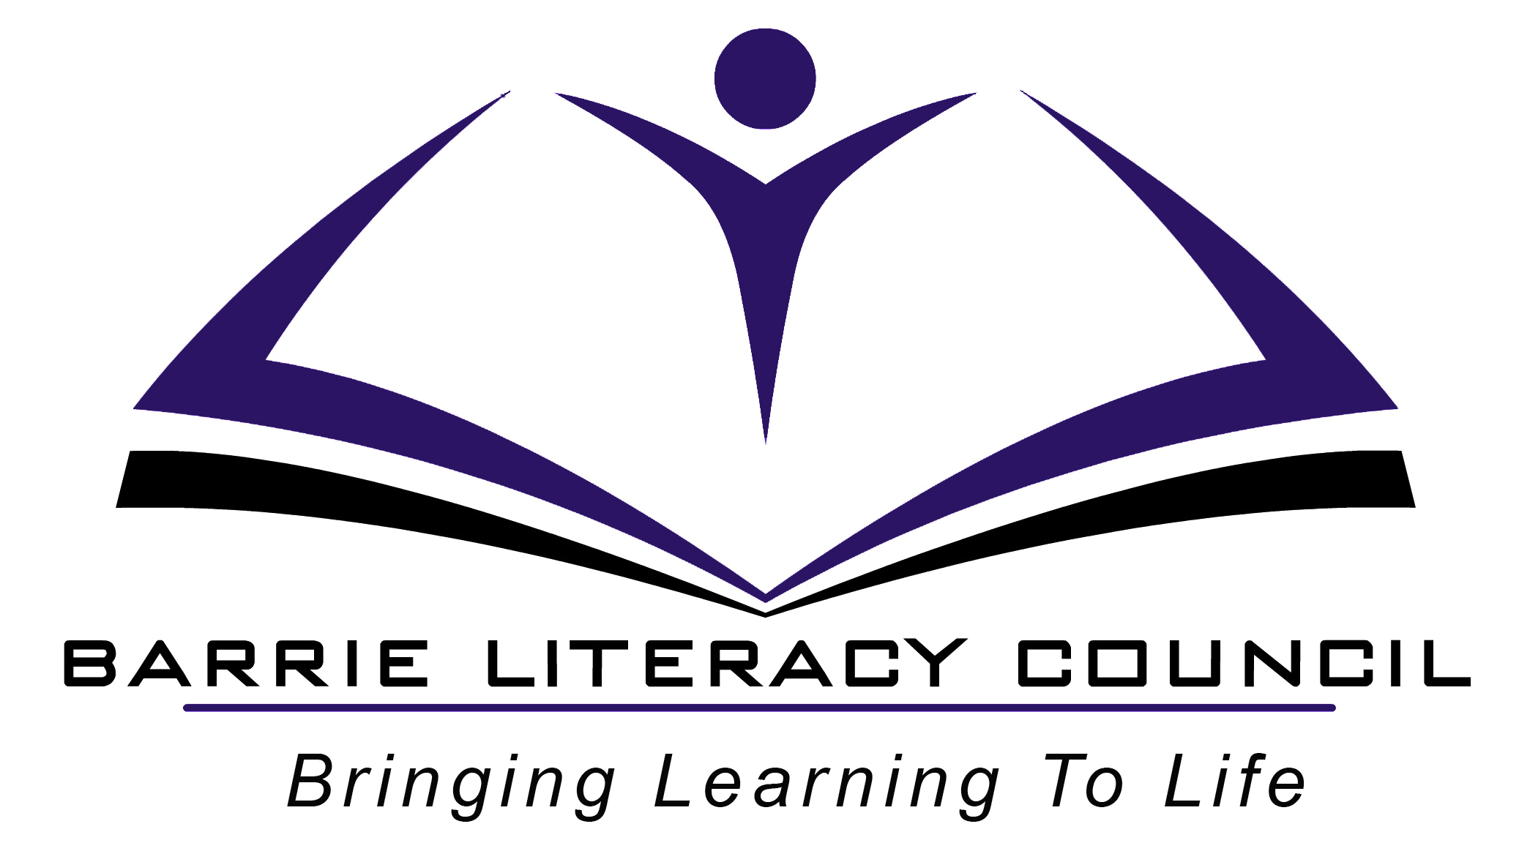
OALCF Task Cover Sheet

Task Title: Compose a paragraph which conveys information
Learner Name:

Date Started: Date Completed:

Successful Completion: Yes___ No___
Goal Path: Employment __ Apprenticeship___ Secondary School✓ Post Secondary___ Independence___
Task Description:
The learner will write a paragraph based on personal interest.

Competency:  B: Communicate ideas and information | Task Group(s):  B2: Write continuous text
Level Indicators:
B2.1: Write brief texts to convey simple ideas and factual information

Performance Descriptors: see chart on last page
Materials Required:
- Paper and pencil or pen or computer
- Dictionary or thesaurus

Task Title: Compose a paragraph which conveys information

Practitioner Instructions:

- Review the learner’s instructions with the student.

- Go over the checklists with your learner so that they are aware of the skills to be demonstrated.

- When they have completed the activity, complete the evaluation together with them, enter the date completed, and note whether it was successful or needs to be tried again.

Practitioner Information:

Paragraphs may be typed on the computer or handwritten. To evaluate, look at both the rough copy and the final copy. Most of the skills listed on the evaluation checklist should be completed successfully, although frequent spelling and grammar errors are expected at this level. Emphasis should be on content. There is no time requirement. If needed, this activity may be completed over more than one class session.

Help Allowed:

Brainstorming and the rough copy should be completed independently by the learner. The practitioner may help with the process of editing grammar and spelling errors, but the learner should be able to identify some of the errors. A dictionary, thesaurus or spell-check may be used.

Adaptation: Any topic relevant to the learner may be chosen.

Task Title: Compose a paragraph which conveys information
Learner Information and Instructions:

Task 1: Choose one of the following subjects to write about:
- First day returning to adult classes
- A special day in your life
- A place you have visited
- A job you would like
- Any memorable event
- An important person in your life

Jot down all of your ideas on this topic. Choose your best ideas.

Task 2: Write a paragraph of at least five sentences on this topic.

Task 3: Read over your rough copy looking for spelling or grammar mistakes. You may use spellcheck on your computer, or use a dictionary. Your final copy does not have to be perfect, but is should clearly express your ideas.

Task 4: Rewrite or print off a final copy.

Task Title: Compose a paragraph which conveys information

Learner’s self reflection:

1. I was able to come up with ideas on my topic. Yes  No 

2. I wrote the rough copy by myself. Yes  No 

3. I made some changes to make the paragraph better. Yes  No 

4. I stayed on the same topic throughout the paragraph. Yes  No 

5. My information was clear so that anyone could understand. Yes  No 

6. Most of the time, I wrote complete sentences. Yes  No 

7. I was able to find some of my errors. Yes  No 

8. I checked the spelling of words that I was unsure of. Yes  No 

9. My final copy looked neat and legible Yes  No 

Other comments:

Task Title: Compose a paragraph which conveys information–Anchor papers

These three samples would indicate successful completion of composing a paragraph at Level 1.

Sample 1: Starting at the Literacy Council

Samples can be viewed in the PDF as they made the Word file to load on the portal.

Rationale for successful completion of Composing a paragraph at Level 1:
One paragraph of 5 sentences, talking about personal experience
Stayed on topic throughout

Rationale for successful completion of task:

One paragraph of 5 sentences, talking about personal experience
Stayed on topic throughout
Neat cursive writing
Used appropriate vocabulary
Wrote complete sentences
Capitals generally used correctly (a couple of exceptions)
Spelling is excellent but used help

Sample 2: Bingo

Rationale for successful completion of task:
- one paragraph of 8 short sentences
- writing about self (an event in his life)
- main idea of how he spent his money after winning at Bingo
- details are sparse (how much he won, what bills he paid, where he went on his trip, etc.)
- some sense of organization introductory sentence and sequencing (then) but there is little evidence of an ending
- cursive writing is legible and well-spaced
- used appropriate words to convey meaning and feeling, but they are trite (happy, whole bunch of money)
- sentence structure is very repetitive (I went... I gave...),
- each sentence expresses a complete thought
- grammar and spelling is flawless but sentences are very simple with few descriptive words

Sample 3: Having Twins

Rationale for successful completion of task:
- one paragraph of 6 sentences
- main idea is the writer’s thoughts and feelings if the doctor told her she was going to have twins
- she goes through her feelings in chronological order which gives some organization to the writing
- uses familiar vocabulary to convey feelings (e.g. stunned and heart attack) and some colloquial expressions such as “After it kicked in”
- writes complete sentences, using periods
- forms plurals of words
- uses capital letters correctly
- only spelling mistake is “stuned”; added ending correctly for “giving”

Task Title: Compose a paragraph which conveys information

Performance Descriptors |  | Needs Work | Completes task with support from practitioner | Completes task independently
B2.1 | - writes simple texts to request, remind or inform
 | - conveys simple ideas and factual information
 | - demonstrates a limited understanding of sequence
 | - uses sentence structure, upper and lower case and basic punctuation
 | - uses highly familiar vocabulary

This task: was successfully completed___ needs to be tried again___

Learner Comments

____________________________ _________________________

Instructor (print) Learner Signature

