OALCF Task Cover Sheet
Task Title: Cooking Frozen Foods
Learner Name:

Date Started: Date Completed:

Successful Completion: Yes___ No___
Goal Path: Employment__ Apprenticeship___ Secondary School___ Post Secondary___ Independence✓
Task Description: Read heating directions for a frozen pizza.
Competency:  A: Find and Use Information  C: Understand and Use Numbers | Task Group(s):  A1: Read Continuous Text  A2: Interpret Documents  C2: Manage Time
Level Indicators:
A1.1: Read brief texts to locate specific details
A2.1: Interpret very simple documents to locate specific details
C2.1: Measure time and make simple calculations
Performance Descriptors: see chart on last page
Materials Required:
- Pen and paper
- Frozen Pizza Directions (attached)
- Egg Timer

Instructor preparation: review the tasks with the learner to check understanding.
Task Title: Cooking Frozen Foods
You are cooking a frozen pizza for a Friday night dinner. Look at the directions to complete these tasks.
Task 1: List 4 steps you should take before putting the frozen pizza into the oven:

- _________________________________________
- _________________________________________
- _________________________________________
- __________________________________________

Task 2: What should you put the frozen pizza on in the oven?
____________________________________________________

Task 3: Set an egg timer (cooking timer) for the amount of time you should cook the pizza before checking to see if it’s done.

Task 4: How will you know that the pizza is cooked completely?
______________________________________________________________________________

Task 5: According to the baking directions, what should you do once you take the pizza out of the oven?

_________________________________________________________________

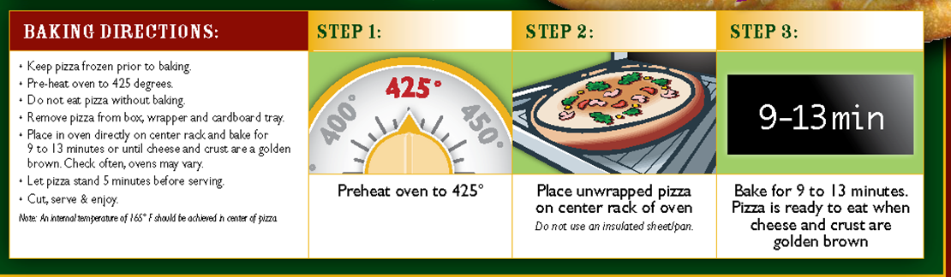
Task Title: Cooking Frozen Foods
Answers:
Task 1: Preheat oven to 425 degrees
remove pizza from box
remove pizza from wrapper
remove pizza from cardboard tray

Task 2: Place pizza directly on the oven rack

Task 3: Observe learner setting an egg-time to 9minutes (shortest amount of cooking time)

Task 4: Cheese and crust will be golden brown

Task 5: Let the pizza stand for 5 minutes before serving
Task Title: Cooking Frozen Food
Performance Descriptors |  | Needs Work | Completes task with support from practitioner | Completes task independently
A1.1 | - Reads short texts to locate a single piece of information
 | - Decodes words and makes meaning of sentences in a single text
 | - Follows simple, straightforward instructional texts
A2.1 | - Scans to locate specific details
 | - Interprets brief text and common symbols
 | - Locates specific details in simple documents, such as labels and signs
 | - Identifies how lists are organized
C2.1: | - Reads time on analog and digital clocks
 | - Identifies and performs required operation
 | - Measures time using common instruments, such as clocks, timers and stopwatches
 | - Chooses appropriate units of measurement (e.g. hours, minutes, seconds)
 | - Follows apparent steps to reach solutions
This task: was successfully completed___ needs to be tried again___

Learner Comments

____________________________ _________________________

Instructor (print) Learner Signature

