Task-based Activity Cover Sheet
Task Title: Find the Expiry Date on a Coupon (Set Two)
Learner Name:

Date Started: Date Completed:

Successful Completion: Yes___ No___
Goal Path: Employment___ Apprenticeship___ Secondary School Post Secondary Independence✓

Task Description: Learner will locate coupon expiry dates in a variety of formats
Competency:  A: Find and Use Information | Task Group(s):  A2: Interpret Documents
Level Indicators:
A2.1: Interpret very simple documents to locate specific details

Performance Descriptors: see chart on last page or click here
Links to skill building activities: see the last page or click here
Materials Required:
- Photocopies of coupons for learner (attached), preferably in colour
ESKARGO:
A2.1
Reading Strategies – Decoding and Comprehension Enhancement
- Uses knowledge of vocabulary and sight words related to specific signs, labels, lists and
- simple forms to understand text
- Uses phonics and knowledge of word parts to decode words
- Uses context cues and personal experience to draw meaning from signs, labels, lists and simple forms
- Uses knowledge of basic abbreviations to gather meaning from text
- Uses background knowledge on common uses and purposes of signs, lists, labels and forms to gather meaning
Forms and Conventions – Find Information/Research/Understand Types of Texts
- Scans to locate a single piece of information or specific details
Comprehension – Read to Understand/Retell
- Reads signs, symbols and common sight words from everyday life
- Locates specific details in simple documents, such as labels and signs
Interpretation – Read and Apply Understanding
- Interprets common signs and symbols
- Locates a single piece of information in lists and simple tables
Attitudes:
Practitioner,
We encourage you to talk with the learner about attitudes required to complete this task set. The context of the task has to be considered when identifying attitudes. With your learner, please check one of the following:
□ Attitude is not important □ Attitude is somewhat important □ Attitude is very important

Task Title Find the Expiry Date on a Coupon (Set Two)
Coupons can save shoppers money. Most coupons have an expiry date, and cannot be used after that date. Find the expiry dates on the coupons to answer the following questions.
Learner Information and Tasks:
Task 1: When was the Montana’s coupon valid until?

Task 2: When was the Swiss Chalet coupon valid until?

Task 3: When did the First Choice coupon expire?

Task 4: When could you use the Jysk coupon?

Task 5: When could you use the Mary Brown coupon?

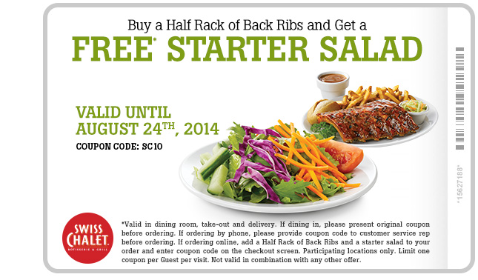

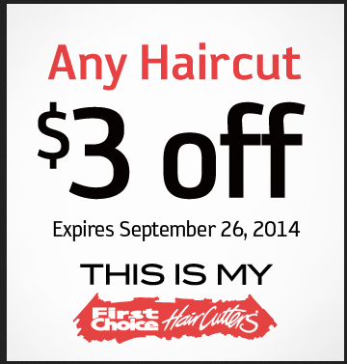


Task Title: Find the Expiry Date on a Coupon (Set Two)
Answer Key
Task 1: When was the Montana’s coupon valid until?
August 31, 2014
Task 2: When was the Swiss Chalet coupon valid until?
August 24th, 2014
Task 3: When did the First Choice coupon expire?
September 26, 2014
Task 4: When could you use the Jysk coupon?
Aug 21st - 27th, 2014
Task 5: When could you use the Mary Brown coupon?
June 16 - September 7, 2014

Task Title: Find the Expiry Date on a Coupon (Set Two)
Performance Descriptors |  | Needs Work | Completes task with support from practitioner | Completes task independently
A2.1 | - Scans to locate specific details
 | - Interprets brief text and common symbols
 | - Locates specific details in simple documents, such as labels and signs
 | - Requires support to identify sources and to evaluate and integrate information

This task: was successfully completed___ needs to be tried again___

Learner Comments

____________________________ _________________________

Instructor (print) Learner Signature
Skill Building Activities
Links to online resources:
- http://www.bbc.co.uk/skillswise/topic/skimming-and-scanning
- http://www.gcflearnfree.org/everydaylife/workskills
- http://www.gcflearnfree.org/everydaylife/foodandcooking/grocery-list
- Interactive games & activities – Spelling, Phonics, Key words - http://www.starfall.com/n/level-a/learn-to-read/play.htm?f
- http://resources.woodlands-junior.kent.sch.uk/interactive/literacy.html#5
- Reading Dates (5 ½ min) https://www.youtube.com/watch?v=MMOTOyA0lG8
- http://www.pennypinchinmom.com/getting-started-on-penny-pinchin-mom/coupon-language-understand-how-to-read-your-coupons/
- http://thechronicleherald.ca/community/south-shore/1195695-how-to-read-and-understand-coupons

LearningHUB Courses Available:
- Live Classes (SABA) – Progressive Spelling 1 & 2; Reading Comprehension
- Reading & Writing, Independent Study – Numerous courses on reading, reading comprehension/strategies , Basic Reading…(assigned by practitioner following assessment)
- Essential Skills, Independent Study – Basic Skills for the Real World
*To access LearningHUB courses, learners must register for the LearningHUB e-Channel program by completing the registration form on their website and completing the course selection (page 2 of the registration form): https://www.learninghub.ca/get_registered.aspx
*To Access LearningHUB Course Catalogue:
http://www.learninghub.ca/Files/PDF-files/HUBcoursecatalogue,%20December%2023,%202014%20revision.pdf

