Task-based Activity Cover Sheet
Task Title: Create a table to compare supplies to be ordered
Learner Name:

Date Started: Date Completed:

Successful Completion: Yes___ No___
Goal Path: Employment ✓ Apprenticeship ✓ Secondary School Post Secondary Independence ___
Task Description:
The learner will create a document to compare supplies to be ordered
Competency:  B:Communicate Ideas and Information  A: Find and Use Information | Task Group(s):  B3: Complete and create documents  A2: Interpret documents
Level Indicators:
B3.2(b) Create simple documents to sort, display, and organize information
A2.2: Interpret simple documents to locate and connect information
Performance Descriptors: see chart or click here
Skill Building Activities: see last page or click here
Materials Required:
- Pen, paper, ruler (could be completed using word processing program if learner is able)
- Attached screen shots of Janitorial supply websites
ESKARGO:
Skills and Knowledge Required for Successful Task Performance
- Follows conventions to display information in simple documents (e.g., use of font, colour
shading, bulleted lists, etc.)
- Sorts entries into categories
- Displays one or two categories of information organized according to content to be
presented
- Identifies parts of documents using titles, row and column headings, and labels
- Creates simple forms, tables
Attitudes:
Practitioner,
We encourage you to talk with the learner about attitudes required to complete this task set. The context of the task has to be considered when identifying attitudes. With your learner, please check one of the following:
□ Attitude is not important □ Attitude is somewhat important □ Attitude is very important
Task Title: Create a table to compare supplies to be ordered
Learner Information and Tasks:
People will often create tables to help make choices about purchasing different products. An employer may request that an employee design a table to compare supplies before making a purchasing decision.

Task 1: Create a table to compare the features and prices of the following six (6) buckets. Use the following column headings:
- Distributor
- Brand
- Model Name
- Model #
- Capacity
- Price
- Discount for multiple orders
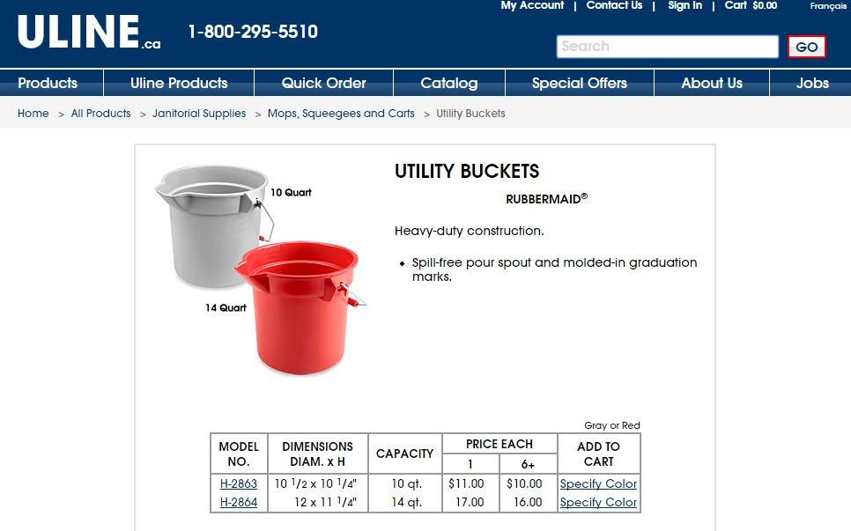
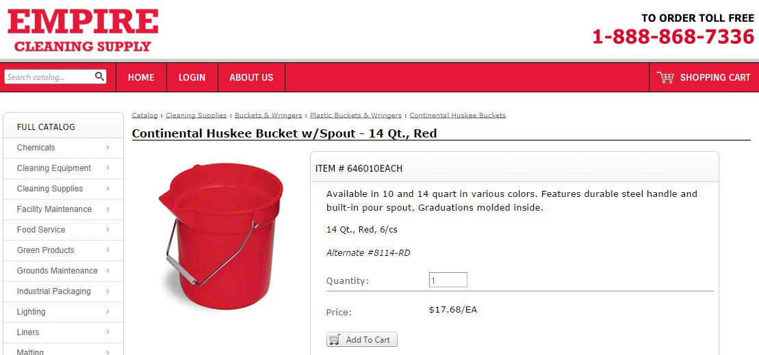
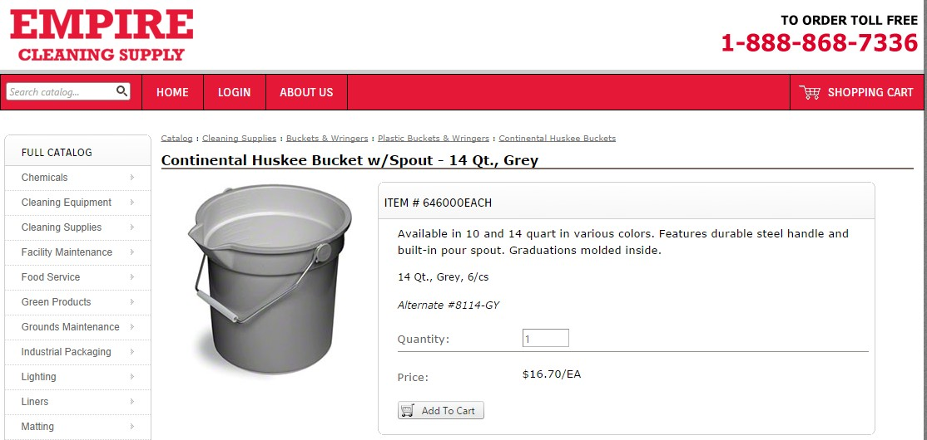
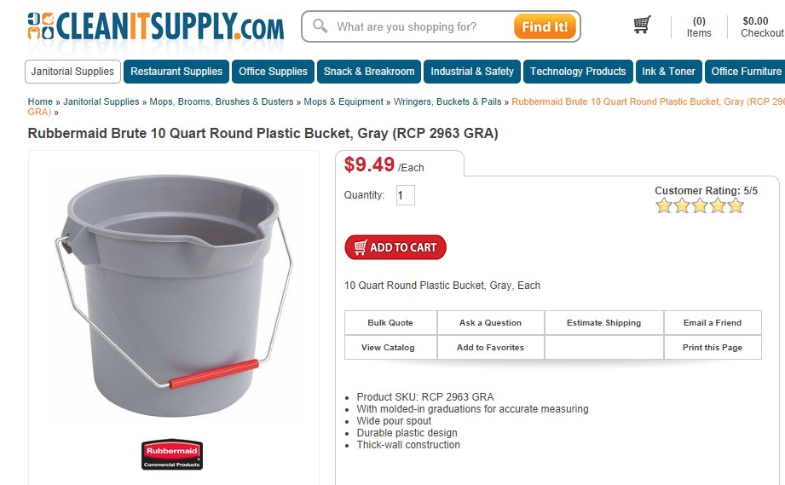
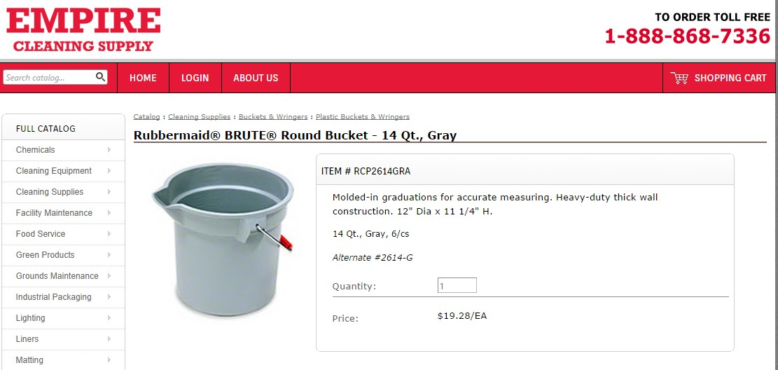

Task Title: Create a table to compare supplies to be ordered
Answer Key
Task 1: Use this exemplar for evaluating.
Utility Bucket feature and price comparison
Distributor | Brand | Model name | Model # | Capacity | Price | Discount for multiple orders
ULINE.com | Rubbermaid | N/A | H-2863 | 10qt. | $11.00 each | $10.00 each for 6 +
ULINE.com | Rubbermaid | N/A | H-2864 | 14qt | $17.00 each | $16.00 each for 6+
Empire Cleaning Supply | Continental | Huskee | 646010-red | 14qt | $17.68 each | N/A
Empire Cleaning Supply | Continental | Huskee | 646000-grey | 14qt | $16.70 each | N/A
CLEANITSUPPLY.com | Rubbermaid | Brute | RCP 2963 | 10qt | $9.49 each | N/A
Empire Cleaning Supply | Rubbermaid | Brute | RCP2614 | 14qt | $19.28 each | N/A

Task Title: Create a table to compare supplies to be ordered
Performance Descriptors |  | Needs Work | Completes task with support from practitioner | Completes task independently
B3.2b | - follows conventions to display information in simple documents (e.g. use of font, colour, shading, bulleted lists)
B3.2b | - sorts entries into categories
B3.2b | - displays one or two categories of information organized according to content to be presented
B3.2b | - identifies parts of documents using titles, row and column headings and labels
A2.2 | - performs limited searches using one or two search criteria
A2.2 | - extracts information from tables and forms
A2.2 | - uses layout to locate information
A2.2 | - makes connections between parts of documents
A2.2 | - makes low-level inferences

This task: was successfully completed___ needs to be tried again___

Learner Comments

____________________________ _________________________

Instructor (print) Learner Signature

Skill Building Activities

Links to online resources:
- http://www.bbc.co.uk/skillswise/worksheet/en13styl-l1-w-presenting-info-in-the-form-of-a-table (An activity that involves reading short biographies about people and ordering details about them, emphasizes how to compare and organize information in the form of a table)
- http://www.mcwdn.org/Graphs/Tables.html (An informative online article that defines Tables and explains what they’re used for, contains a link to a ‘Tables Quiz’ that can be completed online to check learning)
- http://www.gcflearnfree.org/office2010/word2010/21 (An online tutorial called “Working With Tables” that teaches how to create basic tables in Microsoft Word 2010, explains some principles of tables and how data can be represented/organized into tables, even though emphasis is on creating tables in a digital format)

LearningHUB online courses available:
- Reading & Writing, Independent Study (assigned by practitioner following assessment):
  - Document Use Level 1 Assignment 2 (“Data Collection 1” + “Reading Graphical Data 1”)
  - Document Use Level 2 Assignment 2 (“Computing Graphical Data 2” + “Scaling and Proportion 2”)
- Independent Study Short Courses (Moodle)
  - Learning to Communicate Using Microsoft Word (use of font/colour/shading/ bulleted lists to display information in simple documents);
  - Learning to Communicate Using Microsoft Excel 2007

*To access LearningHUB courses, learners must register for the LearningHUB e-Channel program by completing the registration form on their website and completing the course selection (page 2 of the registration form): https://www.learninghub.ca/get_registered.aspx
*To Access LearningHUB Course Catalogue:
http://www.learninghub.ca/Files/PDF-files/HUBcoursecatalogue,%20December%2023,%202014%20revision.pdf

