Task-based Activity Cover Sheet
Task Title: Create a Collage
Learner Name:

Date Started: Date Completed:

Successful Completion: Yes___ No___
Goal Path: Employment ___ Apprenticeship___ Secondary School ✓ Post Secondary Independence ✓
Task Description:
Create a collage (e.g. vision board)
Competency:  B Communicate Ideas and Information | Task Group(s):  B4 Express oneself creatively
Level Indicators:
B4: Express oneself creatively, such as by writing journal entries, telling a story, and creating art
Performance Descriptors: see chart or click here
Skill Building Activities: see last page or click here
Materials Required:
- Paper or Bristol board
- Magazines, newspapers, and flyers for cutting photos, pictures, and words
- If possible or desired, personal photographs
- Craft supplies such as wrapping paper, ribbon, buttons,
- Glue
- Sample collage (attached)
ESKARGO:
B4
- Create a collage (e.g., vision board)

Attitudes:
Practitioner,
We encourage you to talk with the learner about attitudes required to complete this task set. The context of the task has to be considered when identifying attitudes.
With your learner, please check one of the following;
Attitude is not important Attitude is somewhat important Attitude is very important

Task Title: Create a Collage
Learner Information and Tasks:
Creating a collage is a unique way to express oneself. Creating a collage is a way to show ideas, observations, or feelings using photos, pictures, craft items, and/or words. Collages that show a dream or goal can be posted on a wall to inspire you every day. Look at the “sample collage”.

Task 1: Let yourself dream of the life you would choose if there were no obstacles. Gather photos, pictures, words, or craft items that show this dream. Create a collage to display your idea.

Sample Collage
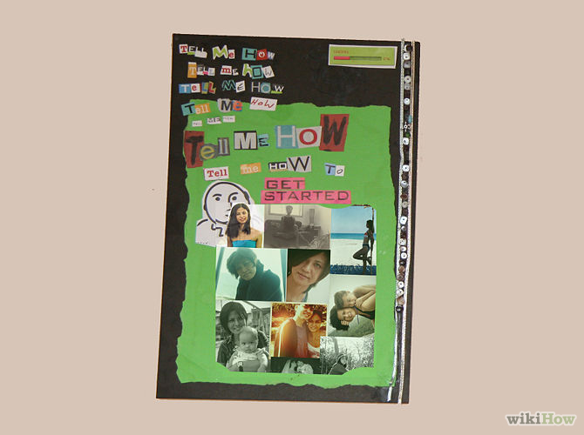
Retrieved from http://www.wikihow.com/Make-a-Collage free download
Task Title: Create a Collage
Answer Key – Notes to Instructor
Note that this task will require time to gather photos and other items beforehand.
As with any creative work, marking a collage or piece of artwork can present challenges. The instructor may wish to develop their own rubric to share with the student, outlining the basic requirements for the piece, such as number of photos used and features expected (eg. use both photos and words). Check-mark rubrics can be particularly effective for creative work.
Expressing oneself creatively produces vulnerability. In order for learners to feel comfortable with creating artwork in the classroom, a climate of trust and confidentiality must be established between instructor and learner. Sensitive or controversial topics must be handled with care. The instructor may wish to institute a consistent marking period for creative work, allowing for a day or two to consider the work before making any comment. The instructor’s considered written or oral response (feedback) to creative work is often more important to the learner than the mark or grade. Feedback should be designed not only to assess the work but to encourage the creative spirit.
Sample rubric for task: Create a collage
(comments or checkmarks can be placed on chart)
Expectation | complete | partially complete | needs work
Had a theme /or
Showed a dream or goal
Well-thought out to display an idea, dream, or goal
Pictures or items used to add to the theme or idea
Learner satisfied that the collage expressed their idea

Task Title: Create a Collage
Performance Descriptors |  | Needs Work | Completes task with support from practitioner | Completes task independently
B4 | - the tasks in this task group are not rated for complexity; the instructor may wish to develop a rubric

This task: was successfully completed___ needs to be tried again___

Learner Comments

____________________________ _________________________

Instructor (print) Learner Signature

Skill Building Activities

Links to online resources:

“Creative Self-Expression” - https://www.youtube.com/watch?v=eMOqIJ9V_K4 – (video) a student examines the definition of “Creative Self-Expression” and looks at different mediums

“How to Make a Collage” - http://www.wikihow.com/Make-a-Collage - article describes and outlines steps for 7 ways of creating collages (paper-based, fabric, digital, etc.)

“Collaging for Beginners” - http://www.rookiemag.com/2012/03/collaging-for-beginners/ - article gives ideas for materials and tools to use when creating a collage

“The Health Benefits of Art Are For Everyone” - http://bebrainfit.com/lifestyle/mental/the-health-benefits-of-art-are-for-everyone/ - article outlines the various benefits of creating art; watch the video, “Can Art be Medicine?” to examine the health benefits of creative self-expression

LearningHUB online courses available:

- Reading & Writing, Independent Study (Assigned by practitioner after assessment; lessons build readiness for creative exercises involving reading and writing text)

- Essential Skills, Independent Study, Short Courses (most short courses include a journaling component which requires the learner to reflect on the assigned topics; the following are examples of courses where journaling/creative expression is more prevalent)
- Creative Writing: Telling Your Story
- Maintaining Healthy Self-Esteem On and Off the Job, Parts 1 & 2
- Goal Setting: Discovering Your Goals

*To access LearningHUB courses, learners must register for the LearningHUB e-Channel program by completing the registration form on their website and completing the course selection (page 2 of the registration form): https://www.learninghub.ca/get_registered.aspx
*To Access LearningHUB Course Catalogue:
http://www.learninghub.ca/Files/PDF-files/HUBcoursecatalogue,%20December%2023,%202014%20revision.pdf

