

Task Title: Understanding a Custodian’s Responsibilities

# OALCF Cover Sheet – Practitioner Copy

**Learner Name:**

**Date Started:**

**Date Completed:**

|  |  |  |
| --- | --- | --- |
| **Goal Path:** | Employment | Apprenticeship |
| Secondary School | Post Secondary | Independence |

**Successful Completion:**  Yes No

**Task Description:**

Learner will read a Summer Cleaning Checklist to understand a caretaker or custodian's job responsibilities.

**Main Competency/Task Group/Level Indicator:**

* Find and Use Information/Interpret documents/A2.2

**Materials Required:**

* Access to a computer or other digital device (if preferred)
* Pen and paper (if preferred)

# Learner Information

Many organizations hire custodians, also known as caretakers, cleaners, or general maintenance workers to clean and take care of their buildings.

Scan the sample Summer Cleaning Checklist.

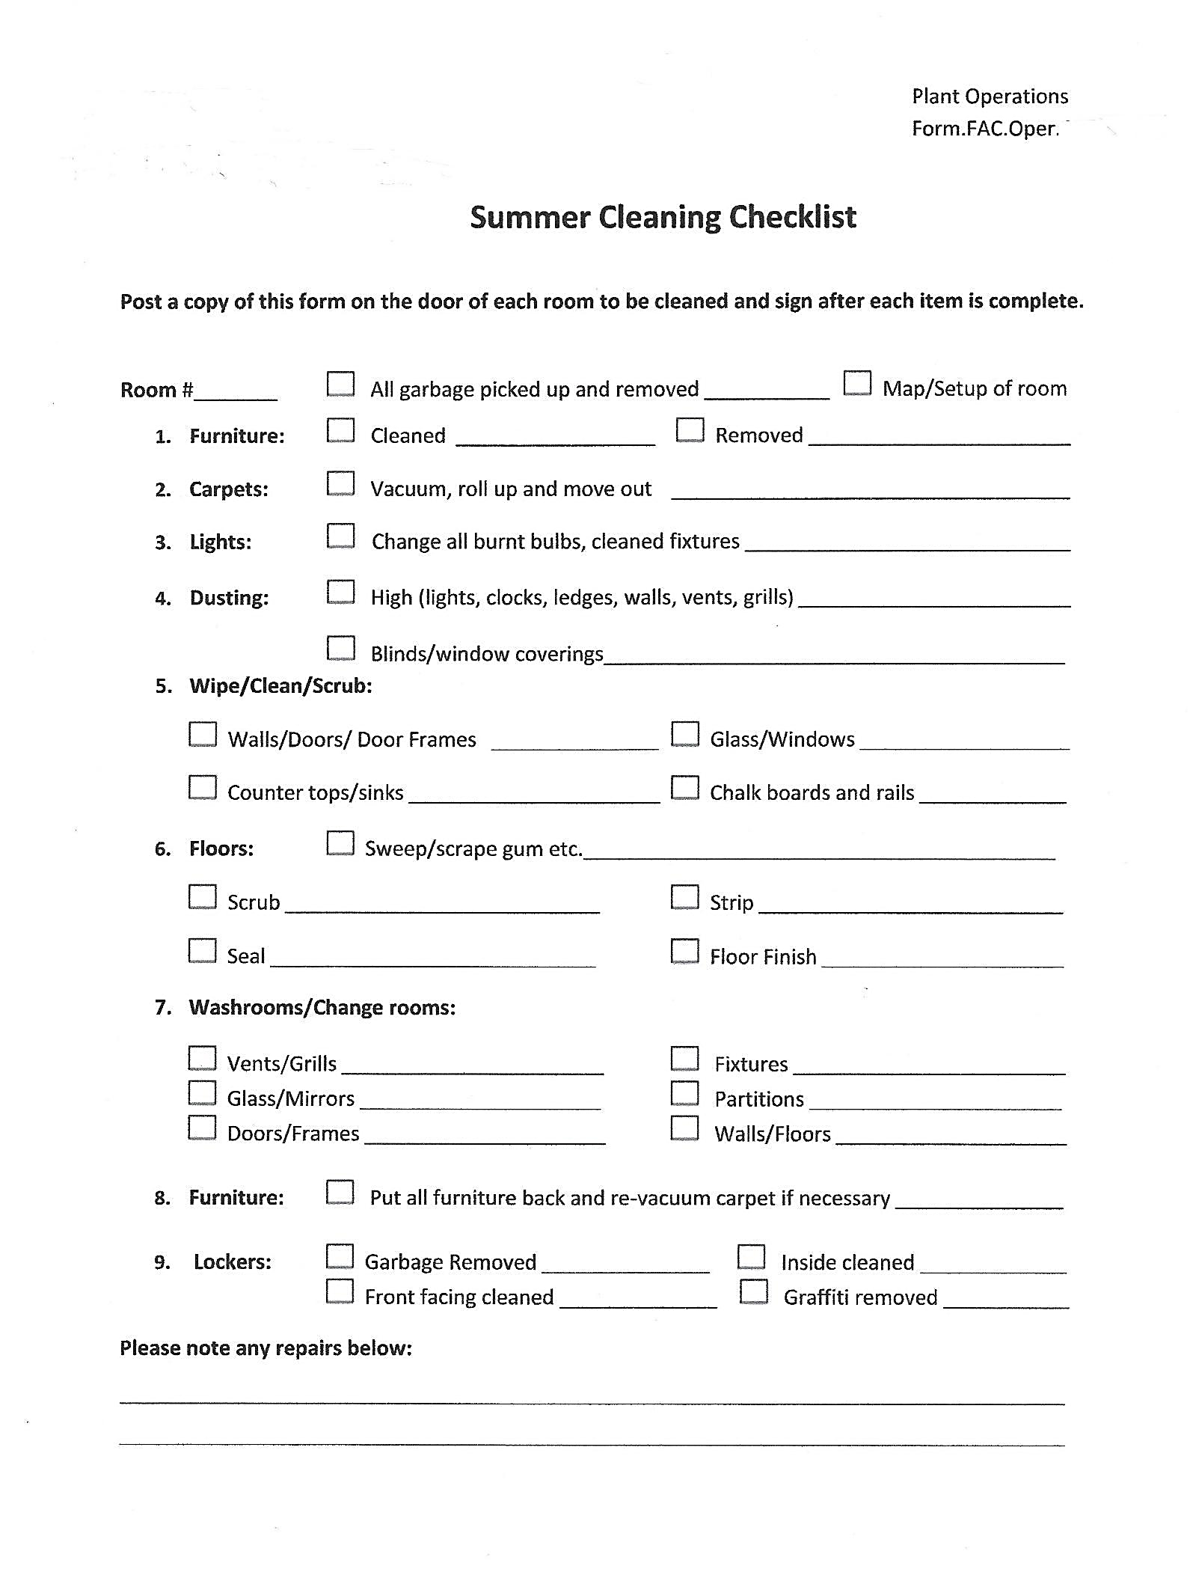

# Work Sheet

**Task 1: What season does the cleaning on this checklist happen?**

Answer:

**Task 2: What are the two things the custodian is expected to do with the form?**

Answer:

**Task 3: List two things that a custodian must do to clean floors.**

Answer:

**Task 4: List two things that a custodian must do to clean lockers.**

Answer:

**Task 5: What does the custodian do if something needs to be repaired?**

Answer:

# Answers

**Task 1: What season does the cleaning on this checklist happen?**

Answer: Summer

**Task 2: What are the two things the custodian is expected to do with the form?**

Answer:

* Post a copy of the form on the door of each room to be cleaned
* Sign after each item is complete

**Task 3: List two things that a custodian must do to clean floors.**

Answer: Any two of the following:

* Sweep/scrape gum
* Scrub
* Strip
* Seal
* Finish floor

**Task 4: List two things that a custodian must do to clean lockers.**

Answer: Any two of the following:

* Remove garbage
* Clean inside locker
* Clean outside locker / front facing
* Remove graffiti

**Task 5: What does the custodian do if something needs to be repaired?**

Answer: Makes a note on the bottom of the checklist form

# Performance Descriptors

| Levels | Performance Descriptors | Needs Work | Completes task with support from practitioner | Completes task independently |
| --- | --- | --- | --- | --- |
| A2.2 | Performs limited searches using one or two search criteria |  |  |  |
| A2.2 | Extracts information from tables and forms |  |  |  |

This task: Was successfully completed Needs to be tried again

Learner Comments:

Instructor (print): Learner (print):