

Task Title: Dietary Aide Menu Planning

# OALCF Cover Sheet – Practitioner Copy

**Learner Name:**

**Date Started:**

**Date Completed:**

|  |  |  |
| --- | --- | --- |
| **Goal Path:** | Employment | Apprenticeship |
| Secondary School | Post Secondary | Independence |

**Successful Completion:**  Yes No

**Task Description:**

Read Canada’s Food Guide and Considerations to understand how to plan a healthy menu.

**Main Competency/Task Group/Level Indicator:**

* Find and Use Information/Read continuous text/A1.2
* Find and Use Information/Interpret documents/A2.1
* Understand and Use Numbers/Use measures/C3.1

**Materials Required:**

* Pen and Paper and/or digital device

# Learner Information

Dietary Aides or Dietary Assistants, work to ensure patients staying in a healthcare facility maintain a healthy diet. Scan Canada’s Food Guide and Considerations.

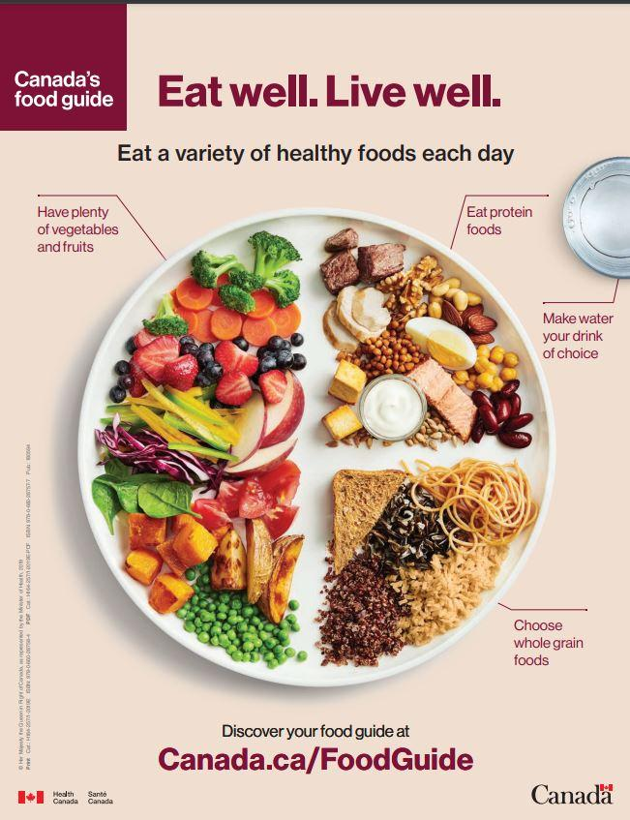

# Work Sheet

**Task 1: What fraction of a plate should be fruits and vegetables?**

Answer:

**Task 2: What fraction of a plate should be protein foods?**

Answer:

**Task 3: List two situations when it is good to choose frozen, canned, or dried foods instead of fresh.**

Answer:

**Task 4: List three ingredients that nutritious foods should not contain or contain little of.**

Answer:

**Task 5: Which liquid should people drink?**

Answer:

Answers

**Task 1: What fraction of a plate should be fruits and vegetables?** (C3.1)

Answer: ½

**Task 2: What fraction of a plate should be protein foods?** (C3.1)

Answer: ¼

**Task 3: List two situations when it is good to choose frozen, canned, or dried foods instead of fresh.** (A1.2)

Answer: Any 2 of the following:

* When fresh food is out of season
* When fresh food is costly
* When fresh food is unavailable
* When preparing fresh food takes too long

**Task 4: List three ingredients that nutritious foods should not contain or contain little of.** (A1.2)

Answer: added sodium, saturated fats, and free sugars.

**Task 5: Which liquid should people drink?** (A2.1)

Answer: water should be the drink of choice

# Performance Descriptors

| Levels | Performance Descriptors | Needs Work | Completes task with support from practitioner | Completes task independently |
| --- | --- | --- | --- | --- |
| A1.2 | Scans text to locate information |  |  |  |
| A1.2 | Locates multiple pieces of information simple texts |  |  |  |
| A1.2 | Makes low-level inferences |  |  |  |
| A2.1 | Scans to locate specific details |  |  |  |
| A2.1 | Locates specific details in simple documents such as labels and signs. |  |  |  |
| C3.1 | Interprets and represents measures using whole numbers, decimals, and simple, common fractions (e.g. ½, ¼) |  |  |  |

This task: Was successfully completed Needs to be tried again

Learner Comments:

Instructor (print): Learner (print):