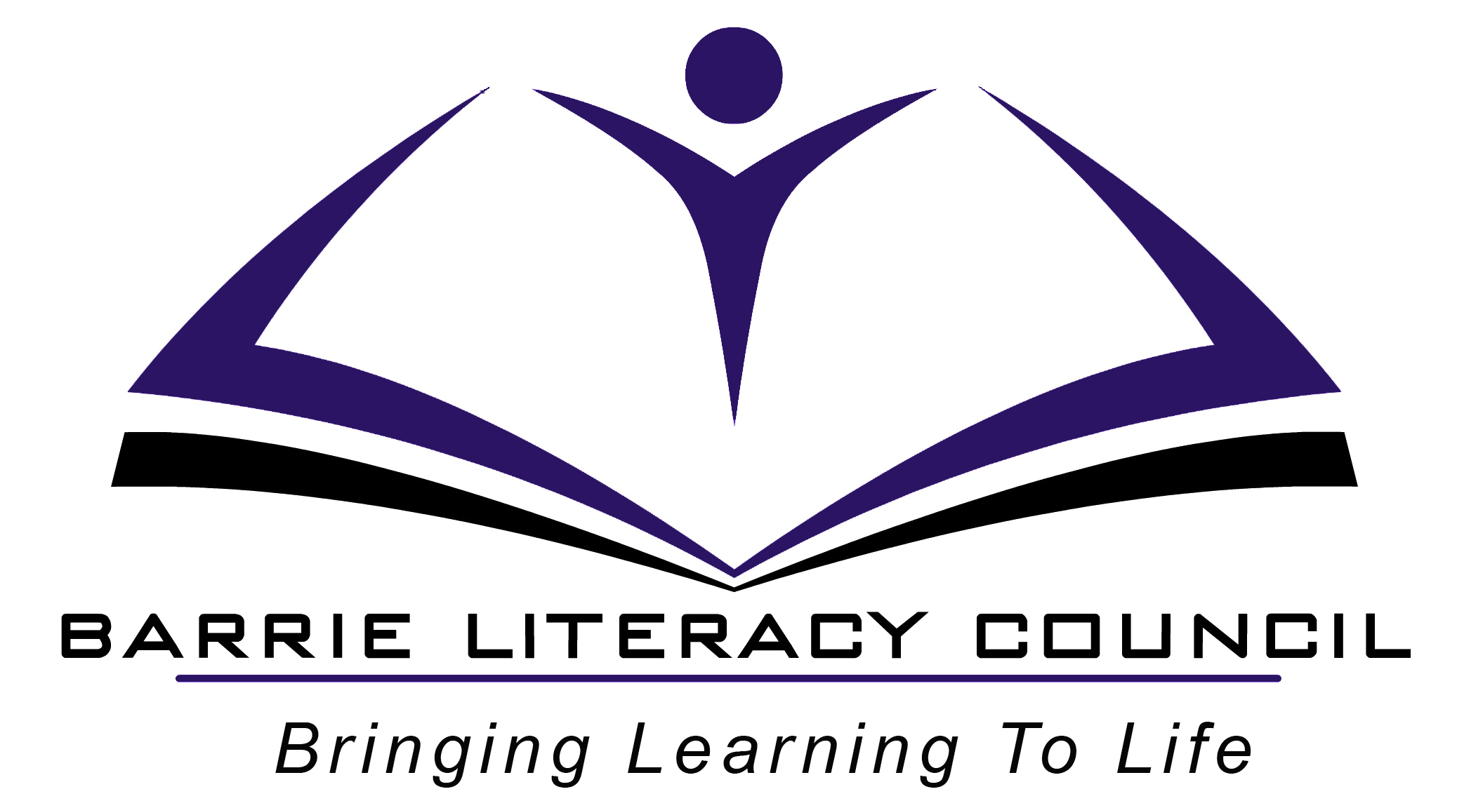
OALCF Task Cover Sheet

Task Title: Divide wholes into halves
Learner Name:

Date Started: Date Completed:

Successful Completion: Yes___ No___
Goal Path: Employment __ Apprenticeship___ Secondary School___ Post Secondary__ Independence__✓
Task Description:
The learner has to distinguish between half and a whole.

Competency:  C: Understand and use numbers  E: Manage learning | Task Group(s):  C3: Use Measures  E: Manage Learning
Level Indicators:
C3.1 Measure and make simple comparisons and calculations
E.1 Set short-term goals, begin to use limited learning strategies, and begin to monitor own learning

Performance Descriptors: see chart on last page
Materials Required:
Learner instruction sheet
pencil

Task Title: Divide wholes into halves
Practitioner Instructions:
- Review the learner’s instructions with them.
- Go over the checklist with your learner so that they are aware of the skills to be demonstrated.
- When the learner has completed the activity, complete the evaluation checklist, enter the date completed, and note whether the learner feels it was successful or needs to be tried again.

Practitioner Information
Help Allowed:
If needed, you may read the questions to them. This is not a reading activity. They should write the number answers. They are not expected to know their two times table, although this would be helpful. The point of this activity is to show that they really understand what a half is and can write one-half.

Task Title: Divide wholes into halves
Learner Information and Instructions:

Answer the tasks below.

Task 1: You order a pizza for 2 people. Each person eats an equal amount and there is none left over. How much of the pizza did each person eat?
Task 2: You have ten candies to divide evenly between your two children. How many candies will each child get?
Task 3: What number on the clock does the big hand point to when it is “half past” any hour?
Task 4: A recipe calls for two cups milk and one teaspoon vanilla. You are dividing the recipe in half. How much milk and how much vanilla will you add to your mixture?
Task 5: An apple pie is cut into 8 slices. After dinner, there is half a pie left. How many slices were eaten?
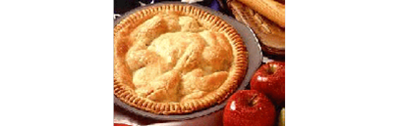

Task Title: Dividing wholes into halves

Learner’s self reflection:

1. I can tell the difference between a whole and a half. Yes  No 

2. I know that two halves make a whole. Yes  No 

3. I can solve real life problems involving halves. Yes  No 

Other comments:

Task Title: Dividing wholes into halves – Answer Key

- ½ pizza
- 5 candies each
- 6
- 1 cup milk and ½ teaspoon vanilla
- 4 pieces

Task Title: Dividing wholes into halves
Performance Descriptors |  | Needs Work | Completes task with support from practitioner | Completes task independently
C3.1 | - interprets and represents measures using whole numbers, decimals, and simple, common fractions
E.1 | - Begins to use a limited number of learning strategies (e.g. bag of objects to divide)
 | - Begins to monitor own learning (checklist)
 | - Uses feedback to improve performance

This task: was successfully completed___ needs to be tried again___

Learner Comments

____________________________ _________________________

Instructor (print) Learner Signature

