

Task Title: Ductwork Installation Guide

# OALCF Cover Sheet – Practitioner Copy

**Learner Name:**

**Date Started:**

**Date Completed:**

|  |  |  |
| --- | --- | --- |
| **Goal Path:** | Employment | Apprenticeship |
| Secondary School | Post Secondary | Independence |

**Successful Completion:**  Yes No

**Task Description:**

Read a Ductwork Installation Guide to answer questions about home installation.

**Main Competency/Task Group/Level Indicator:**

* Find and Use Information/Interpret documents/A2.2

**Materials Required:**

* Pen and Paper and/or digital device

Learner Information

# Installation guides give homeowners tips on how to complete simple construction projects at home. Scan the Ductwork Installation Guide.

# 

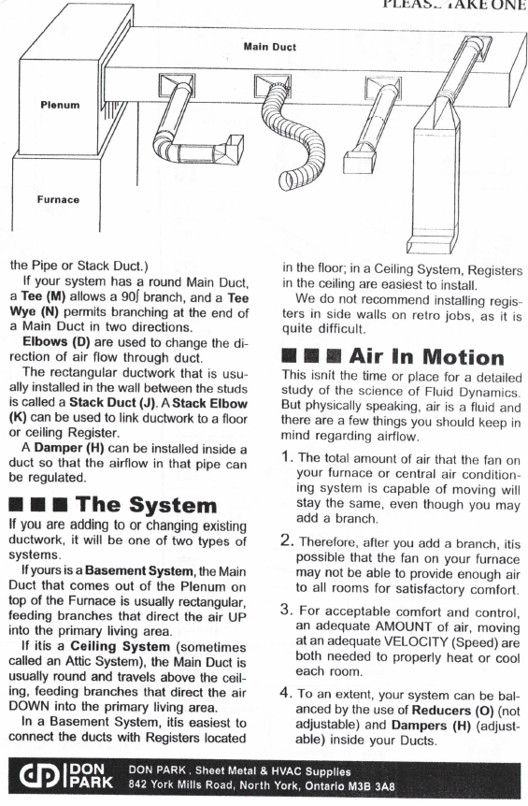

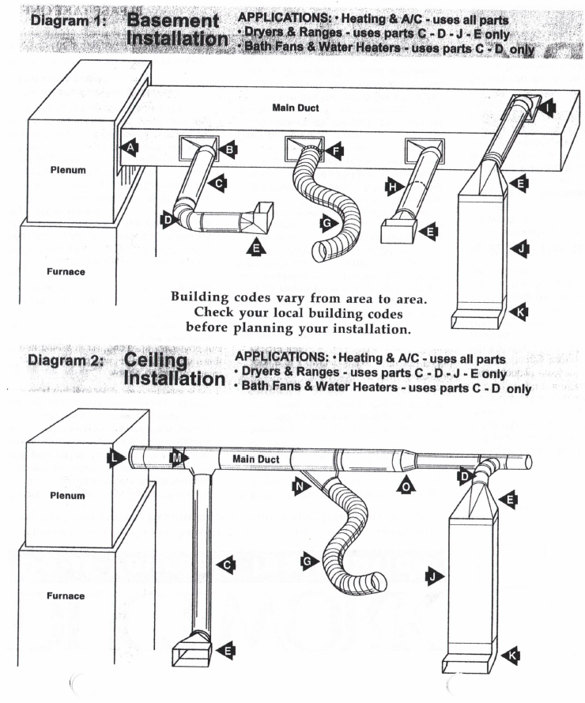

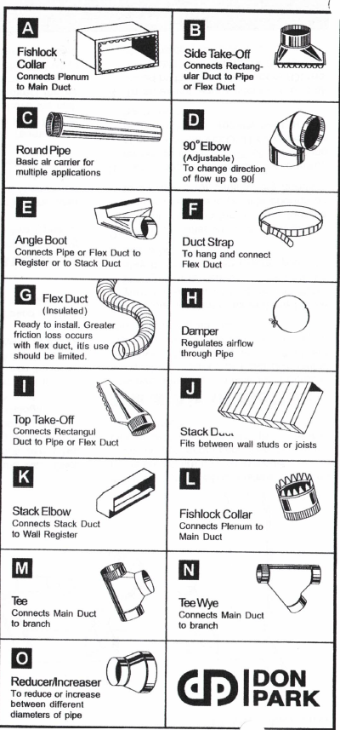

# Work Sheet:

**Task 1: Which 2 types of installations are found in the instructions?**

Answer:

**Task 2: Which code must the installer check before planning the installation?**

Answer:

**Task 3: List the 5 steps that are part of the Process.**

**Task 4: How does someone know this installation does not need to be done by an expert?**

**Task# 5: Where does an installer use a “reducer/increaser”?**

# Answers

**Task 1: Which 2 types of installations are found in the instructions?**

Answer: Basement, ceiling

**Task 2: Which code must the installer check before planning the installation? (answer is difficult to find)**

Answer: (Local) building codes

**Task 3: Locate where the Process is explained. List the 5 steps that are part of the Process. (distractors: another list is numbered while this list is not)**

Answer:

1. Draw a diagram.
2. Write a checklist of the ducts, fittings, pipes, and tools and supplies needed
3. Estimate the type of pipes needed.
4. Measure the lengths of distances and write down these measurements.
5. Discuss the diagram with a store representative to be sure you have everything needed.

**Task 4: How does someone know this installation does not need to be done by an expert? (low-level inference required)**

Answer: This is a “Do It Yourself” instruction sheet so the process does not need to be doneby an expert.

**Task 5: Where does an installer use a “reducer/increaser”?**

Answer: To reduce or increase between diameters of pipe

# Performance Descriptors

| Levels | Performance Descriptors | Needs Work | Completes task with support from practitioner | Completes task independently |
| --- | --- | --- | --- | --- |
| A2.1 | Scans to locate specific details |  |  |  |
| A2.1 | Locates specific details in simple documents |  |  |  |
| A2.2 | Makes low-level inferences |  |  |  |
| A2.2 | Uses layout to locate information |  |  |  |

This task: Was successfully completed Needs to be tried again

Learner Comments:

Instructor (print): Learner (print):