

Task Title: Employment Workshop Calendar

# OALCF Cover Sheet – Practitioner Copy

**Learner Name: __________________________________________**

**Date Started: ___________________________________________**

**Date Completed: _________________________________________**

|  |  |  |
| --- | --- | --- |
| **Goal Path:** | Employment | Apprenticeship |
| Secondary School | Post Secondary | Independence |

**Successful Completion:**  Yes No

**Task Description:** In this task, a learner is asked to respond to questions relating to a workshop calendar from an Employment Services organization.

**Main Competency/Task Group/Level Indicator:**

* Find and Use Information/Read continuous text/A1.2
* Find and Use Information/Interpret documents/A2.2

**Materials Required:**

* Pen/pencil and paper and/or digital device

# Learner Information

# When searching for a job, or looking at courses related to your hobbies or interests, you may need to review workshop calendars to find the best options.

Scan the “**Career Solutions Monthly Calendar for March 2025**”.

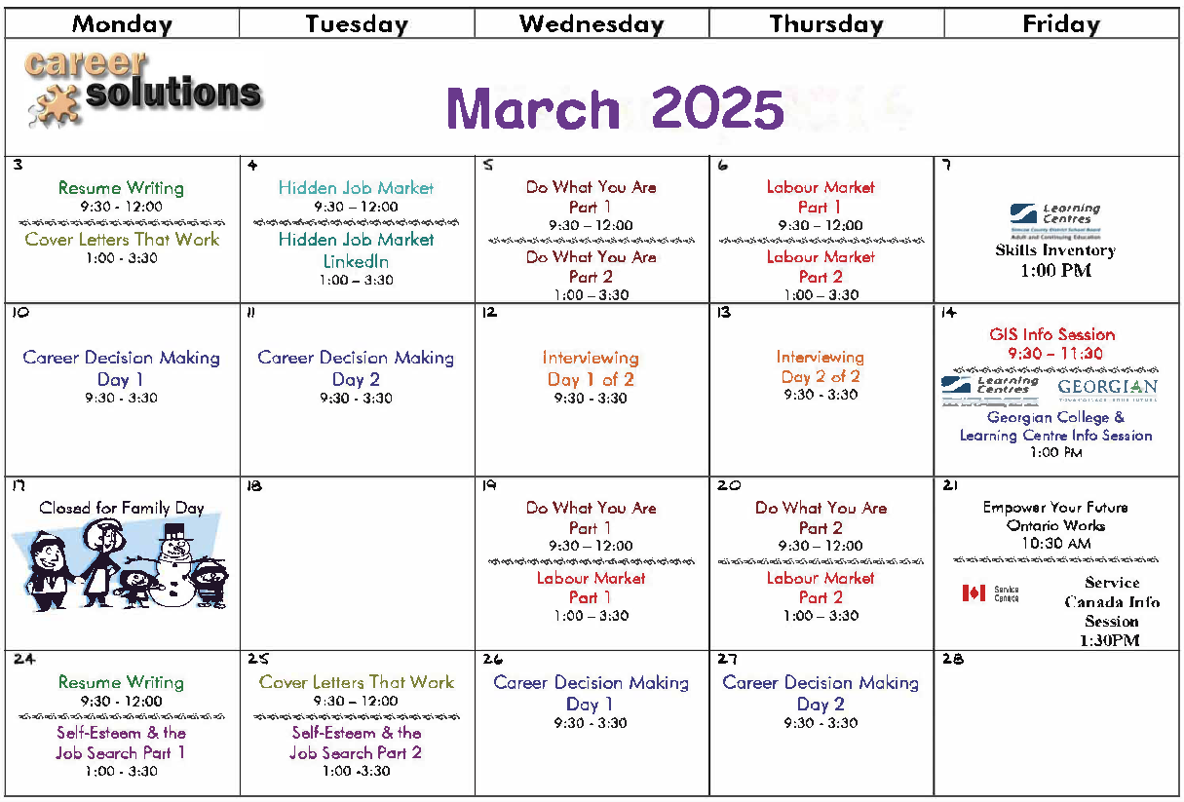

# 

# Work Sheet

**Task 1: What is the month on the calendar?**

Answer:

**______________________________________________________**

**Task 2: What dates are the resume writing workshops offered?**

Answer:

**______________________________________________________**

**Task 3: List two of the two-part workshops.**

Answer:

**______________________________________________________**

**Task 4: What employment-related topics are two full-day workshops?**

Answer:

**______________________________________________________**

**Task 5: Which two-part workshop promotes finding a job that reflects your personal interests?**

Answer:

**______________________________________________________**

Answers

**Task 1: What is the month on the calendar?**

Answer: March.

**Task 2: What dates are the resume writing workshops offered?**

Answer: March 3 and March 24.

**Task 3: List two of the two-part workshops.**

Answer: Any two of:

* Do What You Are
* Labour Market
* Self-Esteem and the Job Search

**Task 4: What employment-related topics are two full-day workshops?**

Answer: Career Decision Making and Interviewing

**Task 5: Which two-part workshop promotes finding a job that reflects your personal interests?**

Answer: Do What You Are

# Performance Descriptors

| Levels | Performance Descriptors | Needs Work | Completes task with support from practitioner | Completes task independently |
| --- | --- | --- | --- | --- |
| A1.2 | scans text to locate information |  |  |  |
|  | locates multiple pieces of information in simple texts |  |  |  |
|  | reads more complex texts to locate a single piece of information |  |  |  |
| A2.2 | extracts information from tables and forms |  |  |  |
|  | uses layout to locate information |  |  |  |



This task: Was successfully completed Needs to be tried again

Learner Comments:

Instructor (print): Learner (print):

**__________________ _________________**