OALCF Task Cover Sheet
Task Title: Explore the Hairstyling Trade
Learner Name:

Date Started: Date Completed:

Successful Completion: Yes___ No___
Goal Path: Employment___ Apprenticeship ✓ Secondary School Post Secondary Independence___
Task Description: Learners will read about the trade and then try out some hairstyling skills.
Competency:  A: Find and Use Information  C: Understand and use numbers | Task Group(s):  A1: Read continuous text  A2: Interpret documents  C2: Manage time  C3: Use measures
Level Indicators:
A1.2: Read texts to locate and connect ideas and information
A2.1: Interpret very simple documents to locate specific details
C2.1: Measure time and make simple comparisons and calculations
C3.2 Use measures to make one-step calculations
Performance Descriptors: see chart on last page
Materials Required:
- Question sheet
- Handout “On the Job with a Hairstylist”
- Handout “Do you have the essential skills to be a hairstylist?”
- Pencil or pen

Task Title: Explore the Hairstyling Trade
The Canadian government provides information for persons interested in entering the skilled trades. Here is an opportunity to learn about being a hairstylist.

Learner Information and Tasks:
Task 1: Look at the entire handout “On the job with a Hairstylist”. List the essential skills used by a hairstylist.

Tasks 2-5: Look at the handout “Do you have the essential skills to be a hairstylist?” Try the questions. Keep in mind that these are questions that a journeyperson (who has had about 3 years of training on the job and in a classroom) should be able to answer.
Using Essential Skills: On the Job with a Hairstylist

Are you starting an apprenticeship in hairstyling or are you thinking about a career in this trade? Pursuing a career as a hairstylist requires strong essential skills such as interacting with others, interpreting documents, using measures and critical thinking.
Use this booklet to:
- learn how hairstylists use essential skills;
- follow the daily routine of a hairstylist; and
- find out how your essential skills compare to those of an experienced hairstylist.

How hairstylists use essential skills
Hairstylists use essential skills to perform a variety of job-related tasks, for example:
- interacting with others to discuss hair colour preferences and other services with clients;
- critical thinking to judge whether a hairstyle will look good on a client; and
- managing learning to keep up to date with trends and products.
Hairstylists cut, shampoo, perm, colour and style hair and perform other services such as adding hair extensions. They work in hairstyling or hairdressing salons, barbershops and vocational schools, or in other specialized settings such as healthcare institutions or theatre, film and television establishments. They may also be self-employed.

A day in the life of a hairstylist: Lisa’s story

Reading an appointment schedule
Lisa is a hairstylist in a busy salon. When she arrives at work, she looks at her appointment schedule for the day. It shows her which clients are coming in, at what time and for which services (interpreting documents).
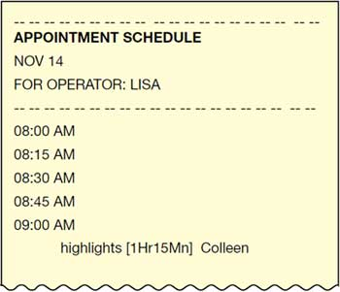

Talking to clients
When clients come in, Lisa greets them and talks about details she remembers about their lives (interacting with others, thinking skills – use of memory).
If clients are new, she asks them their preferences, such as what kind of highlights they want or which styles they prefer. Asking clients questions helps Lisa decide how she will cut and style their hair (interacting with others, thinking skills – critical thinking).

Reading client history cards
Client history cards give Lisa information such as when clients were last in, what services they had done, which colour formulas they were given and what prices were charged. Lisa fills in these cards after each client leaves and reviews them next time the clients return to the salon (interpreting documents).
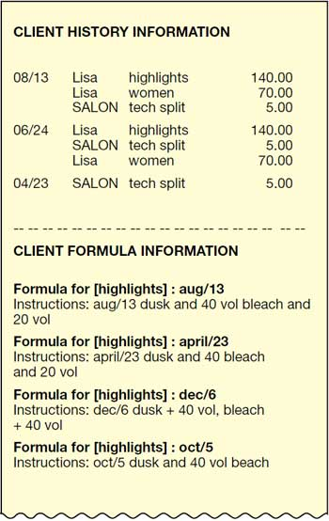

Mixing hair colour
Lisa is asked to colour a client’s hair. She reads the colour formulas from the client’s last visit. To get a light colour, she measures one scoop of Brightener Powder and adds Conditioning Cream, according to the instructions on the label (interpreting documents). If she wants additional lift, she mixes one scoop of Brightener Powder with one part Brightener Cream and two parts Colour Developer (using measures).
Lisa must work swiftly and efficiently with the colour because it oxidizes quickly and loses potency. She can only mix enough colour to work with for a half hour at a time. If more colour is needed, she mixes another batch.
After Lisa applies the colour, she leaves it on the client’s hair to develop for a certain amount of time. She sets a digital timer that will beep when the time is up. Once the colour has developed enough, Lisa can rinse and shampoo her client’s hair, and then go on to cut it.

Reading product labels
Lisa has a client who is new to the salon. The client explains that she is allergic to parabens—chemicals used as preservatives in many shampoos and conditioners. Any chemical with methyl, ethyl, propyl or butyl in the name is a paraben. Lisa checks the chemicals in all the products she is going to use on this client’s hair by reading the ingredients list on the back of the products (interpreting documents).
She sees that there are many parabens in the conditioner she was going to use, so she chooses another. When the client leaves, Lisa makes a note on the client’s history card about her allergy and which products to use (completing and creating documents).

Charging for services
The client settles the bill with the receptionist. Lisa charges according to how much experience she has and which training courses she has completed. She gets weekly training about new products; she also goes to out-of-town workshops and seminars to make sure her knowledge is up to date (managing learning).
At the end of her shift, Lisa tidies up her station. The tools she uses every day are her own, but she also uses the salon’s products and equipment. The salon has agreed to pay Lisa a set amount for every service she performs. At the end of each day, Lisa can leave the salon knowing that her daily earnings and tips will be calculated and recorded by the salon.

Adapted from Using Essential Skills: On the Job with a Hairstylist
http://www.esdc.gc.ca/eng/jobs/les/tools/awareness/hairstylist_story.shtml
Do you have the essential skills to be a hairstylist?
Complete the following questions to see how your skills compare to those of an experienced hairstylist.

2. Appointment schedule
Hairstylists look at their schedule at the beginning of the day. The schedule tells them what kind of service each client has booked and how long each appointment will take.
Look at the appointment schedule below. If the hairstylist’s last appointment is at 5:15 pm, what time will she finish work on this day?
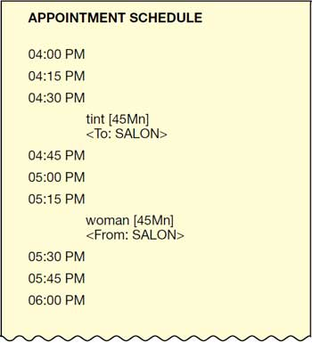

3. Client history card
It is useful for hairstylists to know how long it has been since a client’s last highlights; this information can help them know how long a colour lasts, if it has faded or grown out, and what to use the next time.
Look at the following client history card. When did this client last have highlights?
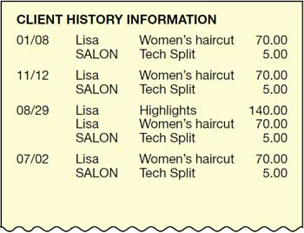

4. Product instructions
Hairstylists have to estimate how much colour to use on a client’s hair.
Look at the Brightener Powder product instructions. The hairstylist estimates that she will need to mix two batches of hair colour for a client. How much conditioning cream will she have to use in total?
Brightener Powder
Brightener Powder ensures that your client’s hair remains shiny and healthy-looking despite frequent blow-drying. The unique blend of natural mineral oils, plant extracts and jojoba creates a lustrous, long-lasting shine. This hypo-allergenic formula also protects clients prone to allergic reactions and its soft mint fragrance creates a more enjoyable experience for both stylists and clients.
For Off-The-Scalp Applications:
Mixing: Measure 1 level scoop of Brightener Powder into a plastic bowl. Add 4 fl oz/120 ml of a conditioning cream of your choice. Ensure thorough mixing to achieve a creamy consistency.
Application: Apply mixture to dry, unwashed hair using any off-the-scalp application technique.
Processing: Leave hair to process at room temperature until desired volume is achieved. Rinse hair completely and follow with light shampooing.

5. Ingredients list
Circle two of the parabens found in the ingredients list.
Reminder: Parabens are chemicals used as preservatives in many shampoos and conditioners. Any chemical with methyl, ethyl, propyl or butyl in the name is a paraben.
Ingredients: Alcohol, Caproate, ALOE LEAF, Cirtus Aurantifolia, Ferula Gabanifua, Water, Lauryl Sulfate, BenzylTriglyceride, Babassuamidiopropyl, Centaurea Cyanus Flower, Morpholine Lactate, Malva Sylvestris (Mallow) Leaf Powder, Citrus Grandis (Grapefruit) peel Oil, Methylchloroisothiazolinone, natural extract, emollient herb, Methylisothiazolinone, Avodcadamine D, Isobutyl, Jojoba Oil, Glycerin, Isostearamidopropyl, Acetylated Lanolin Alcohol, Lauramidopropyl, Cetearyl Alcohol, Acetate, Cocamide Dea, Wheat Protein, Panthenol, Peg-75 Lanolin Oil, Sodium Lactate, Sorbitol Cocamidopropyl, Ethyl Acetate.
Date modified:
2013-04-15

Adapted from Using Essential Skills: On the Job with a Hairstylist
http://www.esdc.gc.ca/eng/jobs/les/tools/awareness/hairstylist_story.shtml
Task Title: Explore the Hairstyling Trade
Answer Key
Task 1: interacting with others interpreting documents using measures
critical thinking managing learning use of memory
completing and creating documents

Task 2: Appointment schedule (interpret documents, manage time)
She will finish work at 6:00 pm.

Task 3: Client history card (interpret documents)
The client last had highlights on August 29.

Task 4: Product instructions (read continuous text, use measures)
2 x 4 fl oz/120 ml = 8 fl oz/240 ml of conditioning cream.

Task 5: Ingredients list (interpret documents)
See the parabens in bold below. Two should be circled by the learner.

Ingredients: Alcohol, Caproate, ALOE LEAF, Cirtus Aurantifolia, Ferula Gabanifua, Water, Lauryl Sulfate, BenzylTriglyceride, Babassuamidiopropyl, Centaurea Cyanus Flower, Morpholine Lactate, Malva Sylvestris (Mallow) Leaf Powder, Citrus Grandis (Grapefruit) peel Oil, Methylchloroisothiazolinone, natural extract, emollient herb, Methylisothiazolinone, Avodcadamine D, Isobutyl, Jojoba Oil, Glycerin, Isostearamidopropyl, Acetylated Lanolin Alcohol, Lauramidopropyl, Cetearyl Alcohol, Acetate, Cocamide Dea, Wheat Protein, Panthenol, Peg-75 Lanolin Oil, Sodium Lactate, Sorbitol Cocamidopropyl, Ethyl Acetate.

Task Title: Explore the Hairstyling Trade
Performance Descriptors |  | Needs Work | Completes task with support from practitioner | Completes task independently
A1.2 | - scans text to locate information
 | - locates multiple pieces of information in simple texts
 | - makes low-level inferences
 | - makes connections between sentences and between paragraphs in a single text
 | - reads more complex texts to locate a single piece of information
 | - follows the main events of descriptive, narrative and informational texts
 | - obtains information from detailed reading
A2.1 | - scans to locate specific details
 | - interprets brief text and common symbols
 | - locates specific details in simple documents, such as labels and signs
 | - identifies how lists are organized (e.g. sequential, chronological, alphabetical)
C2.1 | - adds, subtracts, multiplies and divides whole numbers and decimals
 | - recognizes values in number and word format
 | - understands chronological order
 | - understands and uses common date formats
 | - identifies and performs required operation
 | - represents dates and times using standard conventions
 | - chooses appropriate units of measurement (e.g. hours, minutes, seconds)
 | - interprets and represents time using whole numbers, decimals (e.g. .25, .5) and simple common fractions (e.g. ½, ¼ hour)
 | - follows apparent steps to reach solutions
C3.2 | - calculates using numbers expressed as whole numbers, fractions, decimals, percentages and integers
 | - chooses and performs required operation(s); may make inferences to identify required operation(s)
 | - selects appropriate steps to solutions

This task: was successfully completed___ needs to be tried again___

Learner Comments

____________________________ _________________________

Instructor (print) Learner Signature

