Task-based Activity Cover Sheet
Task Title: Follow a flow chart to learn the steps in the Amazon book order process
Learner Name:

Date Started: Date Completed:
Successful Completion: Yes___ No___
Goal Path: Employment ✓Apprenticeship __ Secondary School __ Post Secondary __ Independence✓
Task Description:
Learner will use a flowchart to follow the process of an Amazon book order
Competency:  A: Find and Use Information | Task Group(s):  A2: Interpret documents
Level Indicators:
A2.3: Interpret somewhat complex documents to connect, evaluate and integrate information
Performance Descriptor: see chart or click here
Skill Building Activities: see last page or click here
Materials Required:
- Pen, pencil, paper
- Attached Amazon book order process flowchart
ESKARGO:
Reading Strategies – Decoding and Comprehension Enhancement
- Manages unfamiliar elements (vocabulary, context, topic) to complete tasks
- Uses knowledge of vocabulary and sight words related to specific to flowcharts to obtain meaning
Forms and Conventions – Find Information/Research/Understand Types of Texts
- Uses layout to locate information
- Uses various conventions of flow charts to obtain meaning
- Uses organizational features, such as headings, to locate information
- Performs complex searches using multiple search criteria
Comprehension – Read to Understand/Retell
- Identifies the purpose and relevance of documents
Attitudes:
Practitioner,
We encourage you to talk with the learner about attitudes required to complete this task set. The context of the task has to be considered when identifying attitudes. With your learner, please check one of the following:
□ Attitude is not important □ Attitude is somewhat important □ Attitude is very important

Task Title: Follow a flow chart to learn the steps in the Amazon book order process
Learner Information and Tasks:
Flow charts are often used by companies to help their customers understand the steps in a process that might be difficult to follow. Look at the “Amazon Book order Process”.

Task 1: What will you click if you are not an existing Amazon user?

Task 2: What search criteria will you use when searching for a book?

Task 3: Which choice do you need to make directly after you have selected your preferred
book?

Task 4: What will you click if you notice your address information is incorrect after selecting
payment?
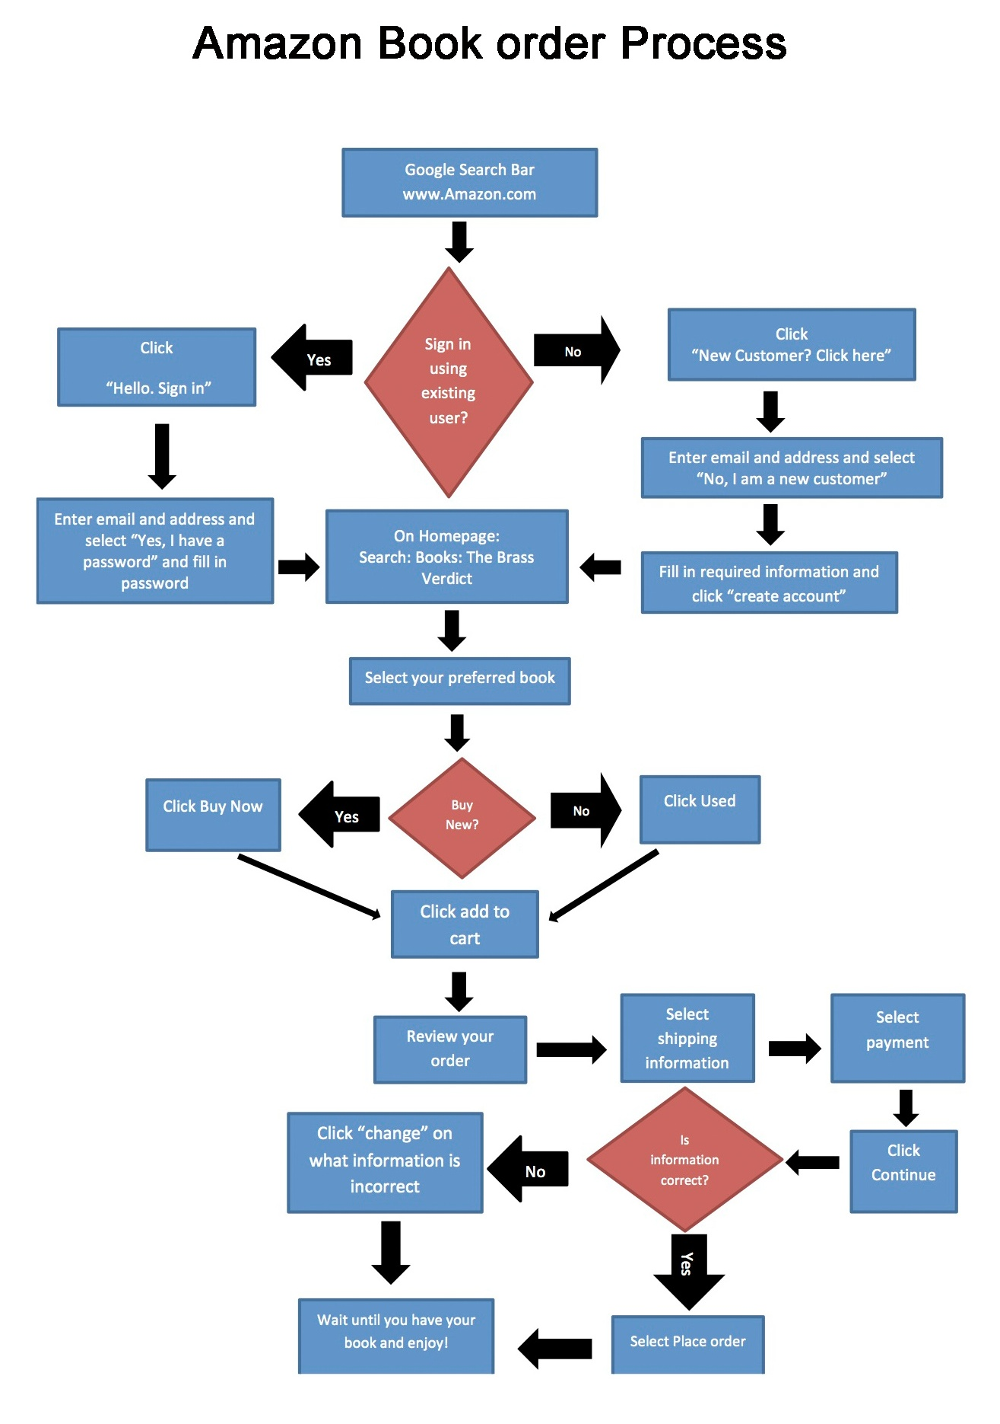

Task Title: Follow a flow chart to learn the steps in the Amazon book order process
Answer Key
Task 1: What will you click if you are not an existing Amazon user? New Customer
- Follow flowchart to “Sign in using existing user?”
- “No”
- Click “New Customer? Click here”
Task 2: What search criteria will you use when searching for a book? Books
- Follow flowchart to “On Homepage: Search: Books: The Brass Verdict”
Task 3: What choice do you need to make directly after you have chosen your preferred book? New or Used
- Follow flowchart to “Select your preferred book”
- “Buy New?”
- “Yes” or “No”
- Choose New (buy now) or Used
Task 4: What will you click if you notice your address information is incorrect after selecting payment? Click “change” on address information
- Follow flowchart to “Select payment”
- “Click Continue”
- “Is information correct?”
- “No”
- Click “change” on the what the information is incorrect

Task Title: Follow a flow chart to learn the steps in the Amazon book order process
Performance Descriptors |  | Needs Work | Completes task with support from practitioner | Completes task independently
A2.3 | - performs complex searches using multiple search criteria
A2.3 | - manages unfamiliar elements (e.g. vocabulary, context, topic) to complete tasks
A2.3 | - integrates several pieces of information from documents
A2.3 | - uses layout to locate information
A2.3 | - identifies the purpose and relevance of documents
A2.3 | - makes inferences and draws conclusions from information displays
A2.3 | - identifies sources, evaluates and integrates information

This task: was successfully completed___ needs to be tried again___

Learner Comments

____________________________ _________________________

Instructor (print) Learner Signature
Skill Building Activities
Links to Online Resources:
Skill Plan’s, “Measure Up” - http://www.skillplan.ca/measure-up , (select “English”, “Choice of Activities”, “Practice”, “Document Use”, and “Graphics including graphs, maps, symbols, pictures”) – practice locating details and performing multiple searches in specialized documents that use a mix of graphics and text
GCF LearnFree – “Everyday Life” - http://www.gcflearnfree.org/everydaylife/edlall – play games (“Bus Map”, “Subway Map”, “Fire Plan”) to practise reading graphical representations of information
https://www.youtube.com/watch?v=hN9xemJYwos – video explains how to read and draw simple flow charts, and explains their use for describing organizational processes
LearningHUB online courses available:

- Reading & Writing, Independent Study (assigned by practitioner after assessment)
  - Reading Level 2, Assignment 1
  - Reading Level 3 Assignment
  - Ready for College Reading, Assignment 3
*all assignments teach strategies for managing unfamiliar elements in texts, using layout to locate details, using pictures to aid comprehension, making inferences, and asking and answer questions while reading
- Essential Skills Independent Study (assigned by practitioner after assessment)
  - Document Use Level 1, Assignment 2 (reading charts, graphs, tables, and flowcharts)
  - Document Use Level 2, Assignment 2 (more on charts, graphs, and tables)
  - Document Use Level 3, Assignment 1 (reading complex flowcharts)

- Live Classes (SABA) – GED Social Studies, Parts 1-3; GED Science, Parts 1-3 (classes provide strategies for understanding questions with graphical information)

*To access LearningHUB courses, learners must register for the LearningHUB e-Channel program by completing the registration form on their website and completing the course selection (page 2 of the registration form): https://www.learninghub.ca/get_registered.aspx

*To Access LearningHUB Course Catalogue:
http://www.learninghub.ca/Files/PDF-files/HUBcoursecatalogue,%20December%2023,%202014%20revision.pdf

