

Task Title: Forestry Safety Part 2

# OALCF Cover Sheet – Practitioner Copy

**Learner Name:___________________________________________**

**Date Started:____________________________________________**

**Date Completed: _________________________________________**

|  |  |  |
| --- | --- | --- |
| **Goal Path:** | Employment | Apprenticeship |
| Secondary School | Post Secondary | Independence |

**Successful Completion:**  Yes No

**Task Description:**

Read a chart to understand causes of distracted driving in Ontario logging operations.

**Main Competency/Task Group/Level Indicator:**

* Find and Use Information/Interpret documents/A2.2

**Materials Required:**

* Pen/pencil and/or digital device

# Learner Information

Forestry safety is important in the logging industry in Ontario. Research has found the use of smartphones and two-way radios have made distracted driving the top health and safety risk for logging workers. Scan the **Distracted Driving Causes** chart.

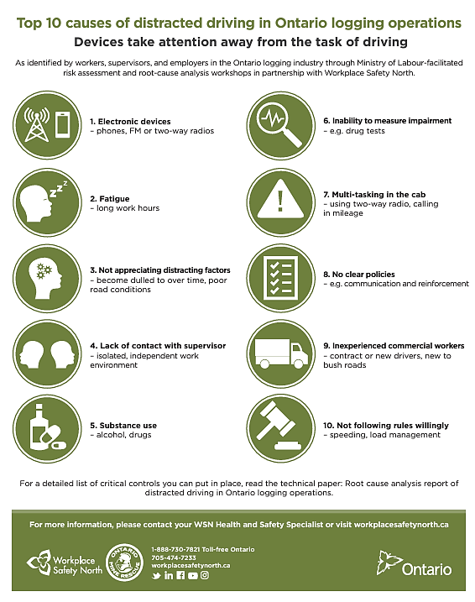**Distracted Driving Causes**

# Work Sheet

**Task 1: Who identified the top 10 causes of distracted driving in Ontario logging operations?**

Answer:

**Task 2: List three causes of distracted driving.**

Answer:

**Task 3: What are the two reasons given for multi-tasking in the cab?**

Answer:

**Task 4: Who do you contact to get more information?**

Answer:

**Task 5: Where can you locate a detailed list of critical controls?**

Answer:

# Answers

**Task 1: Who identified the top 10 causes of distracted driving in Ontario logging operations?**

Answer: Workers, Supervisors, Employers

**Task 2: List three causes of distracted driving.**

Answer: Any 3 of the following:

* Electronic devices (phones, FM or two-way radios)
* Fatigue
* Not appreciating distracting factors (become dulled over time, poor road conditions)
* Lack of contact with supervisor (isolated)
* Substance abuse (alcohol, drugs)
* Inability to measure impairment
* Multitasking in the cab
* No clear policies
* Inexperienced commercial workers (contract or new drivers, new to bush roads)
* Not following rules willingly (speeding, load management)

**Task 3: What are the two reasons given for multi-tasking in the cab?**

Answer: Using two-way radio and calling in mileage

**Task 4: Who do you contact to get more information?**

Answer: Your WSN Health and Safety Specialist

**Task 5: Where can you locate a detailed list of critical controls?**

Answer: the technical paper: Root cause analysis report of distracted driving in Ontario logging operations

# Performance Descriptors

| Levels | Performance Descriptors | Needs Work | Completes task with support from practitioner | Completes task independently |
| --- | --- | --- | --- | --- |
| A2.2 | Performs limited searches using one or two search criteria |  |  |  |
| A2.2 | Extracts information from tables and forms |  |  |  |
| A2.2 | Uses layout to locate information |  |  |  |
| A2.2 | Makes connections between parts of documents |  |  |  |

This task: Was successfully completed Needs to be tried again

Learner Comments:

Instructor (print): Learner (print):