OALCF Task Cover Sheet
Task Title: Interpret Blueprints
Learner Name:

Date Started: Date Completed:

Successful Completion: Yes___ No___
Goal Path: Employment ✓ Apprenticeship ✓ Secondary School Post Secondary Independence___
Task Description:
Carpenters interpret blueprints and other scale drawings.
Competency:  A: Find and Use Information  B: Communicate Ideas and Information | Task Group(s):  A1: Read continuous text  A2: Interpret documents  B2: Write continuous text
Level Indicators:
A1.2: Read texts to locate and connect ideas and information
A2.2: Interpret simple documents to locate and connect information
A2.3: Interpret somewhat complex documents to connect, evaluate, and integrate information
B2.2: Write brief texts to convey simple ideas and factual information
Performance Descriptors: see chart on the last page
Materials Required:
- Test Drawing No. 3
- Building Code Excerpt
- Pencil
Task Title: Interpret Blueprints
Carpenters interpret blueprints and other scale drawings to determine placement of building materials. They also consult the Building Code to determine if modifications are legal.
Learner Information and Tasks:
Using the Test Drawing No. 3 and the excerpt from the Building Code, the carpenter determines where the building materials are to be placed. Using the relevant excerpt from the Building Code, the carpenter can also explain why a modification is not legal.
Task 1: What type of door separates the Kitchen and the Dining Room?

Task 2: On which side of the Living Room are the awning type of windows found?

Task 3: Which bedrooms have bi-fold doors?

Task 4: Bedroom 1 is 7.5’ x 9’. The owner wants to have the closet run the whole length of the south wall. Using the excerpt from the Building Code, write a note to the customer explaining why that is not possible.
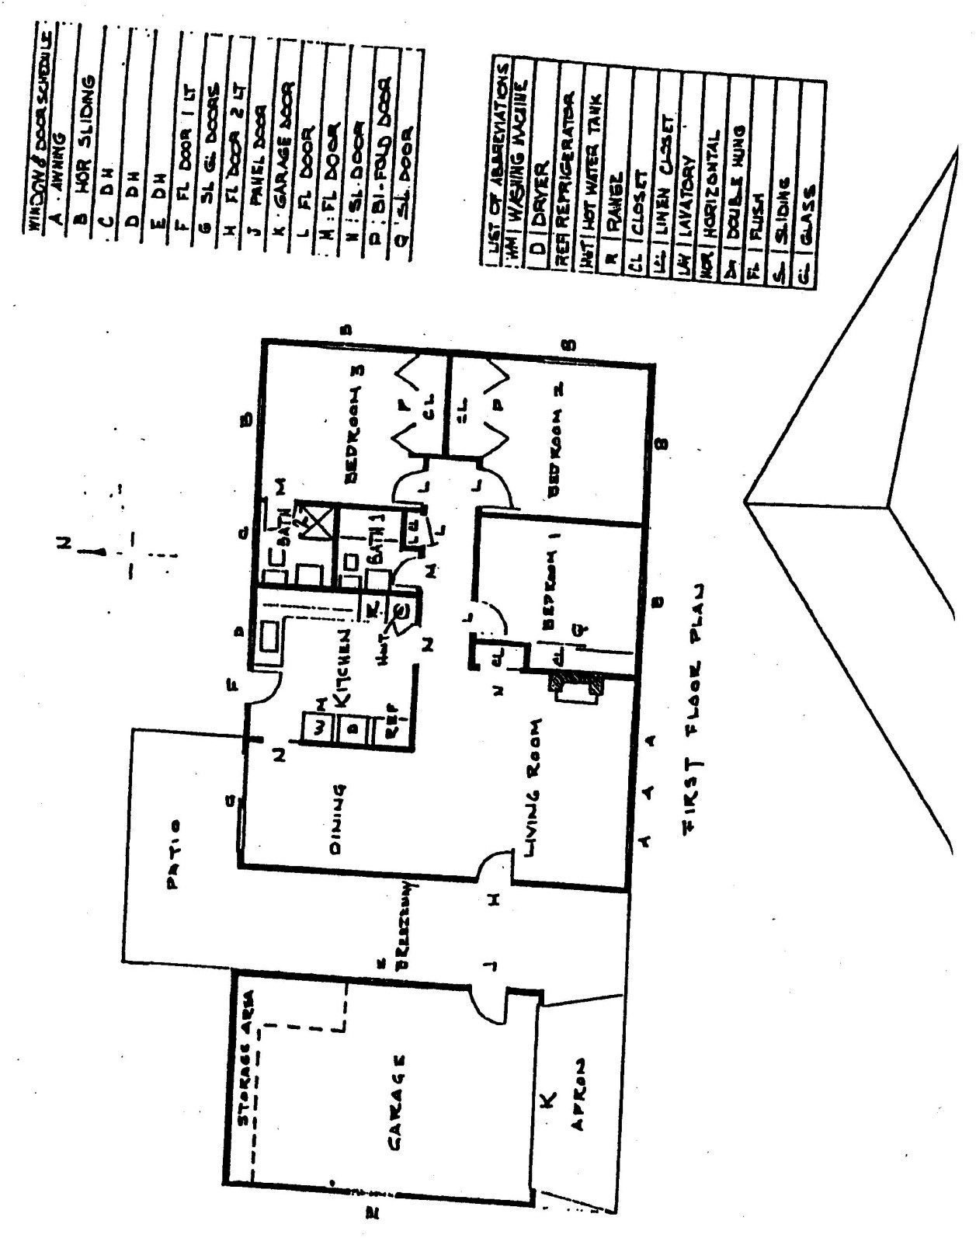

Building Code Excerpt
9.7.1. General
9.7.1.1. Application
(1) Windows and skylights shall conform to the requirements of this Section.
9.7.1.2. Minimum Window Areas
(1) Except as required in Article 9.7.1.3. and Sentence (3), the minimum window glass area for rooms in buildings of residential occupancy or that are used for sleeping shall conform to Table 9.7.1.2.
(2) The unobstructed glass area of a door or skylight is considered equivalent to that of a window.
(3) Work areas in live/work units shall conform to Clause 3.7.2.1.(2)(a).
(4) Where rooms with different requirements for window glass area are combined as described in Sentence 9.5.1.4.(1), the more restrictive requirement shall govern.
Table 9.7.1.2.
Glass Areas for Rooms of Residential Occupancy
Forming Part of Sentence 9.7.1.2.(1)
Column 1 | Column 2 | Column 3
Location | Minimum Unobstructed Glass Area With No Electric Lighting | Minimum Unobstructed Glass Area With Electric Lighting
Laundry, basement recreation room, unfinished basement | 4% of area served | Windows not required
Water closet room | 0.37 m² | Windows not required
Kitchen | 10% of area served | Windows not required
kitchen space
kitchen alcove
Living rooms and dining rooms | 10% of area served | 10% of area served
Bedrooms and other finished rooms not mentioned above | 5% of area served⁽¹⁾ | 5% of area served⁽¹⁾

Notes to Table 9.7.1.2.:
⁽¹⁾See Article 9.7.1.3.
9.7.1.3. Bedroom Windows
(1) Except where a door on the same floor level as the bedroom provides direct access to the exterior, every floor level containing a bedroom in a suite shall be provided with at least 1 outside window that,
(a) is openable from the inside without the use of tools,
(b) provides an individual, unobstructed open portion having a minimum area of 0.35 m² with no dimension less than 380 mm, and
(c) maintains the required opening described in Clause (b) without the need for additional support.
(2) Except for basement areas, the window described in Sentence (1) shall have a maximum sill height of 1 000 mm above the floor.
(3) When sliding windows are used, the minimum dimension described in Sentence (1) shall apply to the openable portion of the window.
(4) Where the sleeping area within a live/work unit is on a mezzanine with no obstructions more than 1 070 mm above the floor, the window required in Sentence (1) may be provided on the main level of the live/work unit provided the mezzanine is not more than 25% of the area of the live/work unit or 20 m² whichever is less and an unobstructed direct path of travel is provided from the mezzanine to this window.

Task Title: Interpret Blueprints
Answer Key
Task 1: N SL DOOR
Task 2: South
Task 3: Bedrooms 2 and 3
Task 4: According to the Building Code 9.7.1.2 and 9.7.1.3, every bedroom must have at least one window as a fire escape to the outdoors. The south wall is the only access to the outside for Bedroom 1.

Task Title: Interpret Blueprints
Performance Descriptors |  | Needs Work |  |  | Completes task with support from practitioner |  |  |  | Completes task independently
A1.2 | - scans text to locate information
 | - reads more complex texts to locate a single piece of information
 | - obtains information from detailed reading
A2.2 | - performs limited searches using one or two search criteria
 | - extracts information from tables and forms
 | - uses layout to locate information
 | - makes connections between parts of documents
A2.3 | - performs complex searches using multiple search criteria
 | - manages unfamiliar elements (e.g. vocabulary, context, topic) to complete tasks
 | - integrates several pieces of information from documents
 | - compares or contrasts information between two or more documents
B2.2 | - writes texts to explain and describe
 | - conveys intended meaning on familiar topics for a limited range of purposes and audiences
 | - uses limited range of vocabulary and punctuation appropriate to the task
 | - begins to select words and tone appropriate to the task
 | - begins to organize writing to communicate effectively

This task: was successfully completed___ needs to be tried again___

Learner Comments

____________________________ _________________________

Instructor (print) Learner Signature

