OALCF Task Cover Sheet
Task Title: Interpret Electrical Measuring Equipment Readings
Learner Name:

Date Started: Date Completed:

Successful Completion: Yes___ No___
Goal Path: Employment ___Apprenticeship ✓ Secondary School Post Secondary Independence___
Task Description:
Electricians use electrical measuring equipment to test systems and components. They use the readings to determine if a component needs to be replaced, if a system has been safely shut down (lock out and tag out) and to determine the voltage, amperage and wattage of systems and components.
Competency:  A: Find and Use Information  B: Communicate Ideas and Information  C: Understand and Use Numbers  D: Use Digital Technology | Task Group(s):  A1: Read continuous text  A2: Interpret documents  A3: Extract info from films, broadcasts and presentations  B2: Write continuous text  B3: Complete and create documents  C3: Use measures
Level Indicators:
A1.3: Read longer texts to connect, evaluate and integrate ideas and information
A2.2: Interpret simple documents to locate and connects information
A3: not rated for complexity
B2.2: Write texts to explain and describe information and ideas
B2.3: Write longer texts to present information, ideas and opinions
C3.1: Measure and make simple comparisons and calculations
D.2: Perform well-defined, multi-step digital tasks
Performance Descriptors: see chart on last page
Materials Required:
- Pencil
- Access to the internet with sound capability
Task Title: Interpret Electrical Measuring Equipment Readings
Electricians use electrical measuring equipment to test systems and components. They use the readings to determine if a component needs to be replaced, if a system has been safely shut down (lock out and tag out) and to determine the voltage, amperage and wattage of systems and components.
Some examples of the electrical measuring equipment Electricians use are voltmeters, ohmmeters and multimeters. Electricians set dials on the meter for various readings and interpret the results (where the needle points) on various scales of the meter.

Learner Information and Tasks:
Task 1: Use the Multimeter Pictures to complete these tasks.
- What colour is used to measure the ohms of a circuit?
- Circle on the picture where the meter setting dial should be set to measure a 9 Volt battery.
- Electricians always set the meter slightly higher than the expected voltage being measured. Circle on the picture where the dial should be set to measure a 240 volt AC circuit.
- Batteries are considered in working order at 70% voltage or better. A 9 Volt battery reading shows the needle at about 43%. In what range will the needle point?

Task 2: Electricians use electrical measuring equipment to ensure power has been shut off during lock out/tag out procedures.
Go to the web site http://www.ccohs.ca/oshanswers/hsprograms/lockout.html and read about lock out and tag out.
- What are 3 key pieces of information to be included on the tag?

- An electrician uses a voltmeter to ensure the power to a circuit is safe to complete the lock out/tag out procedure. What should the voltage reading be? Why?

Task 3: Watch this video about using ohmmeters (digital and analog) and answer the following questions.
http://www.youtube.com/watch?v=ocvaqGzvE2I
- How does an electrician test the ohmmeter to be sure it is working?

- How does an electrician ‘zero’ out the analog ohmmeter?

- Using a meter reading at the two terminals, how do you know if a stove element is working?

- Draw a line to the dial to be used when ‘zeroing’ the analog meter.
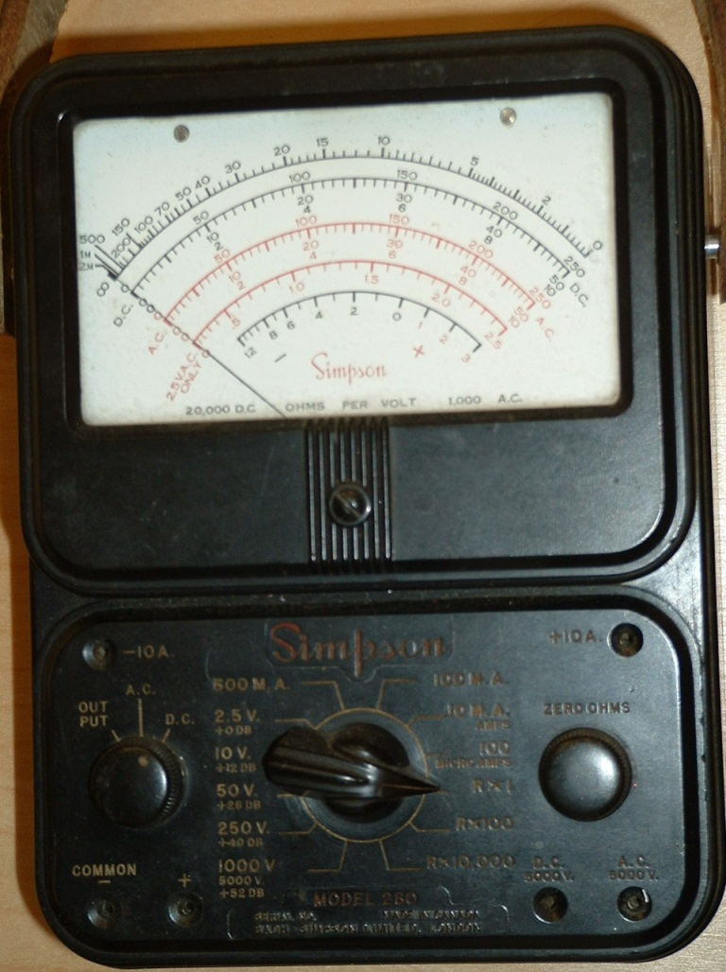

Task Title: Interpret Electrical Measuring Equipment Readings
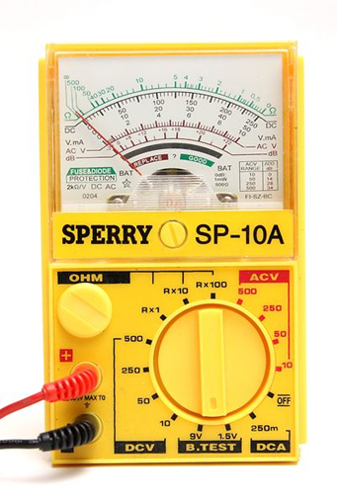
Multimeter Pictures
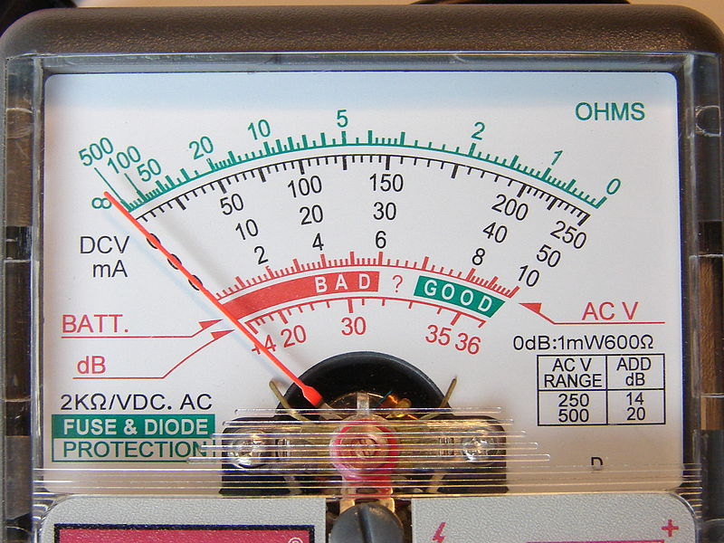
Task Title: Interpret Electrical Measuring Equipment Readings

Answer Key
Task 1: a) green
b) 9 V (green circle)
c) 250 (blue circle)

d) The needle will point in the Bad range.

Task 2: a) The 3 key pieces of information to be included on the tag are:
- Why the lockout/tag out is required (repair, maintenance, etc.).
- Time of application of the lock/tag.
- The name of the authorized person who attached the tag and lock to the system.
b) Answers may vary but should be similar to the following:
The reading should show 0 volts. This has to be the reading because there should not be any electrical power at the lock out/tag out site. This is for safety reasons.
Task 3: a) The electrician touches the 2 leads together and makes sure the ohmmeter displays 0.
b) The electrician turns the dial until the ohmmeter displays 0 ohms.
c)
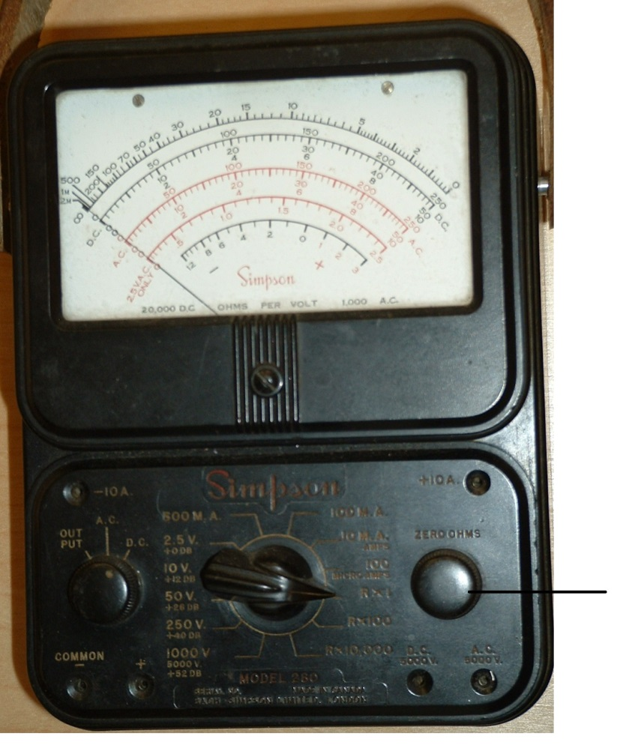

- The ohmmeter should display some value if the stove element is working

Task Title: Interpret Electrical Measuring Equipment Readings
Performance Descriptors |  | Needs Work | Completes task with support from practitioner | Completes task independently
A1.3 | - integrates several pieces of information from texts
 | - manages unfamiliar elements (e.g. vocabulary, context, topic) to complete tasks
 | - skims to get the gist of longer texts
 | - infers meaning which is not explicit in texts
 | - uses organizational features, such as headings, to locate information
 | - follows the main events of descriptive, narrative, informational and persuasive texts
 | - obtains information from detailed reading
 | - identifies sources, evaluates and integrates information
A2.2 | - performs limited searches using one or two search criteria
 | - uses layout to locate information
 | - makes connections between parts of documents
 | - makes low-level inferences
A.3 | - no complexity levels indicated
B2.2 | - writes texts to explain and describe
 | - conveys intended meaning on familiar topics for a limited range of purposes and audiences
 | - begins to sequence writing with some attention to organizing principles (e.g. time, importance)
 | - uses limited range of vocabulary and punctuation appropriate to the task
 | - begins to select words and tone appropriate to the task
 | - begins to organize writing to communicate effectively
B2.3 | - writes texts to present information, summarize, express opinions, present arguments, convey ideas or persuade
 | - manages unfamiliar elements (e.g. vocabulary, context, topic) to complete tasks
 | - selects and uses vocabulary, tone and structure appropriate to the task
 | - organizes and sequences writing to communicate effectively
 | - uses a variety of vocabulary, structures and approaches to convey main ideas with supporting details
C3.1 | - Recognizes values in number and word format
 | - Understands numerical order
D.2 | - selects and follows appropriate steps to complete tasks
 | - begins to identify sources and evaluate information

This task: was successfully completed___ needs to be tried again___

Learner Comments

____________________________ _________________________

Instructor (print) Learner Signature

