Task-based Activity Cover Sheet
Task Title: Interpret a line graph to compare production rates between facilities over time
Learner Name:

Date Started: Date Completed:

Successful Completion: Yes___ No___
Goal Path: Employment✓ Apprenticeship___ Secondary School ___ Post Secondary___ Independence___
Task Description:
Interpret and compare the information on a line graph about production rates of lumber in Canada
Competency:  A: Find and Use Information | Task Group(s):  A2: Interpret documents
Level Indicators:
A2.3: Interpret somewhat complex documents to connect, evaluate and integrate information

Performance Descriptors: see chart or click here
Skill Building Activities: see the last pages or click here
Materials Required:
- Attached Document- Chart 1 Total lumber production for sawmills, 2003-2012 Statistics Canada
- Practitioner Note: Use a colour printer to produce the above document or show it to the learner on a computer screen
- Pencil or pen, paper, highlighter
ESKARGO: A2.3
Reading Strategies – Decoding and Comprehension Enhancement
- Manages unfamiliar elements (vocabulary, context, topic) to complete tasks
- Uses knowledge of vocabulary and sight words related to specific forms, tables, graphs, maps and flow charts to obtain meaning
Forms and Conventions – Find Information
- Uses layout to locate information
- Uses conventions of more complex forms, tables, graphs, maps and flow charts to obtain meaning
- Uses organization features, such as headings, to locate information
Interpretation - Read and Apply Understanding
- Integrates several pieces of information from documents
- Makes inferences and draws conclusions based on the analysis of tables, charts and graphs

Attitudes:
Practitioner,
We encourage you to talk with the learner about attitudes required to complete this task set. The context of the task has to be considered when identifying attitudes. With your learner, please check one of the following:
□Attitude is not important □ Attitude is somewhat important □ Attitude is very important

Task Title: Interpret a line graph to compare production rates between facilities over time
Learner Information and Tasks:
Various jobs within manufacturing read production graphs comparing amounts produced over different years. Look at “Chart 1 Total Lumber Production for Sawmills from 2003 – 2012”.

Task 1: How is lumber production measured on this chart?

Task 2: During which year was lumber production the highest in Canada?

Task 3: Which two Provinces produce the most lumber?

Task 4: List the province that has surpassed at least one other province in lumber production and the year the surpass occurred.

Task 5: When did lumber production fall to the lowest point and why did that occur?

Chart 1
Total lumber production for sawmills, 2003 to 2012
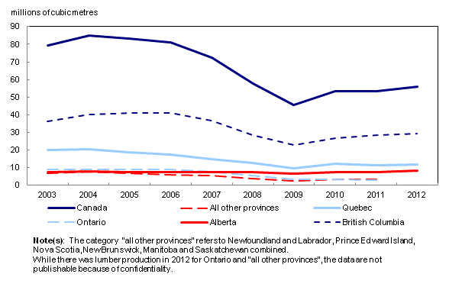

Softwood lumber production and housing starts go hand-in-hand

Softwood lumber is an essential product in home construction. As such, the demand is largely driven by the trends in the Canadian and American housing markets. The United States is the largest importer of Canadian lumber and, in terms of quantity, accounted for 64.6% of Canada's lumber exports in 2012.
Canadian housing starts were up 10.8% in 2012 compared with 2011, while US housing starts rose 28.2% over the same period.
Despite the much larger increase in the US market in 2012, housing starts in Canada were back to a level much closer to their peak of the past decade. This reflects the fact that the economic downturn was not as severe in Canada as it was in the United States.
Looking at the past decade, Canadian housing starts peaked in 2004 with 233,400 units and then fell 36.1% to a low of 149,000 units in 2009 at the trough of the economic downturn. Since 2009, Canadian housing starts have been steadily increasing and stood 8.0% below the 2004 peak in 2012.
Housing starts in the United States reached their highest point in the last decade in 2005 with 2.1 million units. From the 2005 peak, housing starts fell 73.7% to an all-time low of 554,000 units in 2009. Even though starts in the United States have been gradually increasing since the economic downturn, they were still 62.3% lower in 2012 than the peak in 2005.
Total Canadian lumber production has followed a similar trend to that of housing starts in Canada and the United States. Canada's total lumber production fell 42.7% from 2003 to 45.5 million cubic metres in 2009. From 2009 to 2012, lumber production rose 22.8% to 55.8 million cubic metres.

Task Title: Interpret a line graph to compare production rates between facilities over time

Answer Key
Task 1: millions of cubic metres
Task 2: 2004
Task 3: British Columbia produces the most lumber. Quebec produces the 2nd most lumber.

Task 4: Alberta surpassed Ontario in lumber production beginning in late 2007.

Task 5: 2009 as housing starts fell 73.7% to an all-time low of 554,000 units in 2009

Task Title: Interpret a line graph to compare production rates between facilities over time
Performance Descriptors |  | Needs Work | Completes task with support from practitioner | Completes task independently
A2.3 | - Manages unfamiliar elements to complete tasks
A2.3 | - integrates several pieces of information from documents
A2.3 | - uses layout to locate information
A2.3 | - identifies the purpose and relevance of documents
A2.3 | - makes inferences and draws conclusions from information displays
A2.3 | - identifies sources, evaluates and integrates information

This task: was successfully completed___ needs to be tried again___

Learner Comments

____________________________ ______________________

Instructor (print) Learner Signature

Skill Building Activities

Links to online resources:
- Great practice interpreting information from a variety of line graphs by answering questions.
http://ca.ixl.com/math/grade-5/interpret-line-graphs

- Printable worksheets providing practice interpreting line graphs.
http://www.mrmaffesoli.com/Printables/DRE0501.pdf

- Another great resource for practicing line graphs.
http://www.bbc.co.uk/skillswise/worksheet/ma37grap-l1-w-interpreting-line-graphs

- This website gives sample lessons and introduces students to the parts of a line graph and the purpose of each. They are shown how to read and interpret data from each part.
http://www.mathgoodies.com/lessons/graphs/line.html

LearningHUB online courses available:

- Math, Independent Study (assigned by practitioner following assessment) :
  - 402 Geometry Basic Skills; 501 Algebra 1; 502 Algebra 2
- Live Classes (SABA) –Geometry A & B; Pre-Algebra; Algebra; Understanding Algebraic Graphing.

*To access LearningHUB courses, learners must register for the LearningHUB e-Channel program by completing the registration form on their website and completing the course selection (page 2 of the registration form): https://www.learninghub.ca/get_registered.aspx
*To Access LearningHUB Course Catalogue:
http://www.learninghub.ca/Files/PDF-files/HUBcoursecatalogue,%20December%2023,%202014%20revision.pdf

