OALCF Task Cover Sheet
Task Title: Interpret and Create Drawings
Learner Name:

Date Started: Date Completed:

Successful Completion: Yes___ No___
Goal Path: Employment ✓ Apprenticeship ✓ Secondary School Post Secondary Independence___
Task Description:
Electricians interpret, modify and create schematic drawings using standardized icons and legends. They use the drawings to plan tasks and determine materials needed for a job.
Competency:  A: Find and Use information  B: Communicate Ideas and Information  C: Understand and Use Numbers | Task Group(s):  A2: Interpret documents  B2: Write continuous text  B3: Complete and create documents
Level Indicators:
A2.2: Interpret simple documents to locate and connect information
A2.3: Interpret somewhat complex documents to connect, evaluate and integrate information
B2.1: Write brief texts to convey simple ideas and factual information
B3.2a: Use layout to determine where to make entries in simple documents
B3.3a: Decide what, where and how to enter information in somewhat complex documents
Performance Descriptors: see chart on last page
Materials Required:
- Pencil
- ELECTRICAL LEGEND
- Blueprint Section
- Electrical Supplies Order Form
- Schematic Drawing (BEDROOM 1)

Task Title: Interpret and Create Drawings
Electricians interpret, modify and create schematic drawings using standardized icons and legends. They use the drawings to plan tasks and determine materials needed for a job.
Use the following ELECTRICAL LEGEND, Blueprint Section, Electrical Supplies Order Form and Schematic Drawing (BEDROOM 1), to complete the tasks.
Learner Information and Tasks:
Task 1: Interpret the ELECTRICAL LEGEND and Blueprint Section to complete the following tasks.
- How many switches are required for bedroom #2?

- What is the electrical apparatus over the sink?

Task 2: The electrician orders supplies. Use the ELECTRICL LEGEND and the Blueprint Section to decide what electrical supplies are needed for the Bathroom and 2 Bedrooms. Complete the Electrical Supplies Order Form.

Task 3: Refer to the icons of the ELECTRICAL LEGEND to draw the electrical apparatuses, as per the directions, on the bedroom diagram.
- Switch for overhead light on west wall near door
- Overhead light centered in room
- Pull cord light switch in closet centred between sliding doors
- 2 duplex receptacles on each of south and east walls
- 1 duplex receptacle on north wall
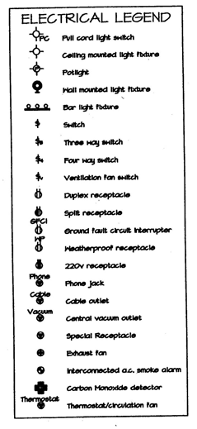

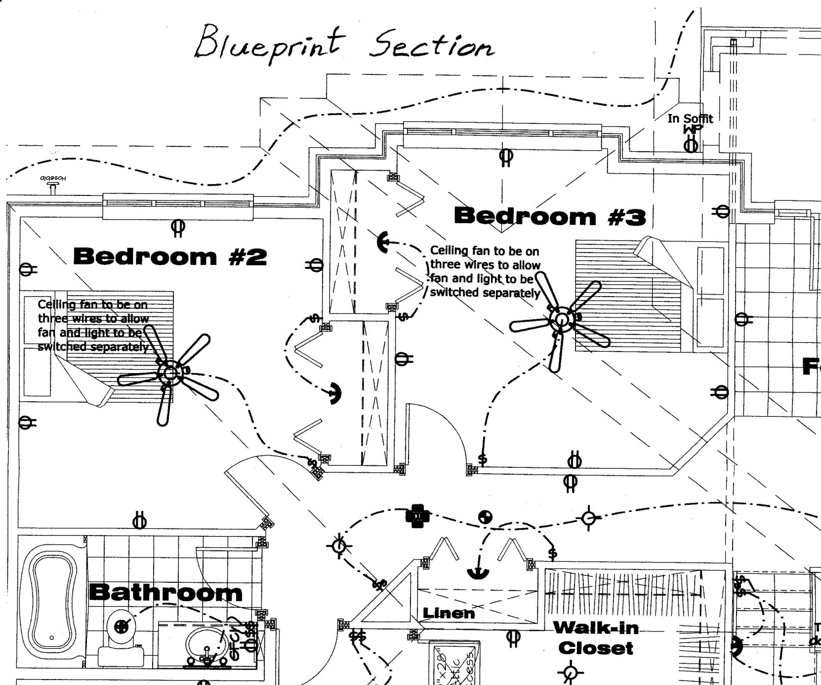

Electrical Supplies Order Form
Item | No. Requested
Pull cord light switch
Ceiling mounted light fixture
Potlight
Bar light fixture
Switch
Three way switch
Ventilation fan switch
Duplex receptacle
Split receptacle
Ground fault circuit interrupter (GFCI)
Weatherproof receptacle
220v receptacle
Phone jack
Cable outlet
Exhaust fan
Interconnected smoke alarm
Carbon Monoxide detector
Thermostat/circulation fan
Other

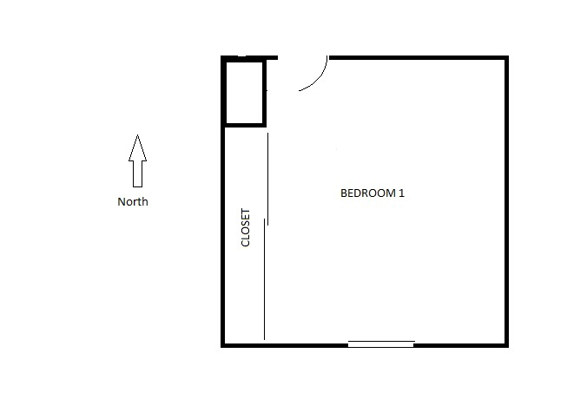
Bedroom Diagram

Task Title: Interpret and Create Drawings
Answer Key
Task 1: a) Scan the ELECTRICAL LEGEND to locate icon for switch. Find the switch icons in Bedroom #2 on the Blueprint Section diagram. Count the switches. 2 switches.
b) Locate the Bathroom on the Blueprint Section. Find the sink. Match the fixture over the sink with an icon on the ELECTRICAL LEGEND. The electrical apparatus over the sink is a Bar light Fixture.
Task 2: Scan the 2 Bedrooms and Bathroom on the Blueprint Section and match the symbols on the ELECTRICAL LEGEND. Count the number of times each symbol is shown in the prescribed rooms and record these totals on the Electrical Supplies Order Form. Note: the items listed in Other are not necessary.
Electrical Supplies Order Form
Item | No. Requested
Pull cord light switch
Ceiling mounted light fixture
Potlight
Bar light fixture | 1
Switch | 6
Three way switch
Ventilation fan switch
Duplex receptacle | 11
Split receptacle
Ground fault circuit interrupter (GFCI) | 1
Weatherproof receptacle
220v receptacle
Phone jack
Cable outlet
Exhaust fan | 1
Interconnected smoke alarm
Carbon Monoxide detector
Thermostat/circulation fan
Other | 2 fans, 2 sconces

Task 3: 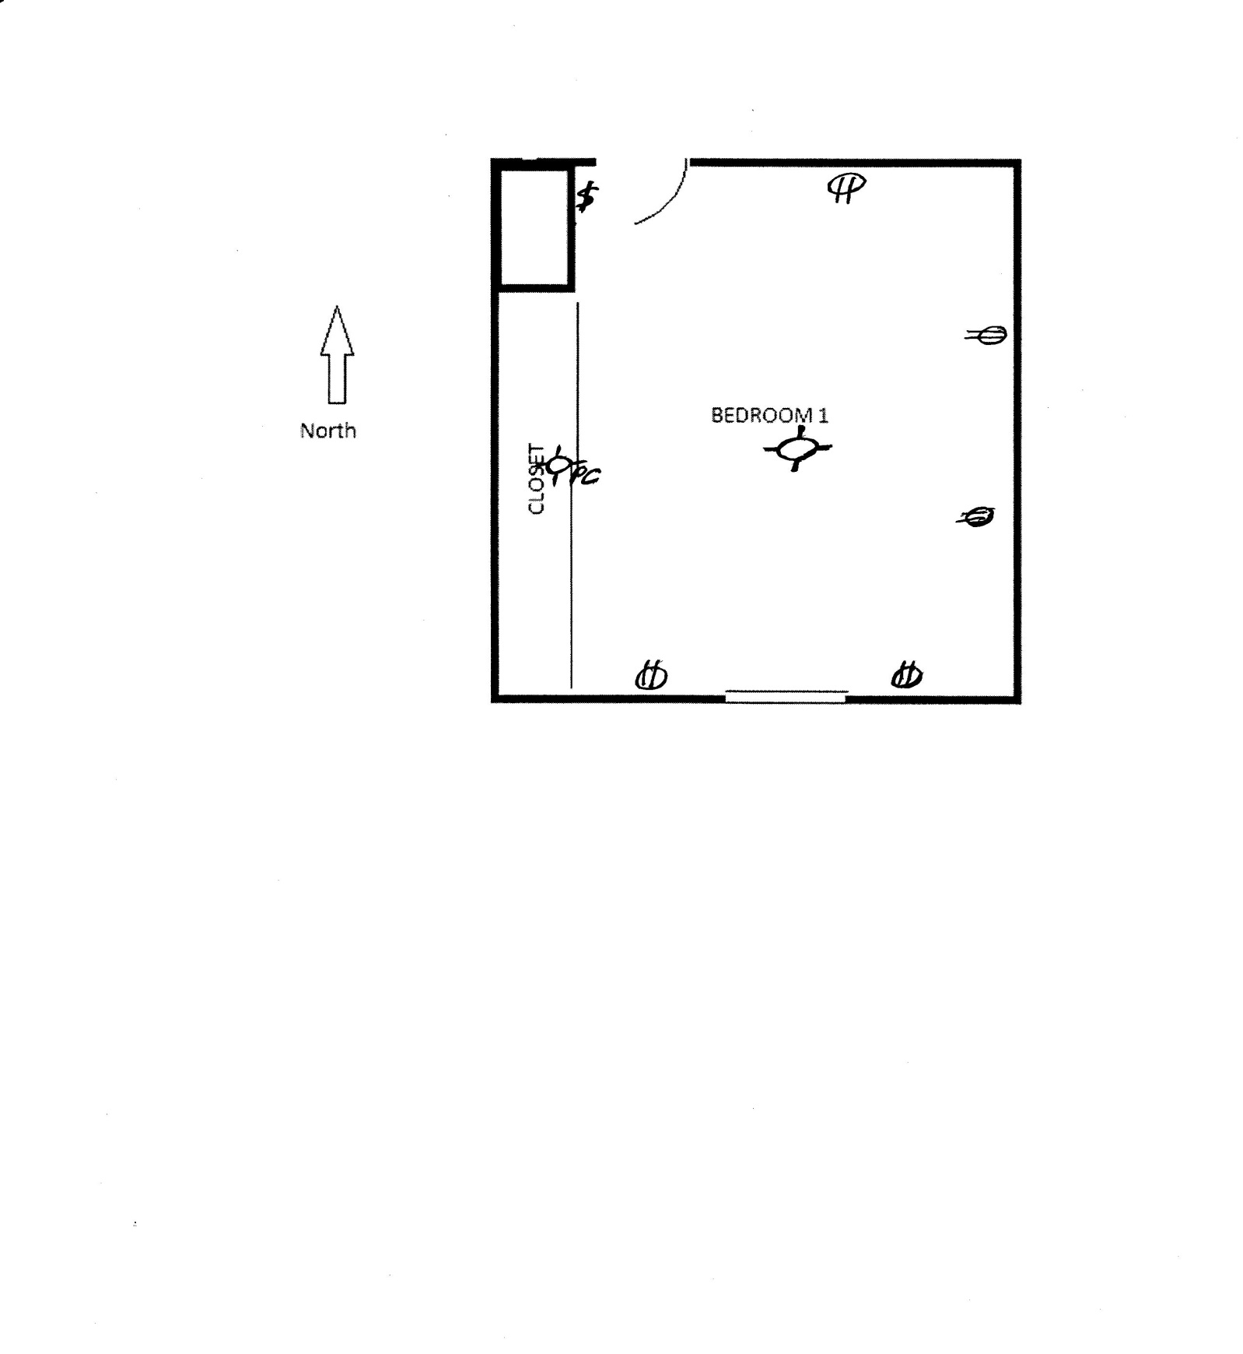

Task Title: Interpret and Create Drawings
Performance Descriptors |  | Needs Work | Completes task with support from practitioner | Completes task independently
A2.2 | - performs limited searches using one or two search criteria
 | - extracts information from tables and forms
 | - uses layout to locate information
 | - makes connections between parts of documents
 | - makes low-level inferences
A2.3 | - performs complex searches using multiple search criteria
 | - integrates several pieces of information from documents
 | - compares or contrasts information between two or more documents
 | - uses layout to locate information
 | - identifies the purpose and relevance of documents
 | - makes inferences and draws conclusions from information displays
 | - identifies sources, evaluates and integrates information
B2.1 | - writes simple texts to request, remind or inform
 | - conveys simple ideas and factual information
 | - demonstrates a limited understanding of sequence
 | - uses highly familiar vocabulary
B3.2a | - uses layout to determine where to make entries
 | - begins to make some inferences to decide what information is needed, where and how to enter the information
 | - makes entries using a limited range of vocabulary
 | - follows instructions on documents
B3.3a | - uses layout to determine where to make entries
 | - makes inferences to decide what, where and how to enter information

This task: was successfully completed___ needs to be tried again___

Learner Comments

____________________________ _________________________

Instructor (print) Learner Signature

