Task-based Activity Cover Sheet
Task Title: Interpret Circle Graph
Learner Name:

Date Started: Date Completed:

Successful Completion: Yes___ No___
Goal Path: Employment✓ Apprenticeship✓ Secondary School __ Post Secondary ___ Independence✓
Task Description:
Understand how to locate and compare information in a circle graph
Competency:  A: Find and Use Information  C: Understand and Use Numbers | Task Group(s):  A2: Interpret documents  C4: Manage data
Level Indicators:
A2.2: Interpret simple documents to locate and connect information
C4.1: Make simple comparisons and calculations
Performance Descriptors: see chart on last page or click here.
Links to skill building activities: see the last page or click here.
Materials Required:

ESKARGO:
Reading Strategies – Decoding and Comprehension Enhancement
- Uses knowledge of vocabulary and sight words related to specific forms, tables, graphs, maps and flow charts to obtain meaning
- Uses layout to locate information
- Uses context cues and personal experience to gather meaning from a document
- Scans to locate specific information
Forms and Conventions – Find Information/Research/Understand Types of Texts
- Skims to understand purpose and use of document
- Identifies basic parts of a form, table, simple graph and chart
- Uses various conventions of forms, tables, simple graphs, maps and flow charts to obtain meaning; i.e., layout, rows and columns, titles, headings and sub-headings, types of graphs, x and y-axis, legends, symbols and icons to comprehend and interpret data
- Performs limited searches using one or two search criteria
Comprehension – Read to Understand/Retell
- Locates multiple pieces of information in forms, tables, simple graphs, maps, flow charts
Interpretation – Read and Apply Understanding
- Interprets data from graphs (e.g., bar graphs, pictographs, and circle graphs)

Attitudes:
Practitioner,
We encourage you to talk with the learner about attitudes required to complete this task set. The context of the task has to be considered when identifying attitudes. With your learner, please check one of the following:
□ Attitude is not important □ Attitude is somewhat important □ Attitude is very important

Task Title: Interpret Circle Graph
Individuals and people working with food budgets use graphs to help them plan their budgets for the year. Look at the circle graph (or pie chart) Ontario Annual Food expenditures, 2012, Dollars per Household.
Learner Information and Tasks:

Task 1: Which Food Expenditure is the most amount of money spent on annually?

Task 2: Which Food Expenditure is the least amount of money spent on annually?

Task 3: Which Food Expenditures are the second and third most money spent on annually?

Statistics Canada collects and collates information for use by different organizations. These organizations take this information and use it to determine how best to serve Canadians. The chart represents the average cost of different foods a family may spend annually in their household in Ontario. This information may be used to determine the affordability of food versus the family income, which in turn will assist community agencies in addressing the needs in the community.

Graph 1 - Ontario Annual Food expenditures, 2012, Dollars per Household
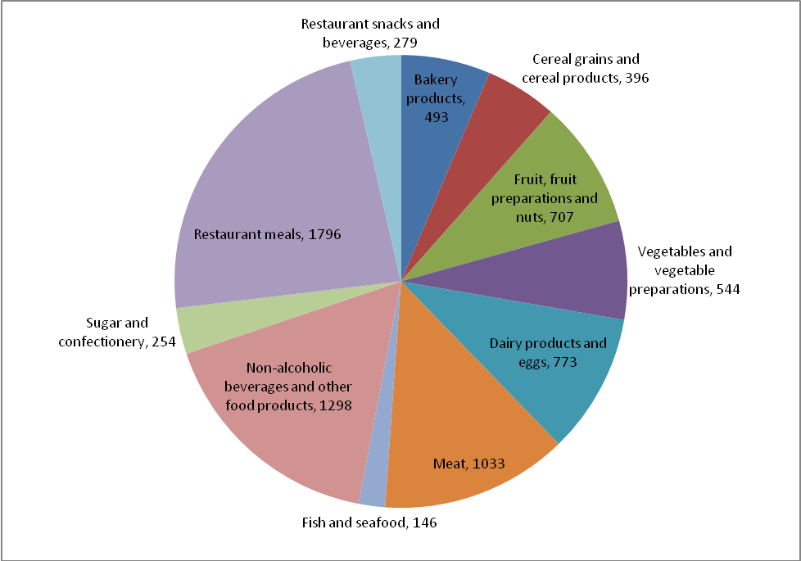
Statistics Canada

Task Title: Interpret Circle Graph
Answer Key
Task 1: Which Food Expenditure is the most amount of money spent on annually?
Restaurant Meals

Task 2: Which Food Expenditure is the least amount of money spent on annually?
Fish and Seafood
Sugar and Confectionary

Task 3: Which Food Expenditures are the second and third most money spent on annually?
Non-alcoholic beverages and other food products
Meat

Task Title: Interpret Circle Graph
Performance Descriptors |  | Needs Work | Completes task with support from practitioner | Completes task independently
A2.2 | - performs limited searches using one or two search criteria
A2.2 | - extracts information from tables and forms
A2.2 | - locates information in simple graphs and maps
A2.2 | - uses layout to locate information
A2.2 | - makes connections between parts of documents

This task: was successfully completed___ needs to be tried again___

Learner Comments

____________________________ _________________________

Instructor (print) Learner Signature

Skill Building Activities
Links to Online Resources:
Skill Plan’s, “Measure Up” - http://www.skillplan.ca/measure-up , (select “English”, “Choice of Activities”, “Practice”, “Document Use”, and “Graphics including graphs, maps, symbols, pictures”) – practise locating details and performing multiple searches in specialized documents that use a mix of graphics and text
Khan Academy – “Reading and Interpreting Data” - https://www.khanacademy.org/math/pre-algebra/applying-math-reasoning-topic – watch video tutorials to learn how to interpret graphical representations of data
GCF LearnFree – “Everyday Life” - http://www.gcflearnfree.org/everydaylife/edlall – play games (“Bus Map”, “Subway Map”, “Fire Plan”) to practise reading graphical representations of information
TV411 – “Reading: Understanding What You Read” - http://www.tv411.org/reading#understanding-what-you-read – Click on “Web Lessons” from the right side of screen; complete activities to learn various reading strategies: Reading Charts and Graphs

LearningHUB online courses available:

- Reading & Writing, Independent Study (assigned by practitioner after assessment)
  - Reading Level 2, Assignment 1
  - Reading Level 3 Assignment
  - Ready for College Reading, Assignment 3
*all assignments teach strategies for managing unfamiliar elements in texts, using layout to locate details, using pictures to aid comprehension, making inferences, and asking and answer questions while reading

- Essential Skills Independent Study (assigned by practitioner after assessment)
  - Document Use Level 1, Assignment 2 (reading charts, graphs, tables, and flowcharts)
  - Document Use Level 2, Assignment 2 (more on charts, graphs, and tables)

- Live Classes (SABA) – GED Social Studies, Parts 1-3; GED Science, Parts 1-3 (classes provide strategies for understanding questions with graphical information)

*To access LearningHUB courses, learners must register for the LearningHUB e-Channel program by completing the registration form on their website and completing the course selection (page 2 of the registration form): https://www.learninghub.ca/get_registered.aspx

*To Access LearningHUB Course Catalogue:
http://www.learninghub.ca/Files/PDF-files/HUBcoursecatalogue,%20December%2023,%202014%20revision.pdf

