OALCF Task Cover Sheet
Task Title: Kraft Dinner Ingredients
Learner Name:

Date Started: Date Completed:

Successful Completion: Yes___ No___
Goal Path: Employment___ Apprenticeship___ Secondary School  Post Secondary  Independence
Task Description:
The learner will examine the ingredient list on a Kraft Dinner box.
Competency:  A: Find and Use Information  B: Communicate Ideas and Information  D: Use Digital Technology | Task Group(s):  A2: Interpret documents  B3: Complete and create documents  D2: Use Digital Technology
Level Indicators:
A2.2: Interpret simple documents to locate and connect information
B3.2a: Use layout to determine where to make entries in simple documents
D2: Perform well-defined, multi-step digital tasks
Performance Descriptors: see chart on last page
Materials Required:
- Learner information and instructions (next page)
- Kraft Dinner Box ingredient list ( on Learner information and instructions page)
- Ingredients chart ( on two pages following Learner information and instructions)
- Pencil or pen (or computer with wordprocessor)
- Paper
- Computer with Internet search access

Task Title: Kraft Dinner Ingredients
Learner Information and Tasks:
For these tasks you will be examining the ingredients in Kraft Dinner.

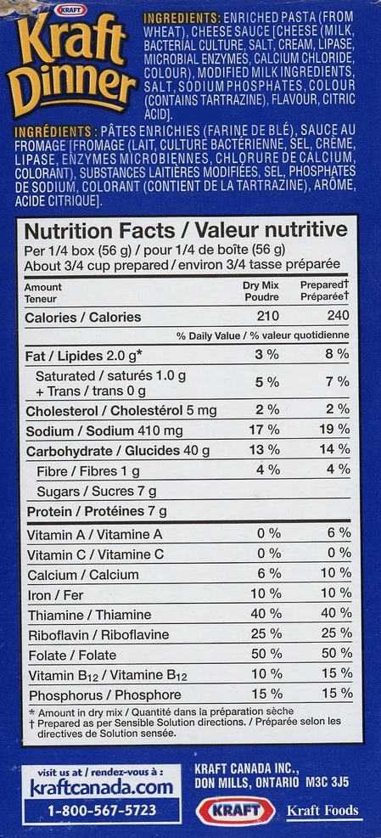
Task 1: Copy the list of ingredients from the Kraft Dinner box below, to the chart on the next two pages.
Task 2: Beside each ingredient check the food/nutrient group that it belongs to or what its purpose is in the product. Put a question mark beside those ingredients you do not know.
Task 3: Use the computer to research the ingredients that are not familiar to you and add the information to the chart.

Task Title: Kraft Dinner Ingredients
Ingredient | Food Group, Nutrient Group or Purpose
 | Fruits & veg | Grains | Milk | Meat | Salt | Sugar | Other - Give Purpose

Task Title: Kraft Dinner Ingredients
Answer Key
Task 1, 2 and 3:
Ingredient | Food Group, Nutrient Group or Purpose
 | Fruits & veg | Grains | Milk | Meat | Salt | Sugar | Other - Give Purpose
Enriched wheat pasta |  | ✓
Cheese – milk |  |  | ✓
Bacterial culture |  |  |  |  |  |  | Provides distinct flavouring and textural characteristics to cheese
Salt |  |  |  |  | ✓
Cream |  |  | ✓
Lipase |  |  |  |  |  |  | An enzyme added to milk to release flavour
Microbial enzymes |  |  |  |  |  |  | An enzyme used to coagulate milk so it can be separated into solids and liquid
Calcium chloride |  |  |  |  |  |  | Salt solution used in cheese making to restore the calcium balance
Colour |  |  |  |  |  |  | Provides colouring to the cheese
Modified milk ingredients |  |  | ✓
Salt |  |  |  |  | ✓
Sodium phosphate |  |  |  |  |  |  | Leavening agent to help the dough rise
Colour - tartrazine |  |  |  |  |  |  | A petroleum by product used to offset colour loss
Flavour |  |  |  |  |  |  | Provides flavouring for the cheese sauce
Citric acid |  |  |  |  |  |  | A preservative to maintain freshness and prevent food spoilage

Task Title: Kraft Dinner Ingredients
Performance Descriptors |  | Needs Work | Completes task with support from practitioner | Completes task independently
A2.2 | - Performs limited searches using one or two search criteria
 | - Extracts information from tables and forms
 | - Uses layout to locate information
 | - Makes low-level inferences
B3.2a | - Uses layout to determine where to make entries
 | - Begins to make some inferences to decide what information is needed, where and how to enter the information
D2 | - Selects and follows appropriate steps to complete tasks
 | - Locates and recognizes functions and commands
 | - Makes low-level inferences to interpret icons and text
 | - Begins to identify sources and evaluate information
 | - Performs simple searches using keywords (e.g. Internet, software help menu)

This task: was successfully completed___ needs to be tried again___

Learner Comments

____________________________ _________________________

Instructor (print) Learner Signature

