

Task Title: Mining Safety Part 2

# OALCF Cover Sheet – Practitioner Copy

**Learner Name:**

**Date Started:**

**Date Completed:**

|  |  |  |
| --- | --- | --- |
| **Goal Path:** | Employment | Apprenticeship |
| Secondary School | Post Secondary | Independence |

**Successful Completion:**  Yes No

**Task Description:**

Read a health and safety poster to understand Mining safety in workplace operations.

**Main Competency/Task Group/Level Indicator:**

* Find and Use Information/Interpret documents/A2.2
* Understand and Use Numbers/Manage data/C4.1

**Materials Required:**

* Pen/pencil and/or digital device

# Learner Information

The mining industry is made up of various occupations which include driving different pieces of equipment on and off the jobsite. In all occupations there is a focus on safety on the job. Scan the **Workplace Health and Safety Snapshot for Ontario Mining Sector in 2022.**

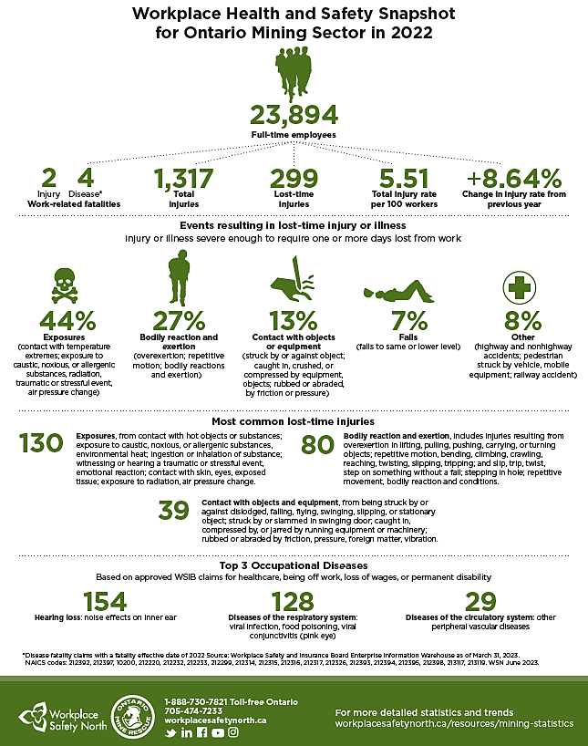

# Work Sheet

**Task 1: How many full-time employees are there in the Ontario Mining Sector?**

Answer:

**Task 2: What are the 3 most common lost time injuries?**

Answer:

**Task 3: What is considered a lost time injury?**

Answer:

**Task 4: List two ways an exposure injury can occur.**

**Task 5: Calculate the total number of Top 3 Occupational Diseases.**

**Task 6: What is the change in injury rate from the previous year?**

# Answer Sheet

**Task 1: How many Full-time employees are there in the Ontario Mining Sector?**

Answer: 23,894

**Task 2: What are the 3 most common lost time injuries?**

Answer

* Exposures
* Bodily reaction and exertion
* Contact with objects or equipment

**Task 3: What is considered a lost time injury?**

Answer: Injury or illness severe enough to require one or more days lost from work

**Task 4: List two ways an exposure injury can occur.**

Answer: Any two of the following:

* Contact with temperature extremes
* Exposure to caustic, noxious or allergenic substances
* Radiation
* Traumatic or stressful event
* Air pressure change

**Task 5: Calculate the total number of Top 3 Occupational Diseases.**

Answer: 154 + 128 + 29 = 311

**Task 6: What is the change in injury rate from the previous year?**

Answer: +8.64%

Performance Descriptors

| Levels | Performance Descriptors | Needs Work | Completes task with support from practitioner | Completes task independently |
| --- | --- | --- | --- | --- |
| A2.2 | Performs limited searches using or two search criteria |  |  |  |
| A2.2 | Extracts information from tables and forms |  |  |  |
| A2.2 | Uses layout to locate information |  |  |  |
| C4.1 | Adds, subtracts, multiplies and divides whole numbers and decimals |  |  |  |
| C4.1 | Begins to interpret integers |  |  |  |

This task: Was successfully completed Needs to be tried again

Learner Comments:

Instructor (print): Learner (print):