OALCF Task Cover Sheet
Task Title: Writing an Informal Letter or Email to a Friend
Learner Name:

Date Started: Date Completed:

Successful Completion: Yes___ No___
Goal Path: Employment___ Apprenticeship___ Secondary School___ Post Secondary___ Independence✓
Task Description:
It’s important to have proper formatting, grammar and spelling in letters, even when they are informal letters to a friend or family member. This task allows the learner to write an informal letter, using proper formatting, spelling and grammar.
Competency:  - Find and Use Information  B. Communicate Ideas and Information | Task Group(s):  A2: Interpret documents  B2: Write continuous text  B4: Express oneself creatively
Level Indicators:
A2.1: Interpret very simple documents to locate specific details
B2.2: Write texts to explain and describe information and ideas
B4: n/a

Performance Descriptors: see chart on last page
Materials Required:
- Sample Informal Letter
- Pen or pencil, paper or
- Computer with word processing program

Instructor’s preparation: Decide if the learner will be writing on paper or typing using a computer. This task should be used following instruction that has occurred about letter formatting, spelling and grammar.
Task Title: Writing an Informal Letter
It’s important to have proper formatting, grammar and spelling in letters, even when they are informal letters to a friend or family member.
Task 1: Identify someone who you would like to write a letter to. Identify the purpose for the letter.

Task 2: Organize your thoughts by writing a list of things you want to make sure you include in the letter. You might want to express your thanks for something. You might want to make plans with the person. Or, you might want to update them about your life. Maybe you want to do all three!

Task 3: Look at the Sample Informal Letter to see the format to use for your letter.

Task 4: Write a three-paragraph letter to the person. Refer to the list you made in Task 2 to make sure you include everything you want. Follow the format as shown in the Sample Informal Letter.
Sample Informal Letter
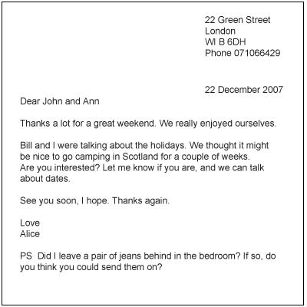
Task Title: Writing an Informal Letter
Performance Descriptors |  | Needs Work | Completes task with support from practitioner | Completes task independently
A2.1 | - scans to locate specific details
B2.2 | - writes texts to explain and describe
 | - conveys intended meaning on familiar topics for a limited range of purposes and audiences
 | - begins to sequence writing with some attention to organizing principles (e.g. time, importance)
 | - connects ideas using paragraph structure
 | - uses limited range of vocabulary and punctuation appropriate to the task
 | - begins to select words and tone appropriate to the task
 | - begins to organize writing to communicate effectively
B4 | n/a

This task: was successfully completed___ needs to be tried again___

Learner Comments

____________________________ _________________________

Instructor (print) Learner Signature

