OALCF Task Cover Sheet
Task Title: Non-Refundable Fees
Learner Name:

Date Started: Date Completed:

Successful Completion: Yes___ No___
Goal Path: Employment √ Apprenticeship___ Secondary School___ Post Secondary √ Independence___

Task Description:
Administrative Clerks in colleges complete and process forms when they collect fees from students.
Competency:  A: Find and Use Information  C: Understand and Use Numbers | Task Group(s):  A2: Interpret Documents  C1: Manage money
Level Indicators:
A2.1: Interpret very simple documents to locate specific details
A2.2: Interpret simple documents to locate and connect information
C1.1: Compare costs and make simple calculations
Performance Descriptors: see chart on last page

Materials Required:
- Pencil/pen
- Non-Refundable Fees Tasks Sheet and Document

Non-Refundable Fees
Administrative Clerks in colleges complete and process forms when they collect fees from students. Look at the Non-Refundable Fees form.

Task 1 What program is the student taking?

Task 2 The student, Cathy Lee, wants to pay using her husband’s credit card.
Enter the following information on the form:
Master Card
John Lee
Expiry 07/09

Task 3 Cathy needs four transcripts to include with her resume. Calculate the total cost of the transcript duplicates.

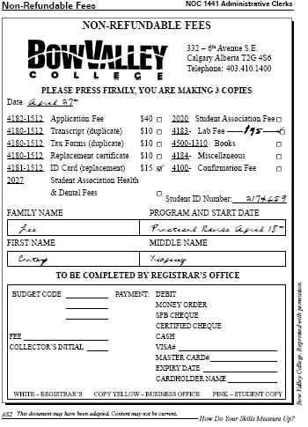

Non-Refundable Fees

Answer Key
5484 4567 XXXX 1234
07/09
John Lee

Task 1 Practical Nurse

Task 2 image on right

Task 3 $40.00

Task Title: Non-Refundable Fees
Performance Descriptors |  | Needs Work | Completes task with support from practitioner | Completes task independently
A2.1: | - scans to locate specific details
 | - interprets brief text and common symbols
 | - locates specific details in simple documents, such as labels and signs
A2.2 | - Extracts information from tables and forms
 | - Uses layout to locate information
 | - Makes connections between parts of documents
 | - Makes low-level inferences
C1.1 | - adds, subtracts, multiplies and divides whole numbers and decimals
 | - recognizes values in number and word format
 | - identifies and performs required operation
 | - interprets and represents costs using monetary symbols and decimals

This task: was successfully completed___ needs to be tried again___

Learner Comments

____________________________ _________________________

Instructor (print) Learner Signature

