 Task-based Activity Cover Sheet
Task Title: Ontario Protected Deposits – What’s Covered - 2
Learner Name:

Date Started: Date Completed:

Successful Completion: Yes □ No □
Goal Path: Employment □ Apprenticeship □ Secondary School □ Post-Secondary □ Independence X
Task Description:
Learners will complete tasks based on what is covered under Ontario Protected Deposits.
Competency:  A: Find and Use Information  C: Understand and Use Numbers | Task Group(s):  A2: Interpret Documents  C1: Manage Money
Level Indicators:
A2.2: Interpret simple documents to locate and connect information
C1.1: Compare costs and make simple calculations

Performance Descriptors: see chart on last page
Materials Required:
- Pencil or pen (calculator – instructor decision)

Task Title: Ontario Protected Deposits – What’s Covered
The Deposit Insurance Corporation of Ontario (DICO) is an Ontario Provincial Agency established under the Credit Unions Act. DICO’s role is to protect depositors of Ontario credit unions from loss of their deposits. Look at “Who Is Covered?”
Learner Information and Tasks:
Task 1: Depositor Rachel has deposits of $108,000. Why is $8,000 not insured?

Task 2: Depositor Rachel, RRSP has Term Deposits, Index-linked Term Deposits and Mutual Funds that total $205,000. Why is only $190,000 insured?

Task 3: Depositor John has over $30,000 in various accounts. Why is only $27,000 insured?

Task 4: Another customer has
- $2,500 in Savings Accounts
- $25,000 in Mutual Funds
- $124,000 in RRSP Accounts
Calculate how much of this customer’s deposits are insured.

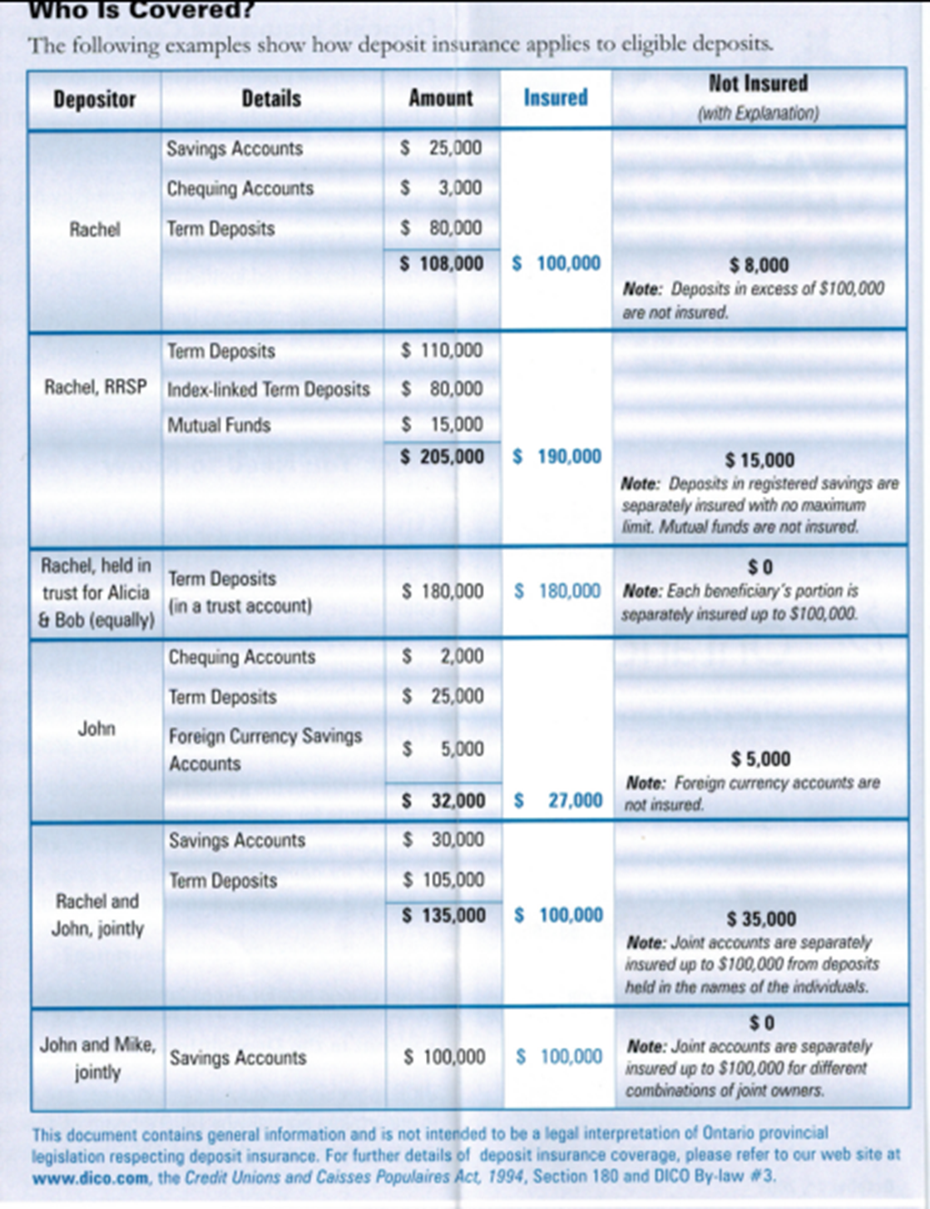
Task Title: Ontario Protected Deposits – What’s Covered
Answer Key
Task 1: Depositor Rachel has deposits of $108,000. Why is $8,000 not insured?
A: deposits in excess of $100,000 are not insured
Task 2: Depositor Rachel, RRSP has Term Deposits, Index-linked Term Deposits and Mutual Funds that total $205,000. Why is only $190,000 insured?
A: Mutual funds are not insured
Task 3: Depositor John has over $30,000 in various accounts. Why is only $27,000 insured?
A: Foreign currency accounts are not insured
Task 4: Another customer has
- $2,500 in Savings Accounts 
- $25,000 in Mutual Funds X
- $124,000 in RRSP Accounts 
Calculate how much of this customer’s deposits are insured.
A: 124,000 + 2,500 = $126,500
Task Title: Ontario Protected Deposits – What’s Covered
Performance Descriptors |  | Needs Work | Completes task with support from practitioner | Completes task independently
A2.2 | - performs limited searches using one or two search criteria
A2.2 | - extracts information from tables and forms
A2.2 | - uses layout to locate information
C1.1 | - adds, subtracts, multiplies and divides whole numbers and decimals
C1.1 | - identifies and performs required operation
C1.1 | - follows apparent steps to reach solutions

This task: was successfully completed □ needs to be tried again □

Learner Comments

____________________________ _________________________

Instructor (print) Learner Signature

