Task Title: Check the Temperature on an Outdoor Thermometer
Learner Name:

Date Started: Date Completed:

Successful Completion: Yes___ No___
Goal Path: Employment__ Apprenticeship__ Secondary School__ Post Secondary__ Independence ✓
Task Description:
Check the temperature on various outdoor thermometers
Competency:  C: Understand and Use Numbers | Task Group(s):  C3: Use measures
Level Indicators:
C3.1: Measure and make simple comparisons and calculations
Performance Descriptors: see after answer key or click here
Links to skill building activities: see the last page or click here
Skill Building Activities: see the list
Materials Required:
- pencil/pen, eraser
ESKARGO:
- Demonstrates understanding of standard units of measurement for temperature
- Subtracts whole numbers by borrowing
- Begins to interpret integers
- Chooses appropriate units of measurement
- Indentifies and performs required operation
- Follows apparent steps to reach solutions
Attitudes:
Practitioner,
We encourage you to talk with the learner about attitudes required to complete this task set. The context of the task has to be considered when identifying attitudes.
With your learner, please check one of the following:
___Attitude is not important ___ Attitude is somewhat important ___ Attitude is very important

Task Title: Check an Outdoor Thermometer
Individuals use outdoor thermometers to check what the temperature is outside.
Learner Information and Tasks:

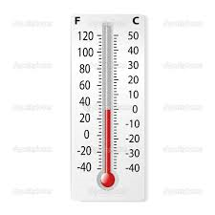
Task 1:

What is the temperature in Celsius outside?

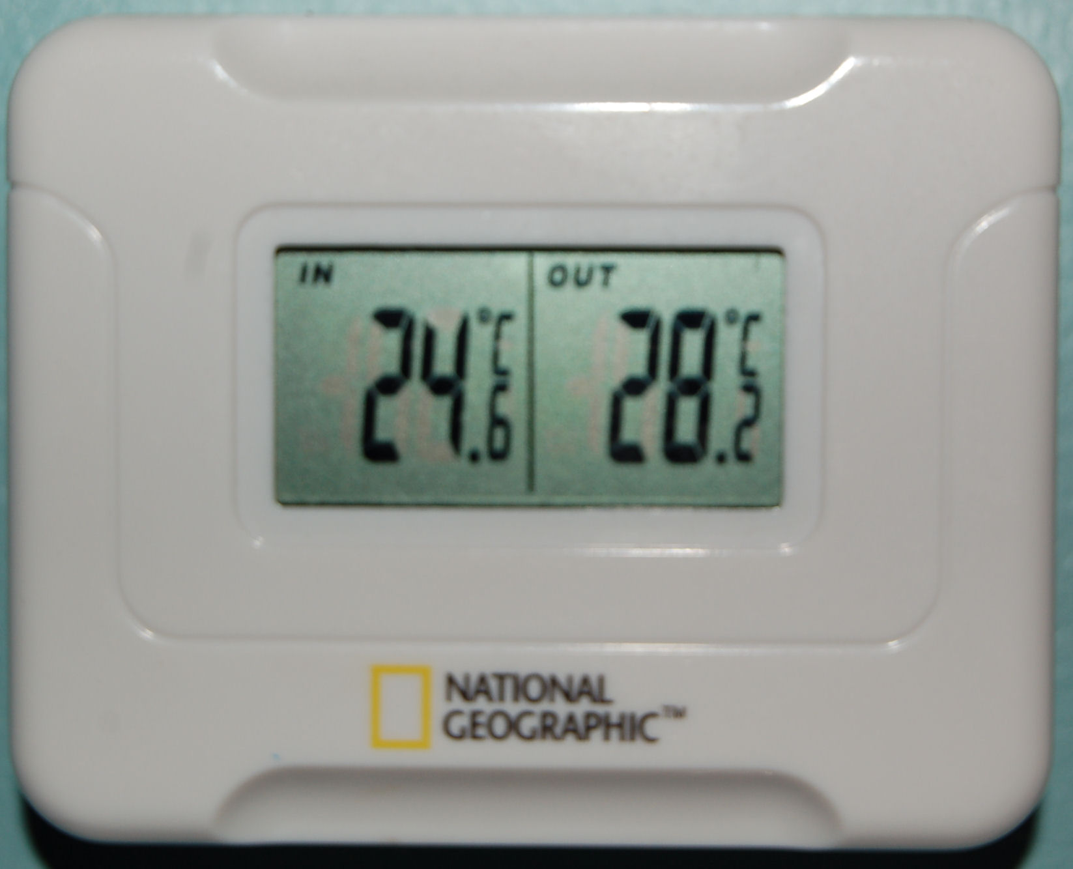

Task 2: What is the temperature outdoors on this digital thermometer?

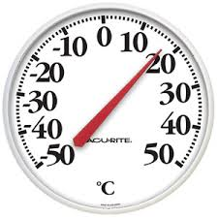
Task 3: What is the temperature outdoors on this thermometer?

Task 4: In the summer, Toronto sometimes has a high of 27 °C. On the same day, Toronto may have a low of 19 °C.

a. Draw a line on the thermometer on the left to show the high of 27 °C.
b. Draw a line on the thermometer on the right to show the low of 19 °C.
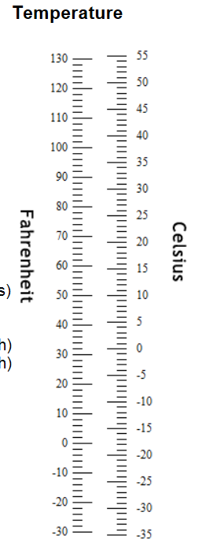
a. b.

Task 5: Calculate the difference between the high (27C )and the low (19C) in Toronto.

Task Title: Check an Outdoor Thermometer
Answer Key
Task 1: What is the temperature in Celsuis outside?
0°C
Task 2: What is the temperature outdoors on this digital thermometer?
28.2°C or 28°C
Task 3: What is the temperature outdoors on this thermometer?
17°C although an answer of 16 or 18 could still be considered “close enough”
Task 4: a. Draw a line on the thermometer on the left to show the high of 27 °C.
b. Draw a line on the thermometer on the right to show the low of 19 °C.
a. b.

Task 5: Calculate the difference between the high (27C )and the low (19C) in Toronto.
8°C or 8 (27-19=8)

Task Title: Check an Outdoor Thermometer
Performance Descriptors |  | Needs Work | Completes task with support from practitioner | Completes task independently
C3.1 | - subtracts whole number measurements
 | - measures temperature
 | - uses common measuring tools, such as thermometers
 | - begins to interpret integers (e.g. temperature, elevation)
 | - chooses appropriate units (e.g. metres, inches) and non-standard units (e.g. paces, cupfuls, scoops)
 | - identifies and performs required operation
 | - interprets and represents measures using symbols and abbreviations (e.g. inches as “, centimeters as cm, pounds as lbs, kilograms as kilos or kg)
 | - follows apparent steps to reach solutions

This task: was successfully completed___ needs to be tried again___

Learner Comments

____________________________ _________________________

Instructor (print) Learner Signature

Skill Building Activities

Activity 1: There are two different ways to talk about or write temperature. Match the symbol to the correct type of temperature.
a. Fahrenheit °C
b. Celsuis °F
Activity 2: In Canada, both Fahrenheit and Celsuis are used. However, Celsuis is metric and metric is the official method. Circle the correct symbol on this thermometer.

Links to online resources:
- Comparing Celsius and Fahrenheit Temperature Scales:
https://www.khanacademy.org/math/pre-algebra/rates-and-ratios/farenheit-celsius-conversion/v/comparing-celsius-and-farenheit-temperature-scales
A 3 minute tutorial provided by Khan Academy on “Comparing Celsius and Fahrenheit Temperature Scales” using a thermometer.
- Subtraction: https://www.mathsisfun.com/numbers/subtraction.html
This link offers great visuals to help explain subtraction. There are several tools and concepts used to understand this math operation. Please note the “Names” section that identifies key words related to subtraction and the online “Worksheets” available for extra practice.
- Signed Integers: http://www.math.com/school/subject1/lessons/S1U1L10GL.html
Integers defined. By clicking on the “Next” button, examples and practice questions are available.
- Reading a Thermometer: https://www.youtube.com/watch?v=saSah6kLGOc
LearningHUB Courses Available:
- Live Classes (SABA) – Math Stories
- Math, Independent Study – 101 Addition & Subtraction, Assignments 1 & 2, 401 Measurement (assigned by practitioner following assessment)
*To access LearningHUB courses, learners must register for the LearningHUB e-Channel program by completing the registration form on their website and completing the course selection (page 2 of the registration form): https://www.learninghub.ca/get_registered.aspx
*To Access LearningHUB Course Catalogue: http://www.learninghub.ca/Files/PDF-files/HUBcoursecatalogue,%20December%2023,%202014%20revision.pdf

