OALCF Task Cover Sheet

Task Title: Paying Household Bills

Learner Name:

Date Started: Date Completed:

Successful Completion: Yes___ No___
Goal Path: Employment ___ Apprenticeship___ Secondary School___ Post Secondary___ Independence √
Task Description:
The learner needs to write cheques for household bills and track monthly expenses.
Competency:  A: Find and Use Information  B: Communicate Ideas and Information  C: Understand and Use Numbers | Task Group(s):  A1: Read continuous text  A2: Interpret documents  B2: Write continuous text  C1 : Manage Money
Level Indicators:
A1.1: Read brief texts to locate specific details
A2.1: Interpret very simple documents to locate specific details
A2.2: Interpret simple documents to locate and connect information
B3.1a: Make straightforward entries to complete very simple documents
C1.1: Compare costs and make simple calculations
C1.2: Make low-level inferences to calculate costs and expense that may include rates such as taxes and discounts
C1.3: Find, integrate and analyze numerical information to make multi-step calculations to compare cost options and prepare budgets
Performance Descriptors: see chart on last page
Materials Required:
- Paper and Pen
- Electricity, Phone, Water, and Cable Bills (attached)
- Cheques and Transaction record (attached)
- Question Sheet

Task Title: Paying Household Bills

Task Description: Learners on the Independence Path will need to read household bills and write cheques for each amount. To keep track of their funds they should also record each transaction onto monthly registers and calculate balances.

Learner Instructions:

Task 1: On the following pages are Veena’s monthly bills for:
- Phone
- Water
- Electricity
- Cable

In addition to the above bills, Veena pays monthly rent of $578 to Reynolds Corporation.
She pays her bills by cheque. Write cheques for the bills and rent. When signing the cheques, use the name Veena Hamilton and today’s date.

Task 2:
Record the amount of each cheque you wrote in Task 1 in the Record of Cheques and Monthly Budget. The beginning balance is $3,465.00. For each entry remember to calculate the new balance.

Global Phone  Veena Hamilton |  | 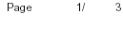
 |  | Account Number 416-225-8448
 |  | Bill date: May 4, 2005

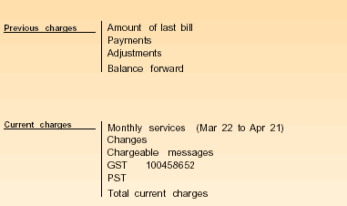
64.34
63.34cr
.00
.00

49.64
.00
5.10
3.84
4.08
62.66

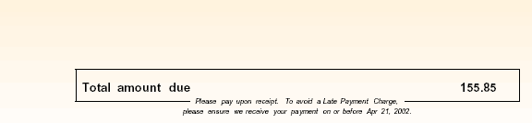 | 62.66
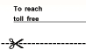

Electricity Bill

Customer: Veena Hamilton

Meter Number | Bill for: | Days | Current meter reading | Previous meter reading |  | Kilowatt Hours Used
0126923 | Oct 2/03 – Nov 2/03 | 31 | 88472 | 87691 |  | 781
 | Customer Charge 14.97
 | *Delivery charge @ $.03 /KWH 23.43
 | Debt retirement charge @$.007/KWH 5.47
 | Electricity Charge @ $.043/KWH 33.58
 | Water Heater Rental 7.00

Total 84.45
GST 5.91

 | Total $90.36
Due Date: | Dec 4/03
*includes distribution, transmission and wholesale operations charges

 | WATER Bill |  |  | Account # |  |  | Meter #
 |  |  |  | 000037788 8988 |  |  | 12577008
Make cheque payable to:  Treasurer, City of Tonto  Mail to: Treasurer,  Box 600  Tonto, Ontario  M5L 5L6 |  |  |  |  |  |  | Amount Paid
 |  |  |  | Client
 |  |  |  | Veena Hamilton |  |  | Payable Before
 |  |  |  |  |  |  | $43.76
 |  |  |  |  |  |  | Due Date
For enquiries pertaining to your account call 444-2323 |  |  |  |  |  |  | 27/Sep/2004
 |  |  |  |  |  |  | Payable after
 |  |  |  |  |  |  | $46.06
 |  |  |  | Please return this portion with your payment
WATER Bill |  |  |  |  | Account # |  |  |  | Meter #
 |  |  |  |  | 000037788 8988 |  |  |  | 12577008
Current Reading Date |  |  | Reading |  | Client
02/Aug/2004 |  |  | 868890.00 |  | Veena Hamilton
Previous Reading Date |  |  | Reading |  |  |  |  | Payable Before
29/Mar/2004 |  |  | 861056.00 |  |  |  |  | $43.76
Total Consumption |  |  |  |  |  |  |  | Due Date
7834 gallons |  |  |  |  |  |  |  | 27/Sep/2004
 |  | Description |  |  |  |  |  | Payable after
 |  |  |  | Last billing | $37.78 |  |  | $46.06
Payment (thank you) |  |  |  |  | -$37.78
 |  |  |  | Previous Balance | $0.00
 |  |  |  | Current Billing
Total 7834 gallons @ .00588 |  |  |  |  | $46.06
Total Current Billing (incl. previous balance) |  |  |  |  | $46.06
 |  |  |  | Keep this portion for your records

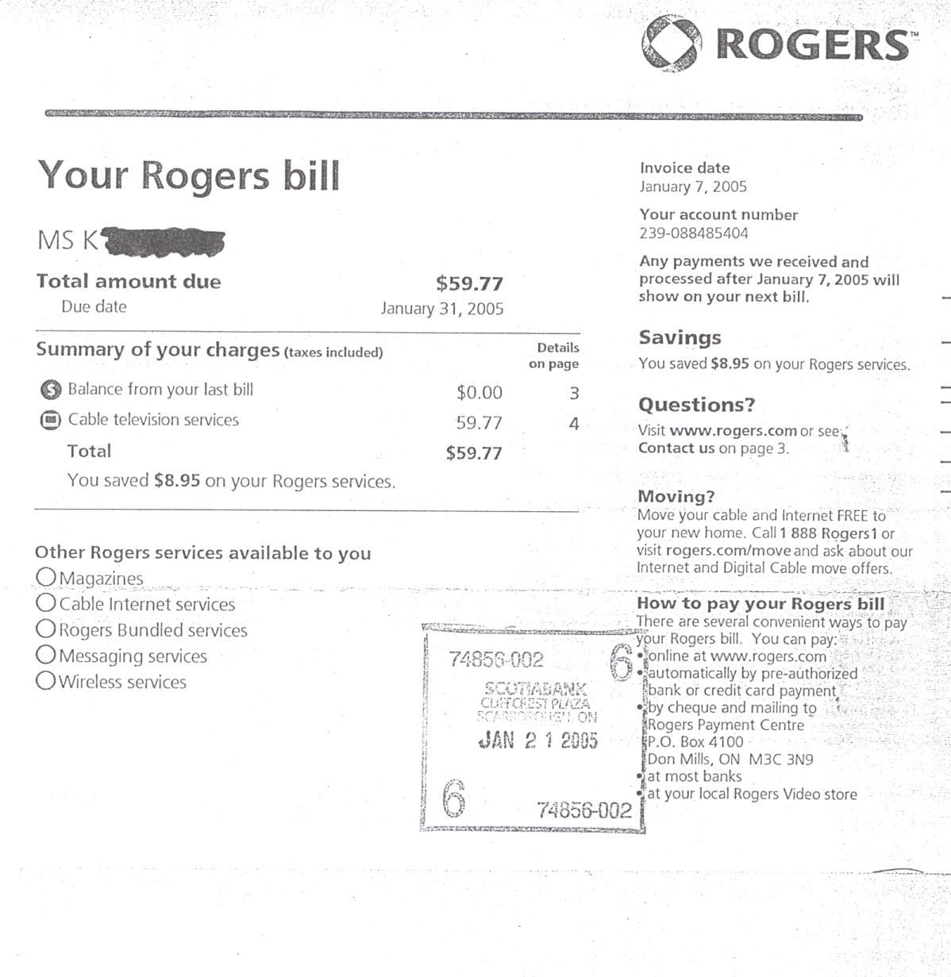

Veena Hamilton

Paul’s Cable

Your Paul’s Bill
Other services
Paul’s Bundled services

Cheques

 | Veena hamilton  777 Any Street  Toronto, Ontario |  |  |  |  |  |  |  |  |  | 598
 |  |  |  |  | Date
 | Pay to the  Order of |  |  |  |  |  | $
 |  |  |  |  |  |  |  | 100 Dollars
 | Memo

 | Veena hamilton  777 Any Street  Toronto, Ontario |  |  |  |  |  |  |  |  |  | 599
 |  |  |  |  | Date
 | Pay to the  Order of |  |  |  |  |  | $
 |  |  |  |  |  |  |  | 100 Dollars
 | Memo

 | Veena hamilton  777 Any Street  Toronto, Ontario |  |  |  |  |  |  |  |  |  | 600
 |  |  |  |  | Date
 | Pay to the  Order of |  |  |  |  |  | $
 |  |  |  |  |  |  |  | 100 Dollars
 | Memo
 | Veena hamilton  777 Any Street  Toronto, Ontario |  |  |  |  |  |  |  |  |  | 601
 |  |  |  |  | Date
 | Pay to the  Order of |  |  |  |  |  | $
 |  |  |  |  |  |  |  | 100 Dollars
 | Memo

 | Veena hamilton  777 Any Street  Toronto, Ontario |  |  |  |  |  |  |  |  |  | 602
 |  |  |  |  | Date
 | Pay to the  Order of |  |  |  |  |  | $
 |  |  |  |  |  |  |  | 100 Dollars
 | Memo

 | Veena hamilton  777 Any Street  Toronto, Ontario |  |  |  |  |  |  |  |  |  | 603
 |  |  |  |  | Date
 | Pay to the  Order of |  |  |  |  |  | $
 |  |  |  |  |  |  |  | 100 Dollars
 | Memo

Record of Cheques and Monthly Budget record
Check No. | Date | Payment/Deposit | Check amount  - |  | Amount of deposit  + |  | Balance
 |  |  |  |  |  |  | $3,465 | 00

Answer Key

Record of Cheques and Monthly Budget record
Check No. | Date | Payment/Deposit | Check amount  - |  | Amount of deposit  + |  | Balance
 |  |  |  |  |  |  | $3,465 | 00
1 | Jan 15 | Phone | 62 | 66 |  |  | $3,402 | 44
2 | Jan 15 | Electricity | 90 | 36 |  |  | $3,311 | 98
3 | Jan 15 | water | 43 | 76 |  |  | $3,268 | 22
4 | Jan 15 | cable | 59 | 77 |  |  | $3,208 | 45
5 | Feb 1 | rent | 578 | 00 |  |  | $2,630 | 45

Task Title: Paying Household Bills

Performance Descriptors |  | Needs Work | Completes task with support from practitioner | Completes task independently
A1.1: | - Reads short texts to locate a single piece of information
A2.1: | - Scans to locate specific details
 | - Interprets brief text and common symbols
A2.2: | - Makes low-level inferences
B3.1a: | - Makes a direct match between what is requested and what is entered
C1.1: | - Interprets and represents costs using monetary symbols and decimals
C1.2: | - Represents costs and rates using monetary symbols, decimals and percentages
 | - Uses strategies to check accuracy (e.g. estimating, using a calculator, repeating a calculation, using the reverse operation)
C1.3: | - Finds, integrates, and analyses numerical information (e.g. tables, graphs)
 | - Uses strategies to check accuracy (e.g. estimating, using a calculator, repeating a calculation, using the reverse operation)
This task: was successfully completed___ needs to be tried again___

Learner Comments

____________________________ _________________________

Instructor (print) Learner Signature

