OALCF Task Cover Sheet
Task Title: How to use a POS (Point of Service) touch screen terminal
Learner Name:

Date Started: Date Completed:

Successful Completion: Yes___ No___
Goal Path: Employment ✓ Apprenticeship___ Secondary School Post Secondary Independence___
Task Description:
Using a POS in a restaurant.
Competency:  A: Find and Use Information  C: Understand and Use Numbers | Task Group(s):  A2: Interpret Documents  C1: Manage Money
Level Indicators:
A2.2: Interpret simple documents to locate and connect information
C1.1: Compare costs and make simple calculations
Performance Descriptors: see chart on last page
Materials Required:
- Pen/Pencil
- POS handout
- Question sheet

Task Title: How to use a POS (Point of Service) touch screen terminal.
To work in the service industry, you may need to use a POS (sometimes called Point Of Service or Point of Sale) terminal to serve your customers. This is a hand held computer, with a screen that you can touch to select specific things. This machine will help you take orders, send orders to the kitchen and help giving customers their bill. Look at the document “POS (Point of Service).”
Learner Information and Tasks:
Task 1: What 3 hot drinks can be served?

Task 2: What are the names of the two taxes that are charged to the TOTAL cost the customer must pay?

Task 3: Circle, highlight or underline the subtotal of the bill.

Task 4: A customer would like to order two coffees. How much will it cost them?

Task 5: A customer wants a healthier drink. What are 3 juices that can be served?

Task 6: A customer is ready to pay their bill. Circle a button that will allow them to pay.

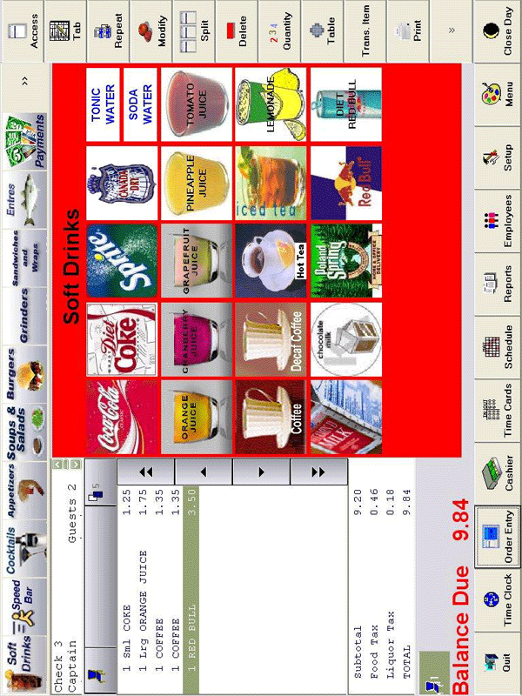
Task Title: How to use a POS (Point of Service) touch screen terminal
Answer sheet
Task 1: Coffee, Decaf Coffee, Hot Tea
Task 2: Food Tax, Liquor Tax
Task 3: $9.20
Task 4: $2.70
Task 5: 3 choices from the following:
- Orange,
- Cranberry
- Grapefruit
- Pineapple
- Tomato Juice

Task 6: Yes. Sandwiches, wraps and salads.
Task 7: Student must have circled the tab/button marked ‘Payments’ or ‘Cashier’.
Task Title: How to use a POS (Point of Service) touch screen terminal
Performance Descriptors |  | Needs Work | Completes task with support from practitioner | Completes task independently
A2.2 | - performs limited searches using one or two search criteria
 | - extracts information from tables and forms
 | - locates information in simple graphs and maps
 | - uses layout to locate information
 | - makes connections between parts of documents
 | - makes low-level inferences
C1.1 | - Adds and subtracts whole numbers and decimals
 | - Understands numerical order
 | - Recognizes values in number and word format
 | - Identifies and performs required operation
 | - Follows apparent steps to reach solutions
 | - Interprets and represents costs using monetary symbols and decimals

This task: was successfully completed___ needs to be tried again___

Learner Comments

___________________________ _________________________

Instructor (print) Learner Signature

