

Task Title: Air Conditioner Installation

# OALCF Cover Sheet – Practitioner Copy

**Learner Name: __________________________________________**

**Date Started: ___________________________________________**

**Date Completed: _________________________________________**

|  |  |  |
| --- | --- | --- |
| **Goal Path:** | Employment | Apprenticeship |
| Secondary School | Post Secondary | Independence |

**Successful Completion:**  Yes No

**Task Description:** The learner will read an excerpt from an air conditioning installation manual and answer questions.

**Main Competency/Task Group/Level Indicator:**

* Find and Use Information/Interpret documents/A2.2

**Materials Required:**

* Pen/pencil and paper and/or digital device

# Learner Information

Heating, Ventilation, and Air Conditioning (HVAC) technicians use manuals to install, repair and troubleshoot problems with air conditioning units.

Scan the excerpts from the air conditioner installation manual “Lennox Installation Instructions Signature Collection CBX40UHV Units”.

**Lennox Installation Instructions Signature Collection**

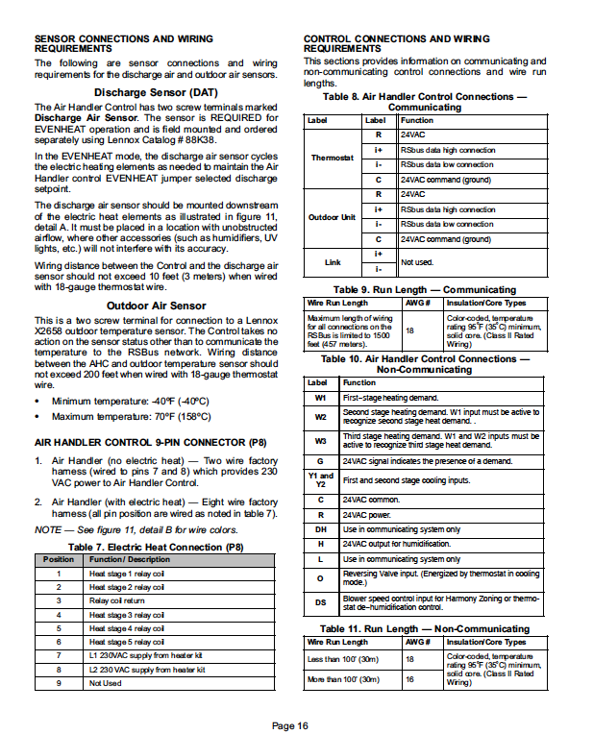**CBX40UHV Units**

# 

# Work Sheet

**Task 1: List two requirements when mounting the discharge air sensor.**

Answer:

**______________________________________________________**

**Task 2: Which position is the electric heat connection in when it is a “heat stage 5 relay coil”?**

Answer:

**______________________________________________________**

**Task 3: List three error codes that occur because of the indoor blower.**

Answer:

**______________________________________________________**

**Task 4: Under which circumstances would error codes 401 to 409 be displayed?**

Answer:

**______________________________________________________**

# Answers

**Task 1: List two requirements when mounting the discharge air sensor.**

Answer: The discharge air sensor should be mounted downstream of the electric heat elements. It must be placed in a location with unobstructed airflow, where other accessories will not interfere with its accuracy.

**Task 2: Which position is the electric heat connection in when it is a “heat stage 5 relay coil”?**

Answer: Position 6

**Task 3: List three error codes that occur because of the indoor blower.**

Answer: Any three of the following: E 201, E292, E295, E312

**Task 4: Under which circumstances would error codes 401 to 409 be displayed?**

Answer: These error codes are only displaced when the AHC L terminal is connected to a non-communicating outdoor unit’s LSOM device.

# Performance Descriptors

| Levels | Performance Descriptors | Needs Work | Completes task with support from practitioner | Completes task independently |
| --- | --- | --- | --- | --- |
| A2.2 | Performs limited searches using one or two search criteria |  |  |  |
|  | Extracts information from tables and forms |  |  |  |
|  | Uses layout to locate information |  |  |  |
|  | Makes connections between parts of documents |  |  |  |
|  | Makes low-level inferences |  |  |  |
|  | Begins to identify sources and evaluate information |  |  |  |

This task: Was successfully completed Needs to be tried again

Learner Comments:

Instructor (print): Learner (print):

**__________________ _________________**