

Task Title: Applying for a Canadian Passport

# OALCF Cover Sheet – Practitioner Copy

**Learner Name: __________________________________________**

**Date Started: ___________________________________________**

**Date Completed: _________________________________________**

|  |  |  |
| --- | --- | --- |
| **Goal Path:** | Employment | Apprenticeship |
| Secondary School | Post Secondary | Independence |

**Successful Completion:**  Yes No

**Task Description:** Learner will read through instructions to learn how to apply for a Canadian passport.

**Main Competency/Task Group/Level Indicator:**

* Find and Use Information/Read continuous text/A1.2
* Communicate Ideas and Information/Write continuous text/B2.1

**Materials Required:**

* Pen/pencil and paper and/or digital device

# Learner Information

Canadian citizens who travel outside of Canada need a Canadian passport. People need to apply for Canadian passports using a passport application. There are several items needed to complete a passport application form.

Scan the requirements page for the “Adult General Passport Application”.

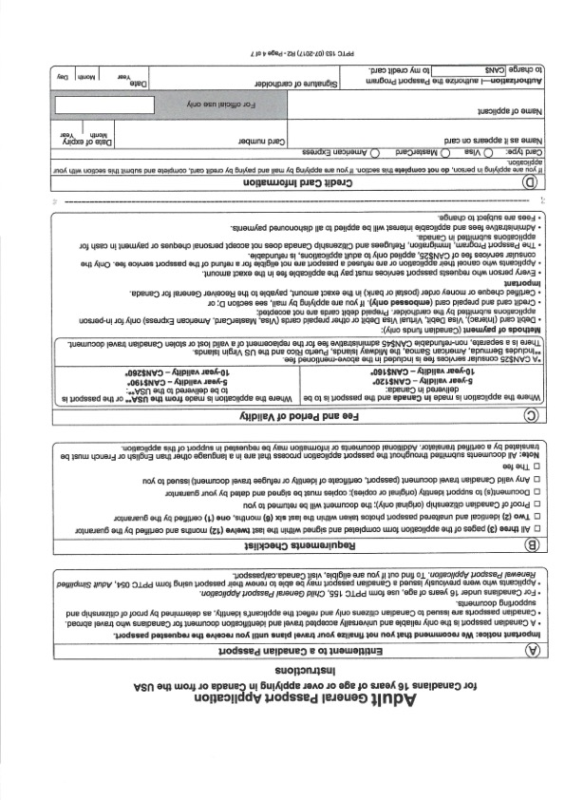

# Work Sheet

**Task 1: Why is it important for a Canadian citizen who is travelling to have a passport (according to the Canadian passport application form instruction sheet)?**

Answer:

**______________________________________________________**

**Task 2: List 3 items you will need to take (or mail) to the passport office so you can get your passport.**

Answer:

**______________________________________________________**

**Task 3: How much does it cost to get a Canadian passport valid for 10 years if you are applying from Canada?**

Answer:

**______________________________________________________**

**Task 4: If you are applying by mail, what are the accepted methods of payment for a passport?**

Answer:

**______________________________________________________**

# Answers

**Why is it important for a Canadian citizen who is travelling to have a passport (according to the Canadian passport application form instruction sheet)?**

Answer: A Canadian passport is the only reliable and universally accepted travel and identification document for Canadians who travel abroad.

**Task 2: List 3 items you will need to take (or mail) to the passport office so you can get your passport.**

Answer: Any three of

* All three pages of the application form completed and signed within the last twelve months, with page one certified by the guarantor
* Two identical and unaltered passport photos taken within the last six months, one certified by the guarantor
* Proof of Canadian citizenship (original only)
* Document(s) to support identity (original or copies)
* Any valid Canadian travel document (passport, certificate of identity or refugee travel document) issued to you
* The fee

**Task 3: How much does it cost to get a Canadian passport valid for 10 years if you are applying from Canada?**

Answer: $160

**Task 4: If you are applying by mail, what are the accepted methods of payment for a passport?**

Answer: Credit card (Visa, Mastercard, American Express)

# Performance Descriptors

| Levels | Performance Descriptors | Needs Work | Completes task with support from practitioner | Completes task independently |
| --- | --- | --- | --- | --- |
| A1.2 | scans text to locate information |  |  |  |
|  | locates multiple pieces of information in simple texts |  |  |  |
|  | makes low-level inferences |  |  |  |
|  | reads more complex texts to locate a single piece of information |  |  |  |
|  | obtains information from detailed reading |  |  |  |
|  | begins to identify sources and evaluate information |  |  |  |
| B2.1 | writes simple texts to request, remind or inform |  |  |  |
|  | conveys simple ideas and factual information |  |  |  |
|  | demonstrates a limited understanding of sequence |  |  |  |
|  | uses sentence structure, upper and lower case and basic punctuation |  |  |  |

This task: Was successfully completed Needs to be tried again

Learner Comments:

Instructor (print): Learner (print):

**__________________ _________________**