

Task Title: Bank Interest Rates

# OALCF Cover Sheet – Practitioner Copy

**Learner Name: __________________________________________**

**Date Started: ___________________________________________**

**Date Completed: _________________________________________**

|  |  |  |
| --- | --- | --- |
| **Goal Path:** | Employment | Apprenticeship |
| Secondary School | Post Secondary | Independence |

**Successful Completion:**  Yes No

**Task Description:** Review bank interest rates for different types of accounts.

**Main Competency/Task Group/Level Indicator:**

* Find and Use Information/Interpret documents/A2.2
* Understand and Use Numbers/Manage money/C1.1

**Materials Required:**

* Pen/pencil and paper and/or digital device

# Learner Information

Financial institutions post interest rates for different types of accounts.

Scan the “Interest Rates for Tangerine Bank”.

**Interest Rates for Tangerine Bank**

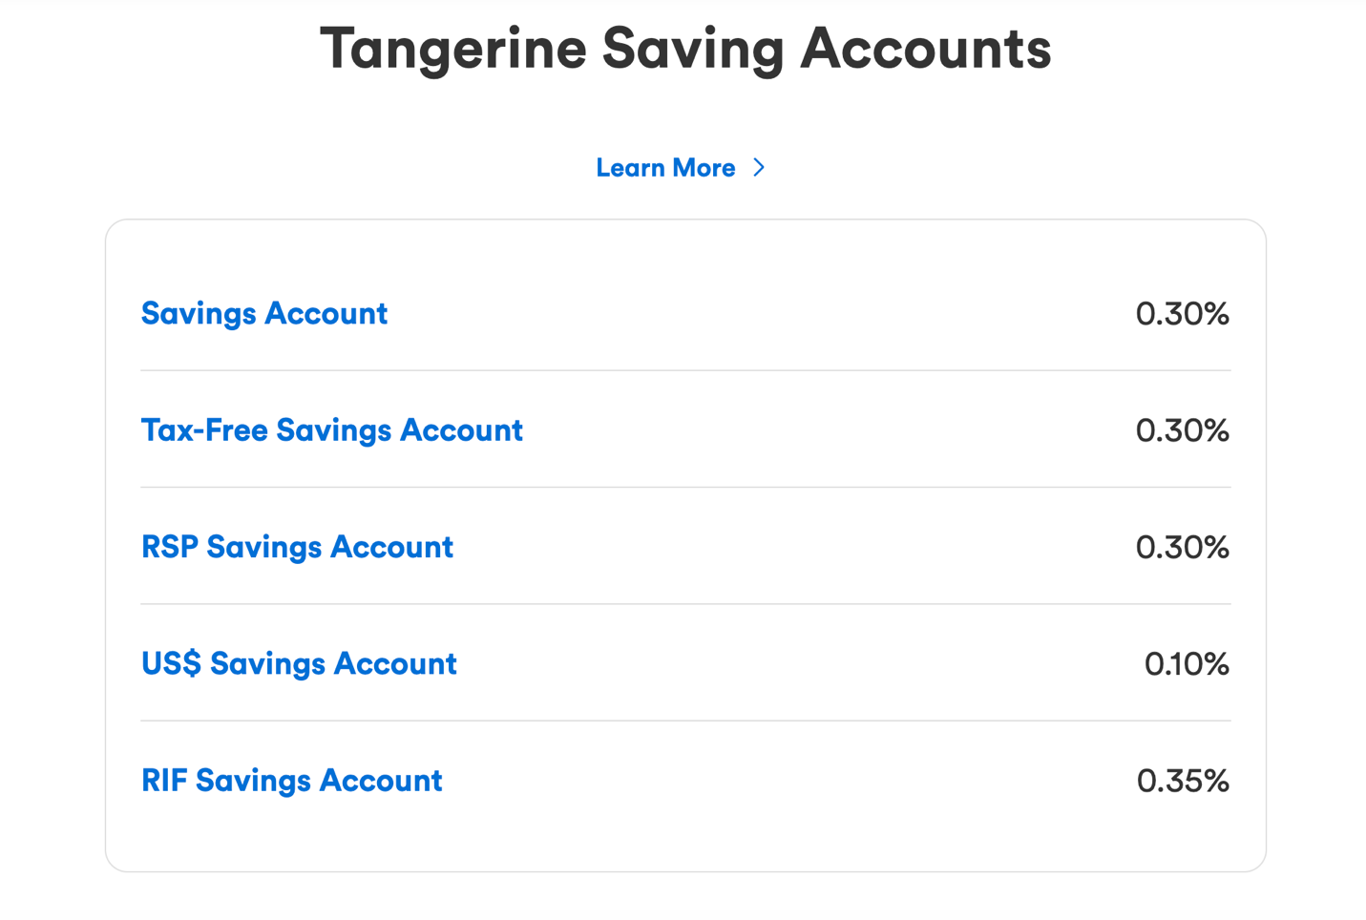

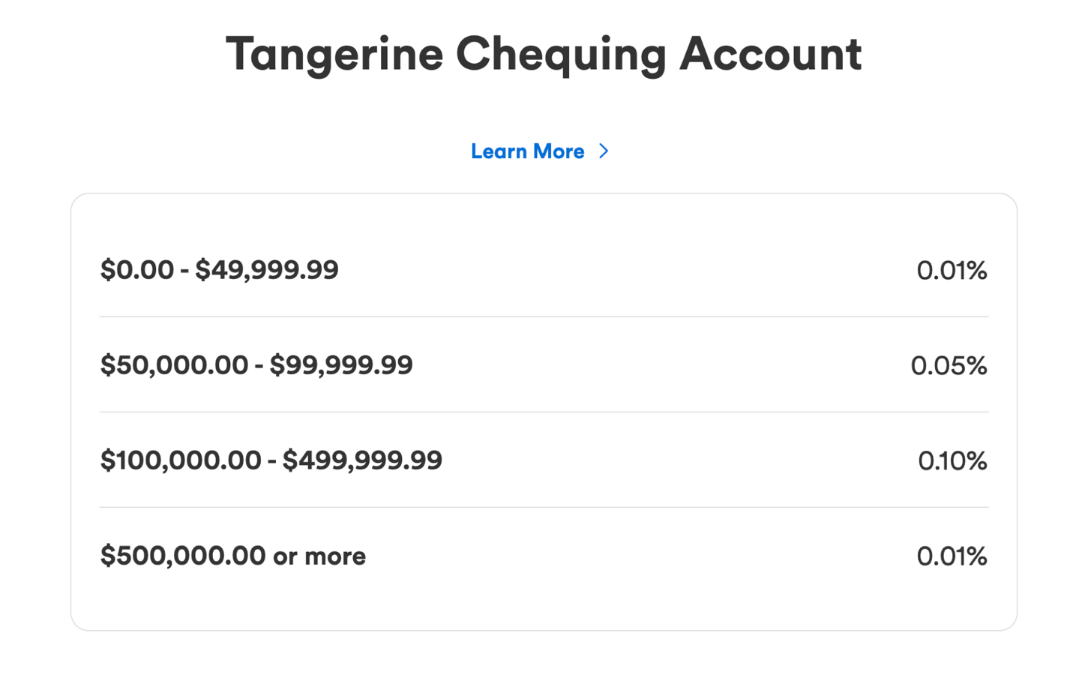

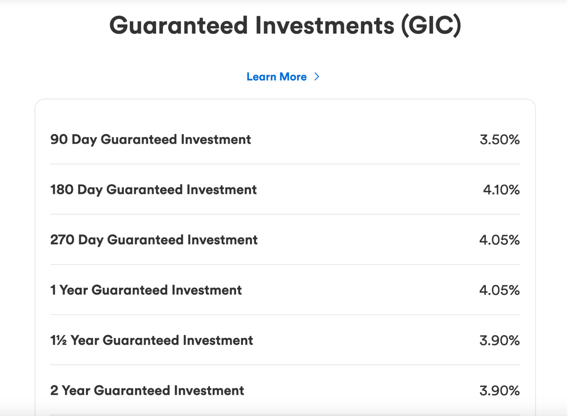

# Work Sheet

**Task 1: What is the interest rate for a chequing account with a balance of $75.00?**

Answer:

_____________________________________________________________

**Task 2: Which types of savings accounts have an interest rate of 0.30%?**

Answer:

_____________________________________________________________

**Task 3: How much money does a customer need to put into a chequing account to get an interest rate of 0.10%?**

Answer:

**______________________________________________________**

**Task 4: How long would a customer need to put money into a GIC (Guaranteed Investment) to get an interest rate of 4.10%?**

Answer:

**______________________________________________________**

# Answers

**Task 1: What is the interest rate for a chequing account with a balance of $75.00?**

Answer: 0.01%

**Task 2: Which types of savings accounts have an interest rate of 0.30%?**

Answer: Savings Account, Tax Free Savings Account, and RSP Savings Account

**Task 3: How much money does a customer need to put into a chequing account to get an interest rate of 0.10%?**

Answer: $100,000.00-$499,999.99.

**Task 4: How long would a customer need to put money into a GIC (Guaranteed Investment) to get an interest rate of 4.10%?**

Answer: 180 days.

# Performance Descriptors

| Levels | Performance Descriptors | Needs Work | Completes task with support from practitioner | Completes task independently |
| --- | --- | --- | --- | --- |
| A2.2 | performs limited searches using one or two search criteria |  |  |  |
|  | extracts information from tables and forms |  |  |  |
|  | uses layout to locate information |  |  |  |
|  | makes low-level inferences |  |  |  |
| C1.1 | understands numerical order |  |  |  |

This task: Was successfully completed Needs to be tried again

Learner Comments:

Instructor (print): Learner (print):

**__________________ _________________**