

Task Title: Banquet Event Order

# OALCF Cover Sheet – Practitioner Copy

**Learner Name: __________________________________________**

**Date Started: ___________________________________________**

**Date Completed: _________________________________________**

|  |  |  |
| --- | --- | --- |
| **Goal Path:** | Employment | Apprenticeship |
| Secondary School | Post Secondary | Independence |

**Successful Completion:**  Yes No

**Task Description:** Find information and make calculations based on a banquet event order form.

**Main Competency/Task Group/Level Indicator:**

* Find and Use Information/Interpret documents/A2.2
* Understand and Use Numbers/Manage money/C1.2

**Materials Required:**

* Pen/pencil and paper and/or digital device
* Calculator or digital device with calculator function

# Learner Information

Cooks and event staff at banquet facilities need to use information recorded on event forms. This ensures that enough food is prepared and that meeting spaces have enough chairs, tables and other equipment for each event.

Scan the “Banquet Event Order” form.

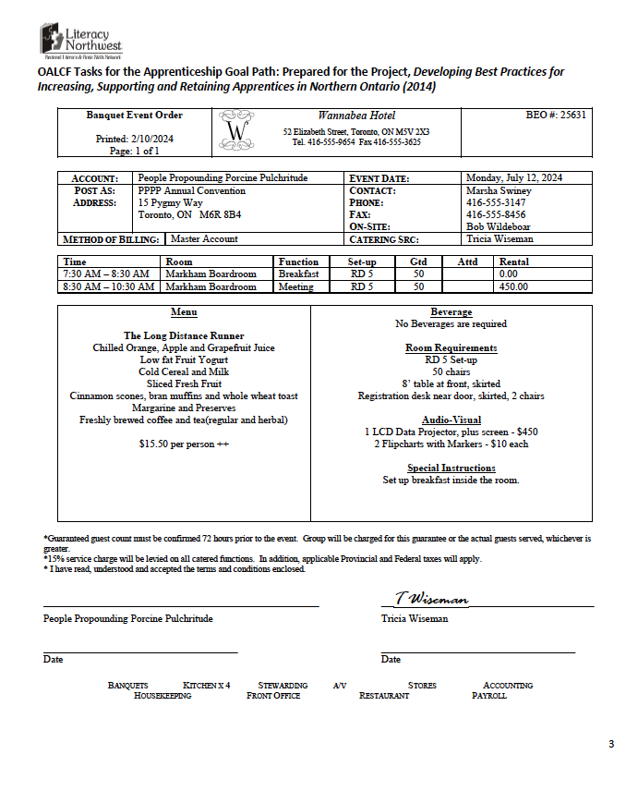

# Work Sheet

**Task 1: Circle the expected number of guests to attend (GTD).**

Answer:

**______________________________________________________**

**Task 2: Highlight or underline the event date and times of the meal and meeting.**

Answer:

**______________________________________________________**

**Task 3: If 50 guests attend the event, calculate the total for the Long Distance Runner event. The total should include the food cost plus the room rental cost for the meeting. HST (13%) is added to both the food and room rental. A Gratuity of 15% is added to the food total only.**

Answer:

**______________________________________________________**

**Task 4: If this group wants to add a flipchart with markers, what will be the new total? 13% HST will need to be added for these rental items.**

Answer:

**______________________________________________________**

Answers

**Task 1: Circle the expected number of guests to attend (GTD).**

Answer: 50 should be circled on the form

**Task 2: Highlight or underline the event date and times of the meal and meeting.**

Answer: The following should be highlighted or underlined on the form: Monday July 12, 2024; 7:30am-8:30am (breakfast); 8:30am-10:30am (meeting)

**Task 3: If 50 guests attend the event, calculate the total for the Long Distance Runner event. The total should include the food cost plus the room rental cost for the meeting. HST (13%) is added to both the food and room rental. Gratuity of 15% is added to the food only.**

Answer:

Food costs:

$15.50 per person x .13 HST = $2.02 HST

$15.50 per person x .15 gratuity = $2.33 gratuity

Total per person for food: $15.50 + $2.02 + $2.33 = $19.85

$19.85 x 50 people = $992.50 Total for food

Room rental cost:

$450 (room rental for meeting) x .13 (HST) = $58.50

Total room rental cost: $450 + $58.50 = $508.50

$992.50 (food) + $508.50 (room rental for meeting) = $1,501.00

**Task 4: If this group wants to add a flipchart with markers, what will be the new total? 13% HST will need to be added for these rental items.**

Answer:

Flip chart with markers: $10 x .13 HST = $1.13

Total for flipchart with markers: $10 + $1.13 = $11.13

New Total: $1,501.00 + $11.13 = $1,512.13

# Performance Descriptors

| Levels | Performance Descriptors | Needs Work | Completes task with support from practitioner | Completes task independently |
| --- | --- | --- | --- | --- |
| A2.2 | extracts information from tables and forms |  |  |  |
|  | uses layout to locate information |  |  |  |
|  | makes connections between parts of documents |  |  |  |
|  | makes low-level inferences |  |  |  |
| C1.2 | calculates using numbers expressed as whole numbers, fractions, decimals, percentages and integers |  |  |  |
|  | represents costs and rates using monetary symbols, decimals and percentages |  |  |  |
|  | interprets, represents and converts amounts using whole numbers, decimals, percentages, ratios and simple, common fractions (e.g. ½, ¼) |  |  |  |
|  | uses strategies to check accuracy (e.g. estimating, using a calculator, repeating a calculation, using the reverse operation) |  |  |  |

This task: Was successfully completed Needs to be tried again

Learner Comments:

Instructor (print): Learner (print):

**__________________ _________________**