

Task Title: Budget Basics

# OALCF Cover Sheet – Practitioner Copy

**Learner Name: __________________________________________**

**Date Started: ___________________________________________**

**Date Completed: _________________________________________**

|  |  |  |
| --- | --- | --- |
| **Goal Path:** | Employment | Apprenticeship |
| Secondary School | Post Secondary | Independence |

**Successful Completion:**  Yes No

**Task Description:** Learner will record their monthly expenses and compare them with their monthly income.

**Main Competency/Task Group/Level Indicator:**

* Communicate Ideas and Information/Complete and create documents/B3.2a
* Understand and Use Numbers/Manage money/C1.1

**Materials Required:**

* Pen/pencil and paper and/or digital device
* Calculator or digital device with calculator function

# Learner Information

Budgeting is an important part of understanding your finances. To create a budget, it can be helpful to track current expenses and income for at least one month.

You will be tracking your expenses and income for the current month. You can repeat this exercise for several months to see how your spending changes.

For each expense, write down how much you anticipate spending each month in the “budget” column. For example, if your bus pass is $60 a month, write $60. Some expenses change each month such as utilities or groceries. Estimate these expenses based on your most recent payment.

As the month progresses, you can add the real expense totals under the “spent” column to see how much was actually spent compared to what was budgeted.

Scan the “Examples of Income Sources, Expenses, Savings and Debt” article and the “Monthly Budget” template.

**Examples of Income Sources, Expenses, Savings and Debt**

Income Sources:

* Employment income
* Government income (OW or ODSP)
* Tax benefits (GST/HST credit, carbon tax rebate, Canada child benefit, etc.)

Fixed Expenses:

* Rent or mortgage
* Utilities: electricity, gas/propane, internet, phone
* Insurance: property, car, life
* Transportation: car payment/gas/repairs, bus pass, parking
* Groceries and household supplies
* Clothing
* Daycare

Additional Expenses:

* Meals or coffee out
* Haircuts or personal care
* Entertainment: movies, concerts, sports events
* Memberships: phone apps, gym membership
* Alcohol or tobacco
* Vacations
* Gifts

Savings:

* Retirement
* Educational savings
* Saving for a downpayment for a house or car

Debt:

* Loan payments
* Credit card payments

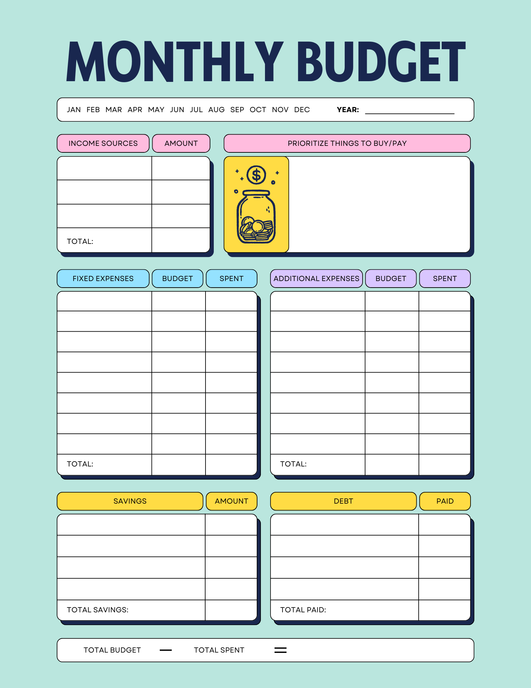

# Work Sheet

**Task 1: Label the budget template with the current month and year.**

Answer: No written response required here.

Task completed: Yes:

_____________________________________________________________

**Task 2: List all your income sources and amounts in the Income Sources section on the budget template.**

Answer: No written response required here.

Task completed: Yes:

**______________________________________________________**

**Task 3: Total all income sources and enter the total on the template.**

Answer: No written response required here.

Task completed: Yes:

**______________________________________________________**

**Task 4: List your expenses in the Fixed Expenses and Additional Expenses sections on the budget template. For each expense, write down how much you anticipate spending each month in the “budget” column.**

Answer: No written response required here.

Task completed: Yes:

**______________________________________________________**

**Task 5: Total all expenses and enter the amounts on the template.**

Answer: No written response required here.

Task completed: Yes:

_____________________________________________________________

**Task 6: Subtract your total expenses (total spent) from your total income sources (total budget) and enter that amount on the template.**

Answer: No written response required here.

Task completed: Yes:

_____________________________________________________________

**Task 8: According to your calculations, will you be underspent or overspent at the end of the month? By how much?**

Answer:

_____________________________________________________________

# Answers

Answers will vary for each learner.

# Performance Descriptors

| Levels | Performance Descriptors | Needs Work | Completes task with support from practitioner | Completes task independently |
| --- | --- | --- | --- | --- |
| B3.2a | uses layout to determine where to make entries |  |  |  |
|  | begins to make some inferences to decide what information is needed, where and how to enter the information |  |  |  |
|  | Follows instructions on documents |  |  |  |
| C1.1 | adds, subtracts, multiplies and divides whole numbers and decimals |  |  |  |
|  | begins to interpret integers, such as in a negative bank balance |  |  |  |
|  | follows apparent steps to reach solutions |  |  |  |
|  | interprets and represents costs using monetary symbols and decimals |  |  |  |
|  | uses strategies to check accuracy (e.g. estimating, using a calculator, repeating a calculation, using the reverse operation) |  |  |  |

This task: Was successfully completed Needs to be tried again

Learner Comments:

Instructor (print): Learner (print):

**__________________ _________________**