

Task Title: Calculate the Area of an Irregular Room

# OALCF Cover Sheet – Practitioner Copy

**Learner Name: __________________________________________**

**Date Started: ___________________________________________**

**Date Completed: _________________________________________**

|  |  |  |
| --- | --- | --- |
| **Goal Path:** | Employment | Apprenticeship |
| Secondary School | Post Secondary | Independence |

**Successful Completion:**  Yes No

**Task Description:** The learner will use a floor plan of an irregular room to determine if specific pieces of furniture will fit.

**Main Competency/Task Group/Level Indicator:**

* Understand and Use Numbers/Use measures/C3.3

**Materials Required:**

* Pen/pencil and paper and/or digital device
* Calculator or digital device with calculator function
* Ruler

# Learner Information

Floor plans are often used to determine where to place furniture in a room.

Scan the “Bedroom Floor Plan”. In the floor plan each small square represents 1 foot squared (1 foot x 1 foot x 1 foot x 1 foot).

**Bedroom Floor Plan**

WINDOW

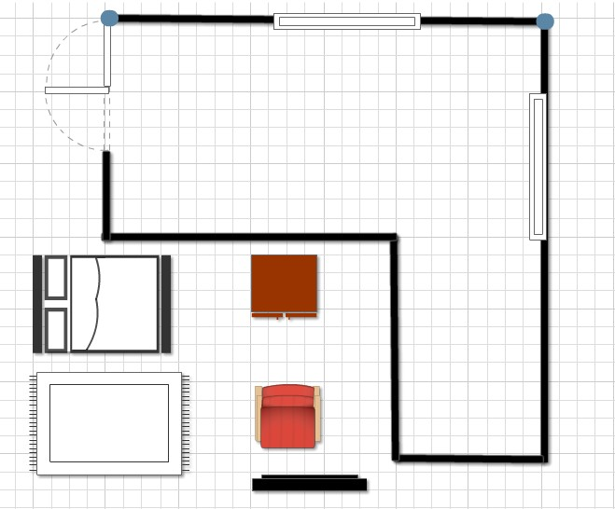

WINDOW

DOOR

DRESSER

BED plans are often used to determine where to place furniture in a room.

CHAIR

RUG

T.V.

# Work Sheet

**Task 1: Calculate in feet the perimeter of the bedroom.**

Answer:

**______________________________________________________**

**Task 2: Calculate in feet the total area of the bedroom.**

Answer:

**______________________________________________________**

**Task 3: Calculate in feet the total approximate amount of the room taken up by windows.**

Answer:

**______________________________________________________**

**Task 4: Use the floor plan to record the placement you’ve decided on for each piece of furniture shown.**

Answer: No written response required here.

Task completed: Yes:

_____________________________________________________________

# Answers

**Task 1: Calculate the perimeter of the bedroom in feet.**

Answer: 24 + 24 + 8 + 12 + 16 + 12 = 96 feet

**Task 2: Calculate the total area (in feet) of the bedroom.**

Answer:

12 x 24 = 288

12 x 8 = 96

288 + 96 = 384 square feet

**Task 3: Calculate the total approximate amount of the room (in feet) taken up by windows.**

Answer: 8 + 8 = 16 feet

**Task 4: Use the floor plan to record the placement you’ve decided on for each piece of furniture shown.**

Answers will vary but will reflect that the learner understands that the size of the furniture is represented by the floor plan grid.

# Performance Descriptors

| Levels | Performance Descriptors | Needs Work | Completes task with support from practitioner | Completes task independently |
| --- | --- | --- | --- | --- |
| C3.3 | calculates using numbers expressed as whole numbers, fractions, decimals, percentages and integers |  |  |  |
|  | understands and uses formulas for finding the perimeter, area and volume of non-rectangular, composite shapes |  |  |  |
|  | manages unfamiliar elements (e.g. context, content) to complete tasks |  |  |  |
|  | makes estimates involving many factors where precision is required |  |  |  |
|  | chooses and performs required operations; makes inferences to identify required operations |  |  |  |
|  | selects appropriate steps to solutions from among options |  |  |  |
|  | identifies a variety of ways to complete tasks |  |  |  |
| C.3 | represents measures using whole numbers |  |  |  |
|  | uses strategies to check accuracy (e.g. estimating, using a calculator, repeating a calculation, using the reverse operation) |  |  |  |

This task: Was successfully completed Needs to be tried again

Learner Comments:

Instructor (print): Learner (print):

**__________________ _________________**