

Task Title: Calculate Cost of Items During BOGO Sale

# OALCF Cover Sheet – Practitioner Copy

**Learner Name: __________________________________________**

**Date Started: ___________________________________________**

**Date Completed: _________________________________________**

|  |  |  |
| --- | --- | --- |
| **Goal Path:** | Employment | Apprenticeship |
| Secondary School | Post Secondary | Independence |

**Successful Completion:**  Yes No

**Task Description:** The learner will calculate the cost of items during a “buy one, get one” sale.

**Main Competency/Task Group/Level Indicator:**

* Understand and Use Numbers/Manage money/C1.2

**Materials Required:**

* Pen/pencil and paper and/or digital device

# Learner Information

Stores will often advertise “BOGO” sales in their weekly flyers. “BOGO” stands for Buy One Get One.

Scan the Sharpie Permanent Marker advertisement.

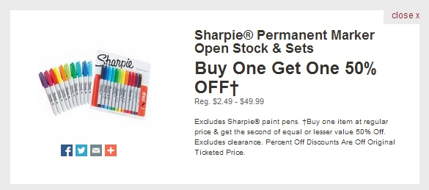

# Work Sheet

**Task 1: One package of Sharpie markers has an original price of $14.98 and the other has an original price of $39.99. After the “BOGO” discount, how much will it cost for the package of Sharpie® Markers that originally cost $14.98?**

Answer:

**______________________________________________________**

**Task 2: Two packages of Sharpie® Markers have the same original price of $29.98. What will be the cost of the discounted package during the “BOGO” sale?**

Answer:

**______________________________________________________**

**Task 3: One package of Sharpie Markers costs $2.64 and another package costs $7.99. How much will the total cost be for both marker packages (before taxes) after the “BOGO” discount is applied?**

Answer:

**______________________________________________________**

# Answers

**Task 1: One package of Sharpie markers has an original price of $14.98 and the other has an original price of $39.99. After the “BOGO” discount, how much will it cost for the package of Sharpie® Markers that originally cost $14.98?**

Answer: $14.98 is the package of lesser value so it is 50% off (or half price). Therefore, the package will be $7.49.

**Task 2: Two packages of Sharpie® Markers have the same original price of $29.98. What will be the cost of the discounted package during the “BOGO” sale?**

Answer: The packages are of equal value so one will be 50% off (or half price). Half of $29.98 is $14.99.

**Task 3: One package of Sharpie Markers costs $2.64 and another package costs $7.99. How much will the total cost be for both marker packages (before taxes) after the “BOGO” discount is applied?**

Answer: The package with the lesser value is $2.64. You will save 50% of $2.64 which is $1.32. Therefore, you will pay $7.99 for one package and $1.32 for the second package which equals $9.31 total for both marker packages.

# Performance Descriptors

| Levels | Performance Descriptors | Needs Work | Completes task with support from practitioner | Completes task independently |
| --- | --- | --- | --- | --- |
| C1.2 | calculates using numbers expressed as whole numbers, fractions, decimals, percentages and integers |  |  |  |
|  | calculates percentages |  |  |  |
|  | chooses and performs required operation(s); may make inferences to identify required operation(s) |  |  |  |
|  | selects appropriate steps to reach solutions |  |  |  |
|  | represents costs and rates using monetary symbols, decimals and percentages |  |  |  |
|  | interprets, represents and converts amounts using whole numbers, decimals, percentages, ratios and simple, common fractions (e.g. ½, ¼) |  |  |  |
|  | uses strategies to check accuracy (e.g. estimating, using a calculator, repeating a calculation, using the reverse operation) |  |  |  |

This task: Was successfully completed Needs to be tried again

Learner Comments:

Instructor (print): Learner (print):

**__________________ _________________**