

Task Title: Calculate Volumes of Concrete Required

# OALCF Cover Sheet – Practitioner Copy

**Learner Name: __________________________________________**

**Date Started: ___________________________________________**

**Date Completed: _________________________________________**

|  |  |  |
| --- | --- | --- |
| **Goal Path:** | Employment | Apprenticeship |
| Secondary School | Post Secondary | Independence |

**Successful Completion:**  Yes No

**Task Description:** Carpenters calculate volumes of window sills, thrust blocks and columns to determine the amount of concrete required.

* Tasks 1, 3, & 4 ‘C3’ tasks are higher than Level 3 OALCF

* Task 3 has been identified as authentic to this particular trade and may need some prior knowledge of the trade to complete.

**Main Competency/Task Group/Level Indicator:**

* Find and Use Information/Interpret documents/A2.1
* Understand and Use Numbers/Use measures/C3.3
* Understand and Use Numbers/Manage data/C4.1

**Materials Required:**

* Pen/pencil and paper and/or digital device
* Calculator or digital device with calculator function

# Practitioner/Instructor Information

* Tasks 1, 3, & 4 ‘C3’ tasks are higher than Level 3 OALCF

* Task 3 has been identified as authentic to this particular trade and may need some prior knowledge of the trade to complete.

# Learner Information

# The carpenter calculates the volume (V) of concrete required for building objects.

For square or rectangular objects:

V = L x W x D, where V = volume, L = length, W = width and D = depth.

For round objects:

V = ∏r2 x H, where V = volume, ∏ = 3.14, r = radius of circle* and H = height

* Radius is ½ of the diameter (diameter = distance across the circle)

1 cubic foot = 0.037 cubic yard

Review the Concrete Building Objects Diagrams.

**Concrete Building Objects Diagrams**

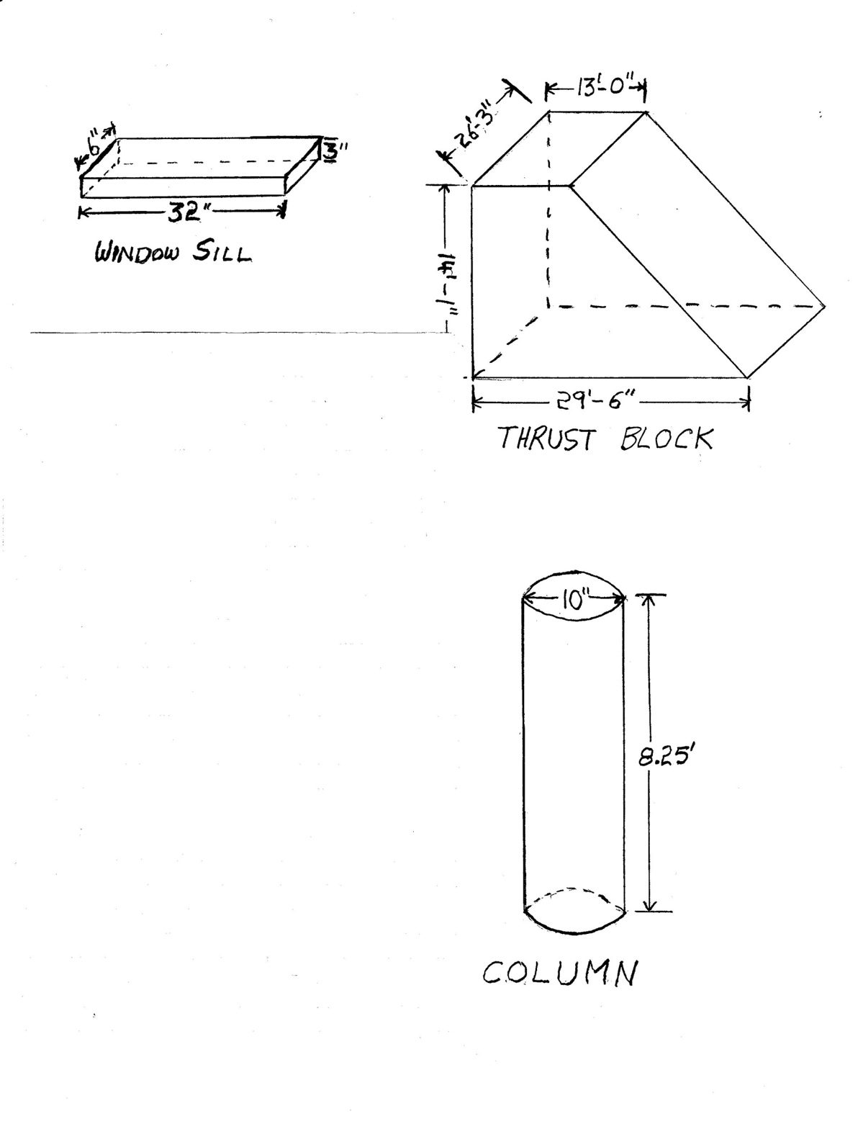

# Work Sheet

**Task 1: Calculate the volume (V) of concrete required for the window sill in cubic feet (ft3).**

Answer:

**______________________________________________________**

**Task 2: A garage floor measures 12’ 6” by 13.75’. The concrete pad will be 4” deep. The cement truck contains 1 cubic yard of concrete. Will you need to order more concrete to complete the garage floor? Concrete can be ordered by ½ and full cubic yards.**

Answer:

**______________________________________________________**

**Task 3: Calculate the volume of concrete required for the thrust block, in cubic yards (yd3). The thrust block is an odd shape. Consider it as a rectangle (13’ x 14’ 1” x 26’3”) plus half of another rectangle ((29’6” – 13’) x 14’ 1”x 26’ 3”).**

Answer:

**______________________________________________________**

**Task 4: Calculate the volume of concrete required for 8 columns, in cubic yards (yd3); 1 ft3 = 0.037 yd3).**

Answer:

**______________________________________________________**

# Answers

**Task 1: Calculate the volume (V) of concrete required for the window sill in cubic feet (ft3).**

Answer:

V = L x W x H

Convert measurements to feet

32” = 32 / 12 = 2.67’

6” = .5’

3” = .25’

V = 2.67’ x .5’ x .25’

V = .334 cubic feet (or .334 ft3)

**Task 2: A garage floor measures 12’ 6” by 13.75’. The concrete pad will be 4” deep. The cement truck contains 1 cubic yard of concrete. Will you need to order more concrete to complete the garage floor? Concrete can be ordered by ½ and full cubic yards.**

Answer:

V = L x W x H

Convert measures to feet.

12’ 6” = 12.5’

4” = .33’

V = 13.75’ x 12.5’ x .33’

= 56.72 ft3 x .037 = 2.09 yd3

Since you only have 1 cubic yard of concrete and you need 2.09 yd3, you will need to order more concrete.

**Task 3: Calculate the volume of concrete required for the thrust block, in cubic yards (yd3). The thrust block is an odd shape. Consider it as a rectangle (13’ x 14’ 1” x 26’3”) plus half of another rectangle ((29’6” – 13’) x 14’ 1”x 26’ 3”).**

Answer:

This is one method of solving the problem. The Thrust Block will be viewed as two geometric figures: a rectangle and a triangle (1/2 a rectangle).

V = L x W x H (Rectangle)

V = 13’ x 26’ 3” x 14’ 1”

= 13’ x 26.25’ x 14.08’

= 4804.8 ft3

V = (L x W x H) / 2 (Half Rectangle)

L = 29.5’ – 13’ = 16.5’

V = 16.5’ x 26.25’ x 14.08’ / 2 = 6098.4 ft3 / 2 = 3,049.2 ft3

The volume of the Thrust Block is 4804.8 + 3049.2 = 7854 ft3

Convert 7854 ft3 to yd3

7854 x .037 = 290.60 yd3

The volume of the Thrust Block is 290.60 yd3.

Note – Answer may vary depending on how many decimal places were used in the calculations.

**Task 4: Calculate the volume of concrete required for 8 columns, in cubic yards (yd3); 1 ft3 = 0.037 yd3).**

Answer:

V = ∏r2 x H

V = 3.14 x 5”2 x 8.25’

Convert 5” to a fraction of a foot : 5/12 = .417

V = 3.14 x .4172 x 8.25’

= 1.309 ft2 x 8.25 = 10.80 ft3

= 10.80 ft3

Convert ft3 to yd3:

V = 10.80 x 0.037

= 0.399 yd3 (for one Column)

Total concrete required for 8 columns is 8 x 0.399 yd3 or 3.192 yd3.

Note: Some rounding has been done so the answer provided is approximate.

# Performance Descriptors

| Levels | Performance Descriptors | Needs Work | Completes task with support from practitioner | Completes task independently |
| --- | --- | --- | --- | --- |
| A2.1 | Scans to locate specific details |  |  |  |
|  | Interprets brief text and common symbols |  |  |  |
| C3.3 | Calculates using numbers expressed as whole numbers, fractions, decimals, percentages and integers |  |  |  |
|  | Calculates the radius, diameter and circumference of circles |  |  |  |
|  | Understands and uses properties of angles and triangles to solve problems |  |  |  |
|  | Understands and uses formulas for finding the perimeter, area and volume of non-rectangular, composite shapes |  |  |  |
|  | Chooses and performs required operations; makes inferences to identify required operations |  |  |  |
|  | Selects appropriate steps to solutions from among options |  |  |  |
|  | Interprets, represents and converts measures using whole numbers, decimals, percentages, ratios and fractions |  |  |  |
|  | Uses strategies to check accuracy (e.g. estimating, using a calculator, repeating a calculation, using the reverse operation) |  |  |  |
| C4.1 | adds, subtracts, multiplies and divides whole numbers and decimals |  |  |  |
|  | identifies and compares quantities of items |  |  |  |
|  | identifies and performs required operation |  |  |  |
|  | interprets and represents values using whole numbers, decimals, percentages and simple, common fractions (e.g. ½, ¼) |  |  |  |
|  | follows apparent steps to reach solutions |  |  |  |

This task: Was successfully completed Needs to be tried again

Learner Comments:

Instructor (print): Learner (print):

**__________________ _________________**