

Task Title: Calculating Shoe Store Discounts

OALCF Cover Sheet – Practitioner Copy

Learner Name: __________________________________________
Date Started: ___________________________________________
Date Completed: _________________________________________

Goal Path: | Employment | Apprenticeship
Secondary School | Post Secondary | Independence
Successful Completion: Yes No

Task Description: The learner will interpret sale information in a flyer and make calculations based on discounts.
Main Competency/Task Group/Level Indicator:
- Find and Use Information/Interpret documents/A2.1
- Understand and Use Numbers/Manage money/C1.2

Materials Required:
- Pen/pencil and paper and/or digital device
- Calculator or digital device with calculator function

Learner Information
Store flyers may be delivered to homes or posted online. This can help customers learn about new items, sales, or other store promotions.

Scan the Shoe Store Flyers for Women’s Sandals and Girls’ Athletics.

Shoe Store Flyer: Women’s Sandals
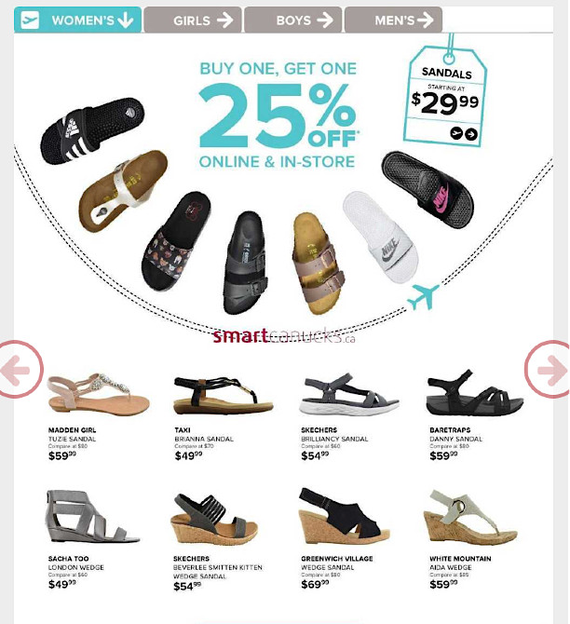

Shoe Store Flyer: Girls’ Athletics
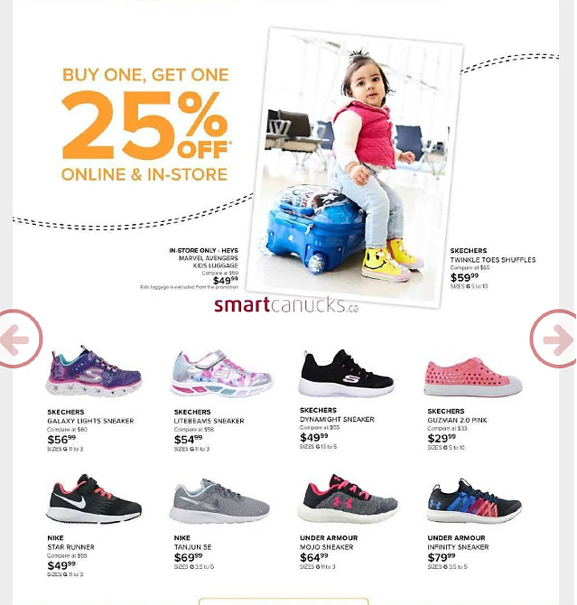

Work Sheet
Task 1: A customer purchases the Sacha Too London Wedge Sandal. Calculate the total cost including sales tax (13%).
Answer:

______________________________________________________
Task 2: A customer purchases the Sketchers Brilliancy Sandal and the White Mountain Aida Wedge Sandal. Calculate the total cost including sales tax (13%). The Buy One, Get One discount is applied to the lowest cost item before tax is calculated.
Answer:

______________________________________________________
Task 3: A customer purchases Sketchers Litebeams Sneakers and Nike Star Runners. Calculate the total cost including sales tax and discounts.
Answer:

______________________________________________________
Task 4: One person visited the shoe store on three different days and made the purchases listed in tasks 1, 2 and 3. Calculate the total amount they spent at the shoe store.
Answer:

______________________________________________________

Answers
Task 1: A customer purchases the Sacha Too London Wedge Sandal. Calculate the total cost including sales tax (13%).
Answer: $49.99 x 0.13 = $6.50
$49.99 + $6.50 = $56.49 total

Task 2: A customer purchases the Sketchers Brilliancy Sandal and the White Mountain Aida Wedge Sandal. Calculate the total cost including sales tax (13%). The Buy One, Get One discount is applied to the lowest cost item before tax is calculated.
Answer: $54.99 x 0.25 = $13.75
$54.99 - $13.75 = $41.24
$41.24 + $59.99 = $101.23
$101.23 x 0.13 = $13.16
$101.23 + $13.16 = $114.39 total

Task 3: A customer purchases Sketchers Litebeams Sneakers and Nike Star Runners. Calculate the total cost including sales tax and discounts.
Answer: $49.99 x 0.25 = $12.50
$49.99 - $12.50 = $37.49
$37.49 + $54.99 = $92.48
$92.48 x 0.13 = $12.02
$92.48 + $12.02 = $104.50 total

Task 4: One person visited the shoe store on three different days and made the purchases listed in tasks 1, 2 and 3. Calculate the total amount they spent at the shoe store.
Answer: $56.49 + $114.39 + $104.50 = $275.38 total

Note for Practitioners: The learner’s answer to this question depends upon correct calculations in the previous tasks. If the learner did not correctly respond to one or more of the previous questions, determine correctness of this answer based on the numbers they have used.

Performance Descriptors
Levels | Performance Descriptors | Needs Work | Completes task with support from practitioner | Completes task independently
A2.1 | scans to locate specific details
 | interprets brief text and common symbols
 | locates specific details in simple documents, such as labels and signs
C1.2 | calculates using numbers expressed as whole numbers, fractions, decimals, percentages and integers
 | calculates percentages
 | chooses and performs required operations; may make inferences to identify required operations
 | selects appropriate steps to reach solutions
 | ises strategies to check accuracy (e.g. estimating, using a calculator, repeating a calculation, using the reverse operation)

This task: Was successfully completed Needs to be tried again

Learner Comments:

Instructor (print): Learner (print):
__________________ _________________

