

Task Title: Check the Temperature on an Outdoor Thermometer

# OALCF Cover Sheet – Practitioner Copy

**Learner Name: __________________________________________**

**Date Started: ___________________________________________**

**Date Completed: _________________________________________**

|  |  |  |
| --- | --- | --- |
| **Goal Path:** | Employment | Apprenticeship |
| Secondary School | Post Secondary | Independence |

**Successful Completion:**  Yes No

**Task Description:** Learner will check the temperature on various outdoor thermometers.

**Main Competency/Task Group/Level Indicator:**

* Understand and Use Numbers/Use measures/C3.1

**Materials Required:**

* Pen/pencil and paper and/or digital device

# Learner Information

Individuals use outdoor thermometers to check what the temperature is outside.

# Work Sheet

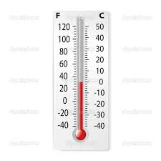**Task 1: What is the temperature in Celsius on this outdoor thermometer?**

Answer:

**______________________________________________________**

**Task 2: What is the temperature outdoors on this digital thermometer?**

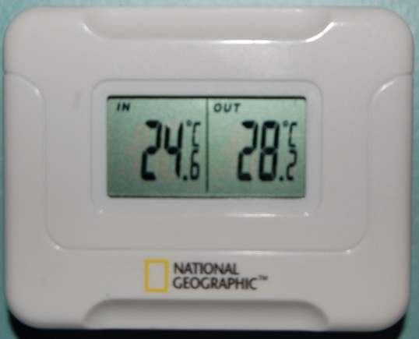  
Answer:

**______________________________________________________**

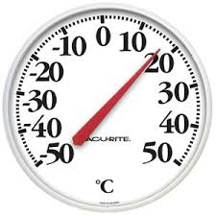**Task 3: What is the temperature outdoors**

**on this thermometer?**

Answer:

**______________________________________________________**

**Task 4: In the summer, Toronto sometimes has a high of 27 °C. On the same day, Toronto may have a low of 19 °C.**

**a) Draw a line on the thermometer on the left to show the high of 27 °C.**

**b) Draw a line on the thermometer on the right to show the low of 19 °C.**

Answer:

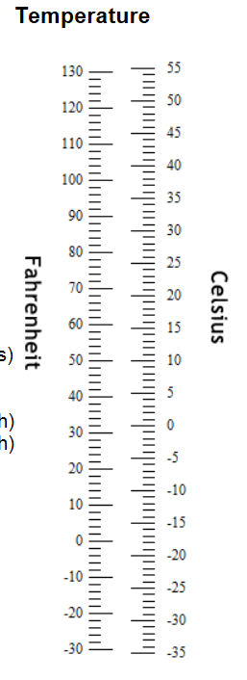

**______________________________________________________**

**Task 5: Calculate the difference in temperature between the high (27C) and the low (19C) in Toronto.**

Answer:

**______________________________________________________**

# Answers

**Task 1: What is the temperature in Celsius on this outdoor thermometer?**

Answer: 0°C

**Task 2: What is the temperature outdoors on this digital thermometer?**

Answer: 28.2°C or 28°C

**Task 3: What is the temperature outdoors on this thermometer?**

Answer: 17°C although an answer of 16 or 18 could still be considered “close enough”

**Task 4: In the summer, Toronto sometimes has a high of 27 °C. On the same day, Toronto may have a low of 19 °C.**

**a) Draw a line on the thermometer on the left to show the high of 27 °C.**

**b) Draw a line on the thermometer on the right to show the low of 19 °C.**

Answer:



**Task 5: Calculate the difference between the high (27C) and the low (19C) in Toronto.**

Answer: 8°C (27-19=8)

# Performance Descriptors

| Levels | Performance Descriptors | Needs Work | Completes task with support from practitioner | Completes task independently |
| --- | --- | --- | --- | --- |
| C3.1 | subtracts whole number measurements |  |  |  |
|  | measures temperature |  |  |  |
|  | uses common measuring tools, such as thermometers |  |  |  |
|  | begins to interpret integers (e.g. temperature, elevation) |  |  |  |
|  | chooses appropriate units (e.g. metres, inches) and non-standard units (e.g. paces, cupfuls, scoops) |  |  |  |
|  | identifies and performs required operation |  |  |  |
|  | interprets and represents measures using symbols and abbreviations (e.g. inches as “, centimeters as cm, pounds as lbs, kilograms as kilos or kg) |  |  |  |
|  | follows apparent steps to reach solutions |  |  |  |

This task: Was successfully completed Needs to be tried again

Learner Comments:

Instructor (print): Learner (print):

**__________________ _________________**