

Task Title: College and University Enrolment

OALCF Cover Sheet – Practitioner Copy

Learner Name: __________________________________________
Date Started: ___________________________________________
Date Completed: _________________________________________

Goal Path: | Employment | Apprenticeship
Secondary School | Post Secondary | Independence
Successful Completion: Yes No

Task Description: The learner will use tables to find information and calculate post-secondary enrolment changes.
Main Competency/Task Group/Level Indicator:
- Find and Use Information/Interpret documents/A2.2
- Understand and Use Numbers/Manage data/C4.2
Materials Required:
- Pen/pencil and paper and/or digital device
- Calculator or digital device with calculator function

Learner Information
Governments track changes in college and university enrolment across Canada. This can help identify trends and future needs in different programs or geographical areas.

Scan the following:

“Table 1: Domestic Student Enrolments from 2015 to 2022 at Colleges and Universities in Canada, Ontario, Alberta and BC”

“Table 2: Ontario Domestic Student Enrolment from 2012 to 2021 by Credential”

“Table 3: Domestic Enrolments from 2015 to 2022 Across STEM and BHASE Fields”

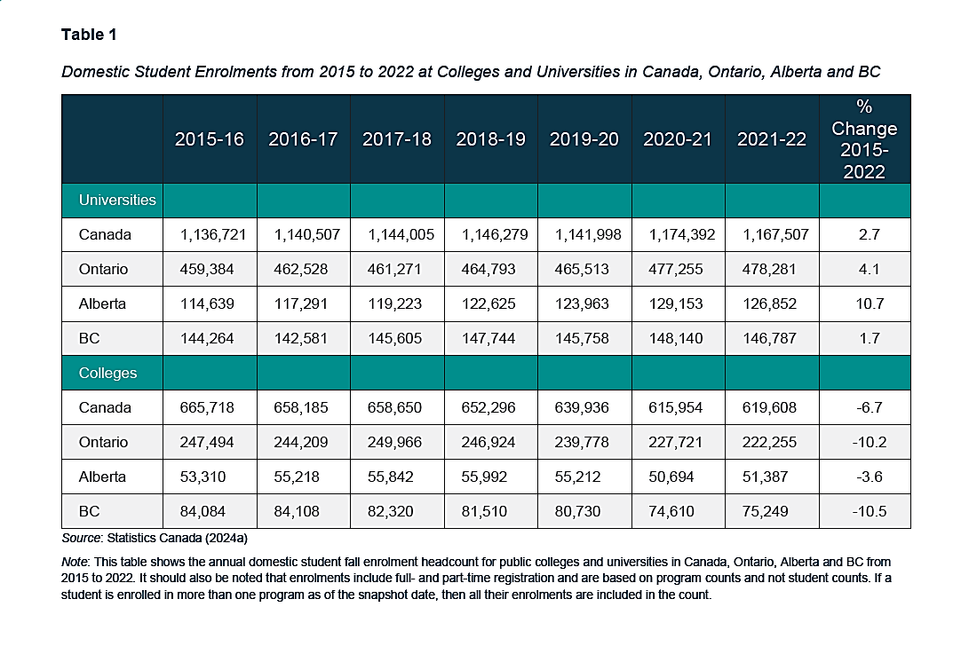

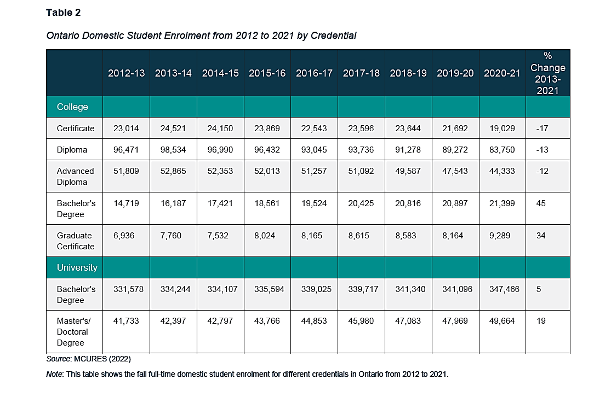
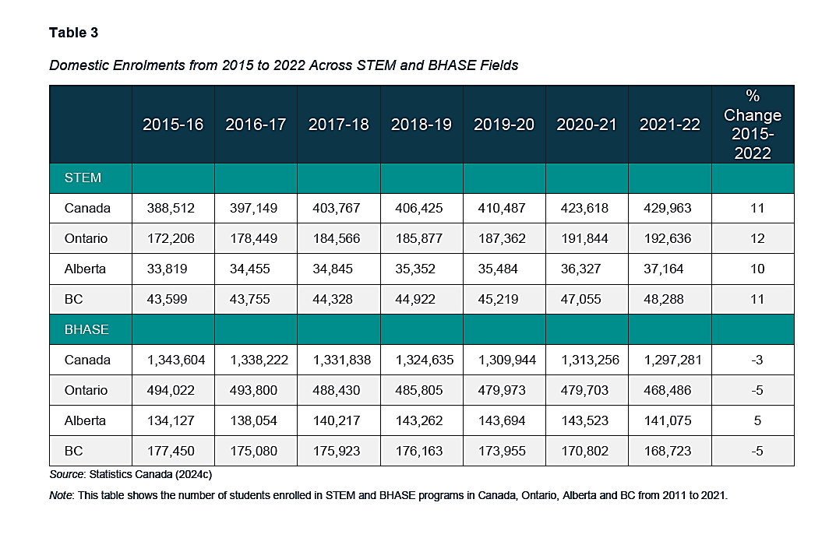

STEM: Science, Technology, Engineering and Mathematics
BHASE: Business, Humanities, Health, Arts, Social Science and Education [Non-STEM fields of study]

Work Sheet
Task 1: Using Table 1, calculate how many more students enrolled in universities in Ontario in 2021-22 compared to 2020-21.
Answer:

______________________________________________________
Task 2: Using Table 2, calculate the total number of Ontario students enrolled in all college programs in 2020-21.
Answer:

______________________________________________________
Task 3a) Using Table 3, calculate the total number of Ontario students enrolled in STEM and BHASE programs in 2021-22.
Answer:

_____________________________________________________________
Task 3b) Calculate the percentage of Ontario students enrolled in STEM programs in 2021-22.
Answer:

______________________________________________________
Task 4: Using Table 3, complete the following chart to estimate 2022-2023 enrolment based on the average annual change.
Answer:
Change from 2019-20 to 2020-21 in Canada STEM enrolment

Change from 2020-21 to 2021-22 in Canada STEM enrolment

Average Change in Canada STEM enrolment between 2019 and 2022

Estimated Canada STEM enrolment for 2022-23

Answers

Task 1: Using Table 1, calculate how many more students enrolled in universities in Ontario in 2021-22 compared to 2020-21.
Answer:
478,281 – 477,255 = 1,026 students

Task 2: Using Table 2, calculate the total number of Ontario students enrolled in all college programs in 2020-21.
Answer:
19,029 (Certificate) + 83,750 (Diploma) + 44,333 (Advanced Diploma) + 21,399 (Bachelor’s Degree) + 9,289 (Graduate Certificate)
= 177,800 students total

Task 3a) Using Table 3, calculate the total number of Ontario students enrolled in STEM and BHASE programs in 2021-22.
Answer:
192,636 (STEM) + 468,486 (BHASE) = 661,122 Total

Task 3b) Calculate the percentage of Ontario students enrolled in STEM programs in 2021-22.
Answer:
192,636 (STEM) / 661,122 (TOTAL) = 29%

Task 4: Using Table 3, complete the following chart to estimate 2022-2023 enrolment based on the average annual change.
Answer:
Change from 2019-20 to 2020-21 in Canada STEM enrolment | 423,618 - 410,487 =  13,131
Change from 2020-21 to 2021-2022 in Canada STEM enrolment | 429,963 - 423,618=  6,345
Average Change in Canada STEM enrolment from 2019-20 to 2021-22 | 13,131 + 6,345 =  19,476 / 2 =  9,738 average change
Estimated Canada STEM enrolment for 2022-23 | 429,963 + 9,738 = 439,701 estimated enrolment

Performance Descriptors
Levels | Performance Descriptors | Needs Work | Completes task with support from practitioner | Completes task independently
A2.2 | extracts information from tables and forms
C4.2 | calculates using numbers expressed as whole numbers, fractions, decimals, percentages and integers
 | calculates averages (mean) and percentages
 | chooses and performs required operation(s); may make inferences to identify required operation(s)
 | selects appropriate steps to solutions
 | recognizes patterns and begins to identify trends in data (e.g. population, crime, demographic, inventory, injury)
 | uses strategies to check accuracy (e.g. estimating, using a calculator, repeating a calculation, using the reverse operation)

This task: Was successfully completed Needs to be tried again

Learner Comments:

Instructor (print): Learner (print):
__________________ _________________

