

Task Title: College Grading Policies

OALCF Cover Sheet – Practitioner Copy

Learner Name: __________________________________________
Date Started: ___________________________________________
Date Completed: _________________________________________

Goal Path: | Employment | Apprenticeship
Secondary School | Post Secondary | Independence
Successful Completion: Yes No

Task Description: The learner will find information about grading policies on a college website.
Main Competency/Task Group/Level Indicator:
- Find and Use Information/Read continuous text/A1.2
- Communicate Ideas and Information/Complete and create documents/B3.1a
- Use Digital Technology/D.2
Materials Required:
- Pen/pencil and paper and/or digital device
- Computer with internet access

Learner Information
Colleges and universities have grading policies that are often different from those in high school. Post-secondary students should be familiar with how grades are assigned and calculated.
Go to the Seneca College Grading Policy website:
https://www.senecapolytechnic.ca/about/policies/grading-policy.html

Work Sheet
Task 1: Define GPA.

______________________________________________________
Task 2: Describe the differences between Cumulative GPA, Program GPA, and Graduating GPA.
Answer:

______________________________________________________
Task 3: Which letter grades and percentage grades correspond to a 4.0 Grade Point Value?
Answer:

______________________________________________________
Task 4: List the criteria for student recognition on the President’s Honour List.
Answer:

______________________________________________________
Task 5: Open the “GPA Calculator” page. Calculate the GPA for a student who has completed the following courses in the Business Administration program. All courses are 3 units (one semester).
Introduction to Business Administration: A
Marketing 1: C+
Mathematics of Business and Finance: B+
Accounting 1: B+
Business Communication for the Digital Workplace: A

Answer:

______________________________________________________

Answers

Task 1: Define GPA.
Answer: Grade Point Average (GPA): Values calculated by dividing the total points earned by the total units of credits attempted. Points are calculated by multiplying the value earned by the units assigned.

Task 2: Describe the differences between Cumulative GPA, Program GPA, and Graduating GPA.
Answer:
Cumulative GPA is the GPA for all completed graded courses a student has completed during their studies.
Program GPA is the GPA of all successfully completed graded courses required for a specific program.
Graduating GPA is the GPA of all successfully completed graded courses used toward the credential requirement upon graduation.

Task 3: Which letter grades and percentage grades correspond to a 4.0 Grade Point Value?
Answer:
Both of the following correspond to a 4.0:
A+, 90% to 100%
A, 80% to 89%

Task 4: List the criteria for student recognition on the President’s Honour List.
Answer: The President’s Honour List is awarded to:
- Full-time students with a term GPA of 4.0
- Students who have an accommodation approved by Accessible Learning Services for the equivalent of a full-time course load and have achieved a term GPA of 4.0
- Students in the Faculty of Continuing Education who have achieved a term GPA of 4.0, with a minimum of four courses over three consecutive terms

Task 5: Open the “GPA Calculator” page. Calculate the GPA for a student who has completed the following courses in the Business Administration program. All courses are 3 units (one semester).
Introduction to Business Administration: A
Marketing 1: C+
Mathematics of Business and Finance: B+
Accounting 1: B+
Business Communication for the Digital Workplace: A

Answer: The calculated GPA is 3.5. Screenshots of entries into the Seneca GPA Calculator website are as follows:
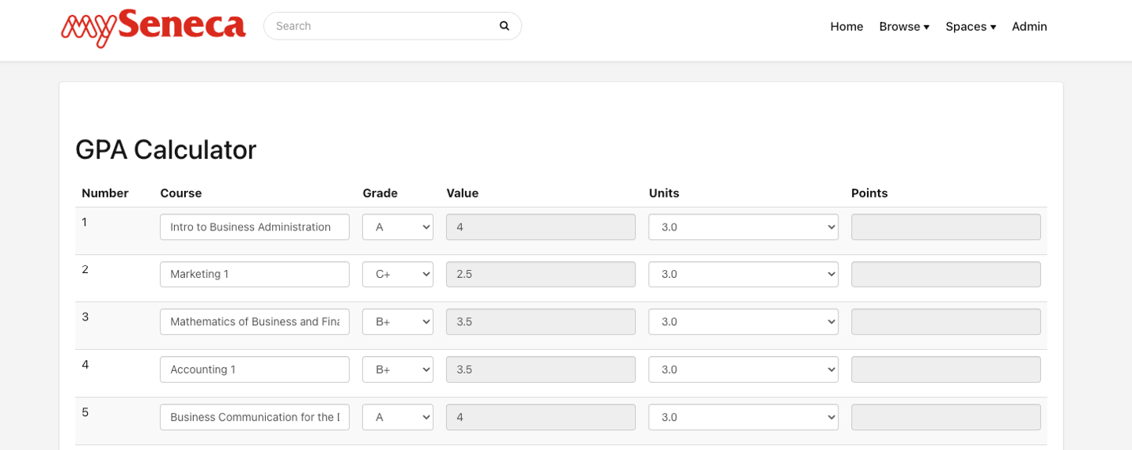

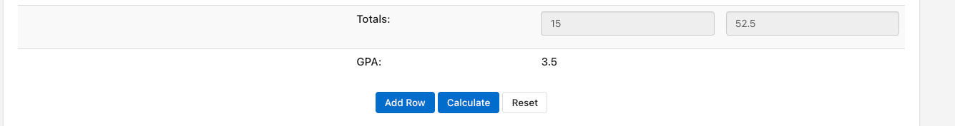

Performance Descriptors
Levels | Performance Descriptors | Needs Work | Completes task with support from practitioner | Completes task independently
A1.2 | scans text to locate information
 | locates multiple pieces of information in simple texts
 | obtains information from detailed reading
 | begins to identify sources and evaluate information
B3.1a | makes a direct match between what is requested and what is entered
D.2 | selects and follows appropriate steps to complete tasks
 | locates and recognizes functions and commands
 | makes low-level inferences to interpret icons and text
 | begins to identify sources and evaluate information

This task: Was successfully completed Needs to be tried again

Learner Comments:

Instructor (print): Learner (print):
__________________ _________________

