

Task Title: College Housing Options

OALCF Cover Sheet – Practitioner Copy

Learner Name: __________________________________________
Date Started: ___________________________________________
Date Completed: _________________________________________

Goal Path: | Employment | Apprenticeship
Secondary School | Post Secondary | Independence
Successful Completion: Yes No

Task Description: The learner will find information about college residence options and calculate cost differences between different room choices.
Main Competency/Task Group/Level Indicator:
- Find and Use Information/Read continuous text/A1.2
- Understand and Use Numbers/Manage money/C1.2
- Use Digital Technology/D.2
Materials Required:
- Pen/pencil and paper and/or digital device
- Calculator or digital device with calculator function

Learner Information
Many students choose college or university residences if they live too far from the campus to commute. Choosing the right residence may depend on factors including cost, whether or not the room is shared, where the residence building is located, and other amenities that are offered.

Scan the single, double, and trio room costs and payment options information for 2025-2026 at St. Lawrence College in Kingston.

Room Costs and Payment Options at St. Lawrence College
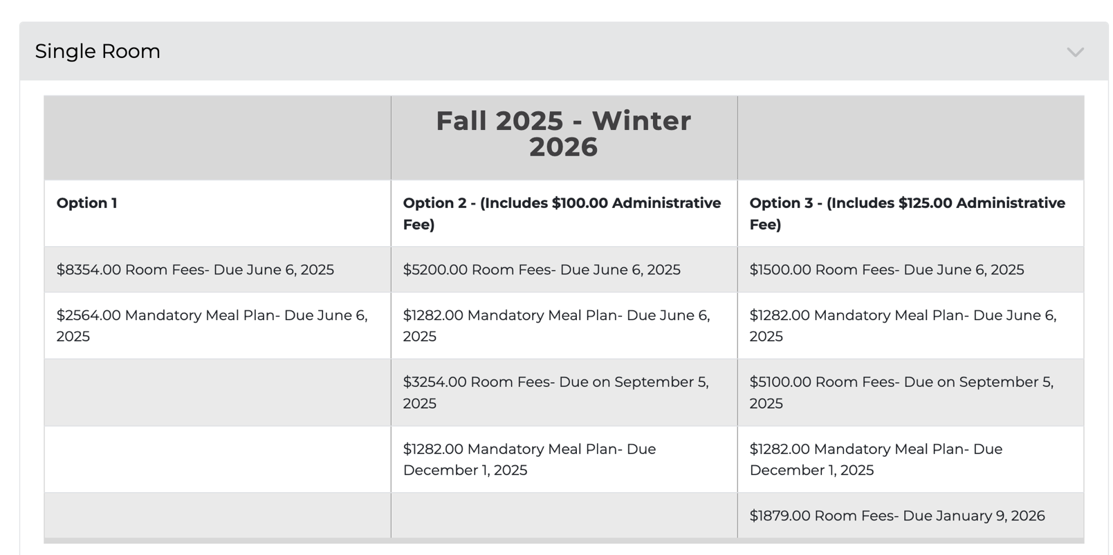

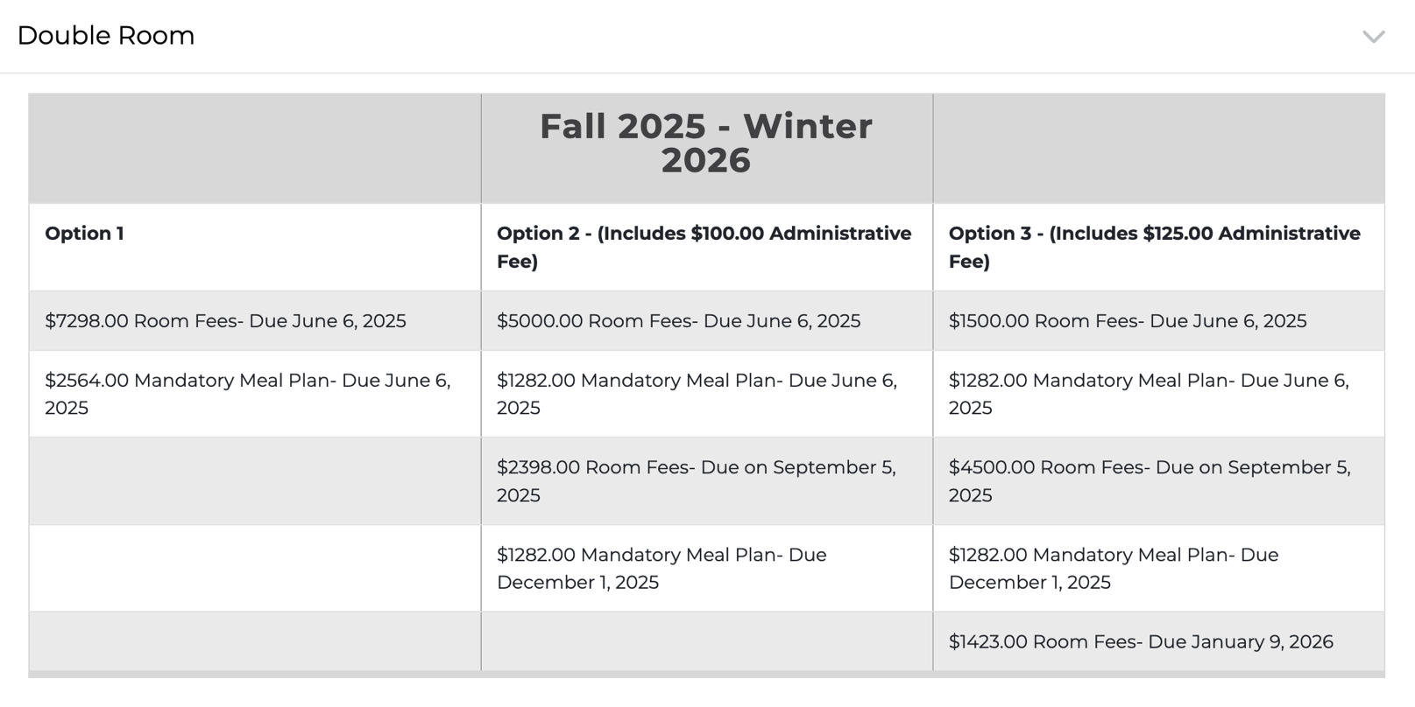

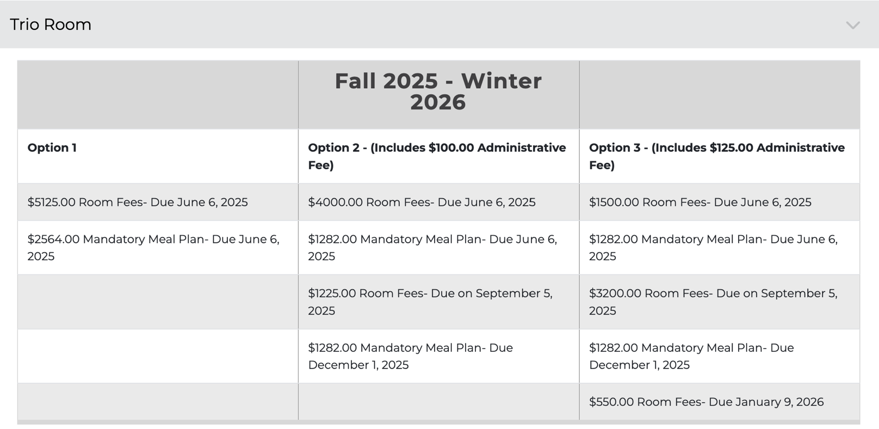

Work Sheet
Task 1a: Calculate the total cost of payment option 1 for single, double, and trio rooms.
Answer:

______________________________________________________
Task 1b: Calculate the amount of money saved if a student chooses a trio room compared to a double room.
Answer:

______________________________________________________
Task 2a: Calculate the total cost of a trio room for payment options 1, 2 and 3.
Answer:

______________________________________________________
Task 2b: Calculate the amount of money saved when choosing option 1 instead of option 3.
Answer:

______________________________________________________
Open the St. Lawrence College Kingston housing website and scroll to the bottom of the page to see Frequently Asked Questions: https://www.stlawrencecollege.ca/services/housing/residences/kingston-campus-residence
Task 3: How many double occupancy rooms are available?
Answer:

______________________________________________________
Task 4: How would you request a roommate of your choice?
Answer:

______________________________________________________
Task 5: List three (3) residence security features.
Answer:

______________________________________________________
Answers
Task 1a: Calculate the total cost of payment option 1 for single, double, and trio rooms.
Answer:
Single: $8,354 + $2,564 = $10,918
Double: $7,298 + $2,564 = $9,862
Trio: $5,125 + $2,564 = $7,689

Task 1b: Calculate the amount of money saved if a student chooses a trio room compared to a double room.
Answer: Trio vs. Double: $9,862 - $7,689 = $2,173 savings

Task 2a: Calculate the total cost of a trio room for payment options 1, 2 and 3.
Answer:
Option 1: $5,125 + $2,564 = $7,689
Option 2: $4,000 + $1,282 + $1,225 + $1,282 = $7,789
Option 3: $1,500 + $1,282 + $3,200 + $1,282 + $550 = $7,814

Task 2b: Calculate the amount of money saved when choosing option 1 instead of option 3.
Answer: $7,814 - $7,689 = $125 savings

Open the St. Lawrence College Kingston housing website and scroll to the bottom of the page to see Frequently Asked Questions: https://www.stlawrencecollege.ca/services/housing/residences/kingston-campus-residence
Task 3: How many double occupancy rooms are available?
Answer: 138
Task 4: How would you request a roommate of your choice?
Answer: If you already know someone who is going to St. Lawrence Residence who you want to room with, you can also send them a direct roommate request through the roommate portal. Search for this person in the roommate matching section of the application process and request to be matched with them.
Task 5: List three (3) residence security features.
Answer: Any three of
- card access controlled main entrance
- key controlled bedroom door
- visitors sign in at the front desk and provide photo identification
- common areas, stairwells, entrances and corridors are video-monitored
- front-desk staff are on duty 24-hours a day

Performance Descriptors
Levels | Performance Descriptors | Needs Work | Completes task with support from practitioner | Completes task independently
A1.2 | makes connections between sentences and between paragraphs in a single text
 | scans text to locate information
 | locates multiple pieces of information in simple texts
 | reads more complex texts to locate a single piece of information
 | makes low-level inferences
 | follows the main events of descriptive, narrative, and informational texts
 | obtains information from detailed reading
 | begins to identify sources and evaluate information
C1.2 | calculates using numbers expressed as whole numbers, fractions, decimals, percentages and integers
 | selects appropriate steps to reach solutions
 | represents costs and rates using monetary symbols, decimals and percentages
C1.2 cont’d | uses strategies to check accuracy (e.g. estimating, using a calculator, repeating a calculation, using the reverse operation)
D.2 | selects and follows appropriate steps to complete tasks

This task: Was successfully completed Needs to be tried again

Learner Comments:

Instructor (print): Learner (print):
__________________ _________________

